This set of activities aims to teach children that many food and other products that we enjoy come from animals who are kept on farms. They will learn that farm animals, like other animals, have basic needs that must be met by the humans who care for them, but will also learn about the ways in which consumers can influence the health and welfare of these animals.

Expectations

After covering this theme:
- most pupils will: understand that many products that we use every day are derived from farm animals and will be able to match some to the animal who helped to make them. They will understand that farm animals have basic needs and that some animals are raised to higher welfare standards than others
- some pupils have not made so much progress and will: understand that many products that we use every day are derived from farm animals. They will understand that farm animals have basic needs
- some pupils will have progressed further and will: understand that many products that we use every day are derived from farm animals and will be able to match an extensive range of them to the animal who helped to make them. They will understand that farm animals have basic needs, will be able to describe those needs and will know that some animals are raised to higher welfare standards than others and that products from these animals are labelled as such.

Initial teacher input
- Slowly unpack a bag containing a couple of animal-related food products (e.g. milk, some sausages), a pair of wellington boots, a toy tractor, a bucket and a picture of a border collie, asking the children after each object comes out if they can guess what this topic is going to be about. Hopefully, they will eventually arrive at the theme of farms!
- Ask who has ever enjoyed the food products that are in the bag. What other things come from farm animals – children suggest ideas. Without farm animals, we wouldn’t ever have these things, so we need to say a big thank you to the animals who made them.
- The RSPCA believes that all people who look after animals, including farm animals, should aim to give them the welfare needs by:
- providing fresh, clean water all of the time and the right type and amount of food to keep them fit and healthy
- making sure that animals have a suitable place to live - the right type of home including shelter, enough space and somewhere comfortable to rest and hide
- helping them stay healthy by preventing them from getting ill or injured and by making sure that animals are treated by a vet if they are sick or injured
- making sure animals can behave normally by giving them enough space and the right kind of facilities
- providing the company that he or she needs by being given appropriate company. Some animals should have company and some should be kept on their own.
- Introduce these needs, linking them to the children’s own basic needs, e.g. “You wouldn’t like to spend all your time on your own with no friends, would you?”
- Also see the factsheet – The five welfare needs

Adult-led activities
- Introduce children to the things that are natural behaviours for hens – flapping their wings, pecking the ground, building a nest, laying eggs on a nest and sitting on them, dustbathing and sitting on a perch at night. Can the children mime these things? Introduce the photos of the caged hens and the free-range hens from the image collection Farm animals. Ask one group of children to sit in a confined space, such as underneath the table, and pretend to be caged hens. Ask another group to pretend to be free-range hens who can choose where to go in the given space. Compare which of those natural behaviours each group can do. Ask which group of hens they think is the happiest. Show examples of egg boxes that are labelled 'caged' or 'free-range' and suggest to the children that the next time they are in a supermarket, they ask an adult to show them the different types.
- Visit an approved working farm with the children. See the link to FACE in the tab Useful websites, which can give links to farms approved for school visits.
- Use the farm animal images from the collection of images Baby animals - Farm animals to play a ‘snap’ game with the children, matching the adult animals to their young. When a child successfully matches up a pair, they must give one example of what that animal needs before they can take the cards.
- Cut out the statements from the activity sheet Who cares for baby? Mother animals do some of the things that are needed to care for their young, but the farmer needs to do other things. With the children, discuss the statements and sort them according to whether they are jobs for the farmer or for the mother (see teachers' notes Who cares for baby? (answers)). Some of them could belong in both categories.
- Play the corners game. Identify four corners of the classroom or playground and label them cow, pig, sheep and chicken. Hold up either food packets or pictures of products that come from animals and the children must run to the corner that represents the animal who helped to make the product.

Opportunities for child-initiated activities
- Attach a trailer to a sit-on toy vehicle and put some toy animals in there, which the farmer is taking to market. Ask the children how they are going to make sure that the animals are safe and comfortable throughout their journey. Ask them if they have enough water on board. Have they checked the vehicle to make sure that it is safe and working? Will they stop during their journey?
- Use a small-world farm but set it up each day so that something different is wrong. Can the children put it right? The children can be told each day what the problem is. See the teachers’ notes Farm play – Situations.
- Put out a selection of food packets, imitation food or pictures of food taken from the activity sheet Products from animals, together with some sorting rings. When the children are sorting them, ask them about the criteria they are using. Have they thought about which ones came from animals?
- Create a farm animal chatterbox – a box of objects relating to farms – that the children can pull out and use to talk to a partner about farms, the animals and their needs. The box could include:
- toy farm animals
- fence pieces and a barn from the farm set
- some strands of hay
- a small bucket
- a toy stethoscope
- woollen gloves
- some imitation food that comes from animals, e.g. an egg, milk carton.
- Put out the images of farm animals and their babies for the children to match up. Ask them about how they have matched them up. Model the use of the correct vocabulary for the animal babies. Ask the children what things the mother animal needs to do for her young and what the farmer needs to do.
- Set up a farm role play area. You will need:
- suitable clothing for the children to dress as the farmer
- areas designated for different animals
- a bucket so that the farmer can fill up the water troughs each day
- different bags/sacks to represent the feed for each animal
- a telephone so that the farmer can call the vet when necessary
- tools to mend the fences and shelters
- a list of possible situations for any adult who might join in the play – see teachers’ notes Farm play - Situations.
- Sing the Happy chicken song after the caged/free-range hens activity. Singing to the tune of If you’re happy and you know it, for each verse, add an example of hens' normal behaviour, e.g. "If you're happy and you know it, flap your wings" or "peck the ground".
- The children could visit a local shop to look at the range of eggs sold there.
- Introduce the RSPCA Assured logo to the children, explaining that products that display this logo have been produced on farms where the animals have been inspected to higher welfare standards (see teachers' notes RSPCA Assured logo). If the children visit a shop (see above), they could look out for which products display this logo.

Did you know?
- More than 900 million cattle, sheep, pigs and poultry are reared in the UK each year for food production, along with many millions of farmed fish.
- Almost 90% of non-caged egg production systems in the UK are RSPCA Assured-approved.*
- Pigs are highly intelligent and inquisitive animals that would naturally spend a large part of their day exploring their environment.
- Some cows are able to produce more than 80 pints of milk per day.
- Sheep’s wool contains a waxy substance called lanolin, which helps sheep to stay dry during wet weather.
- From 1 January 2012 the barren battery cage will be banned across the EU. However, the so-called 'enriched' battery cage will still be permitted. Although the enriched battery cage does provide some additional facilities and slightly more usable space (an extra 50cm² per hen - about the size of a beer mat), the RSPCA does not believe that these are adequate enough to provide for the full behavioural and physical needs of laying hens. Visit the RSPCA website for more information on enriched battery cages.
*figure correct as of 2014

Vocabulary
caged
calf
cattle
chick
chicken
cow
duck
duckling
free-range
goat
hen
kid
lamb
needs
pig
piglet
sheep
shelter
transport

Useful websites
RSPCA - All about animals - Farm animals
RSPCA Assured
FACE - Farming and Countryside Education
Video - What do farm animals need?
Teachers’ Notes – Who cares for baby? (answers)

Teaching a duckling to swim
This is done by the duck (mother/female duck).

Calling the vet if the animal is ill or injured
Animals cannot do this and so the farmer must do it.

Putting out fresh water every day
This is a job for the farmer.

Feeding a lamb
This could be in both categories. Normally the ewe (mother/female sheep) will do this, but in cases where the lamb is orphaned or is rejected by its mother, the farmer may need to feed it with a bottle.

Washing a newborn calf
This is done by the cow (mother/female).

Protecting a lamb from foxes
This is done by both the farmer and the ewe (female sheep). A ewe can keep her lamb close to her to try to protect it from foxes, but the farmer also has an important role to play in maintaining strong fencing around the sheep and lambs and/or securing buildings where sheep and lambs are housed.

Showing a chick how to keep its feathers clean
This is done by the hen (mother/female chicken).

Making sure the animal can have a drink on a cold day by breaking the ice on the water trough
Animals cannot do this and so the farmer must do it.

Making sure there is enough straw for the piglets to lie on and keep warm
Animals cannot do this and so the farmer must do it.
Teachers’ Notes – Farm play - Situations

Suggestions for setting up the small-world farm with some ‘emergencies’ or for
role-play situations.

- Put small scrunched-up pieces of paper and other small objects such as a paper clip, balloon, bottle top, etc, in the field where the cows are to suggest that rubbish has been dumped in the field. The cows may get injured by it.
- Move the pieces of fencing apart and put a toy car nearby to suggest that there is a hole in the fence next to the road – the animals may escape and be hurt on the road.
- Place a lamb in a separate field, suggesting that it has strayed from its mother and become lost.
- Put a toy fox amongst the chickens to suggest that the chickens weren’t shut into their shed the night before.
- Stick a large yellow sun on the wall next to the farm and put the pigs in the field with an empty drinking trough. It is a sunny day and the pigs are out in a field where there isn’t any shade or water.
- Stick a blue ice symbol on the wall next to the farm and replace the water in the drinking trough with an ice cube to suggest it is a very cold day and the water in the sheep’s drinking trough has iced over.
- Wrap a small amount of string around the leg of one of the animals, with some of it trailing behind, as though it has been caught up in something and may be injured.
Teachers’ Notes – RSPCA Assured logo

RSPCA Assured is the RSPCA’s farm assurance and food-labelling scheme, dedicated to improving the lives of farm animals.

It gives consumers the option of choosing products that have come from animals that have been inspected to higher welfare standards. A trained RSPCA Assured assessor visits and completes a thorough inspection of the farms every year and RSPCA farm livestock officers carry out risk-based visits on a proportion of members every year.

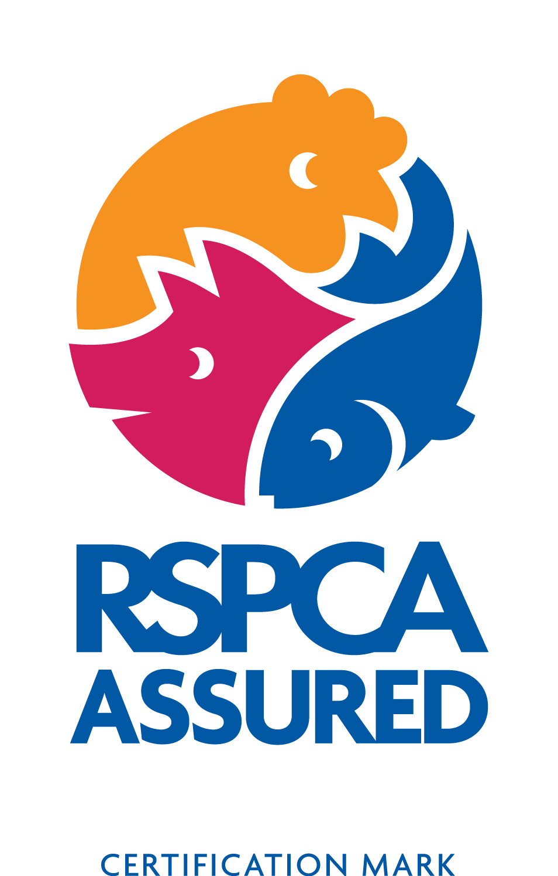
Factsheet – The five welfare needs
The Animal Welfare Act 2006 requires anyone who owns or looks after an animal to provide everything that the animal needs to be happy and healthy. These needs can be described as:


A suitable place to live
Animals should have the right type of home, including shelter, enough space, and somewhere comfortable to rest and hide.


A healthy diet
Animals should have access to fresh, clean water all the time and should be given the right type and amount of food to keep them fit and healthy.


The ability to behave normally
Animals should have enough space and the right kind of facilities to allow them to behave normally.


The company he or she needs
Animals should be given appropriate company. Some animals should have company and some should be kept on their own.


To stay healthy
Animals should be protected from pain, suffering, injury and disease and should be treated by a vet if they are sick or injured.

Activity sheet – Who cares for baby?

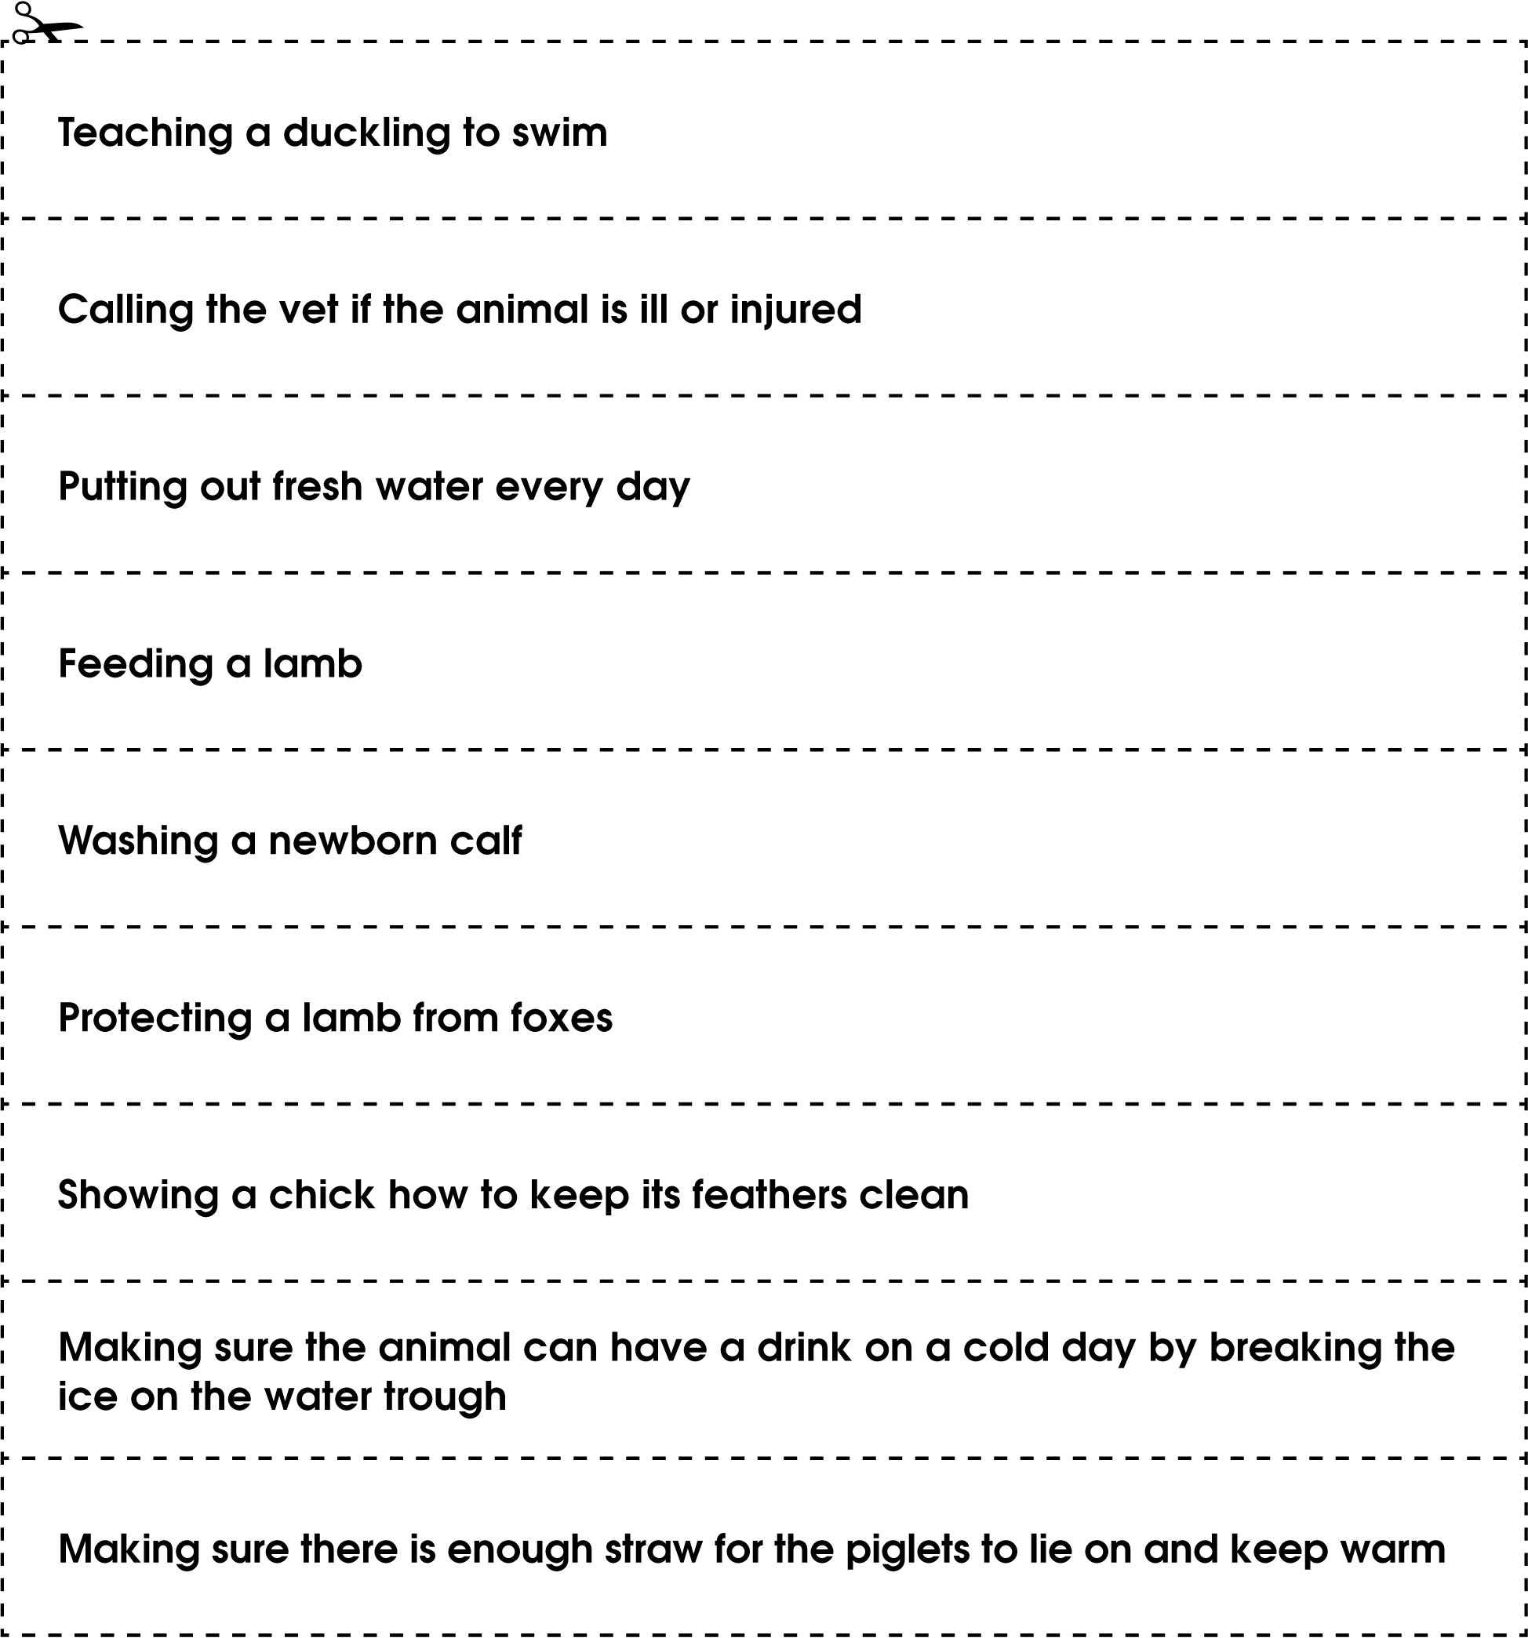
Activity sheet – Products from animals

Activity sheet – Products from animals

