In this lesson pupils will learn what a farmer needs to do to meet the needs of farm animals. It is based on the popular story Farmer Duck written by Martin Waddell. Pupils act out a study based on what would happen on Farmer Duck's day off - the farmer needs to do everything to ensure that the farm animals are happy and healthy. To prepare for this lesson, pupils could make their own farm animal masks.

Starter activity
What do I need?
- Draw a human face on the board and ask the pupils to identify things that they need to be happy and healthy.
- Draw and/or write the items suggested around the face on the board.
- Change the human face into that of a farm animal.
- Ask the pupils whether the farm animal needs all the things that they needed.
- Review each item in turn, replacing them with the specific items that the farm animal would need, as appropriate.
Learning styles: visual, auditory.

Main activity
What do farm animals need?
- With the pupils working in pairs, give each pair a different farm animal worksheet, e.g. A cow needs, A duck needs, etc. Alternatively, there is a blank worksheet, My farm animal needs. Each pair also needs a copy of the worksheet Farm animal needs.
- Nominate, in each pair, one pupil as the 'cutter' and one pupil as the 'sticker'.
- Ask the pupils to cut and stick all the items from the worksheet Farm animal needs that they think their farm animal needs onto their sheet.
- Select pairs of pupils to present their work to the rest of the class, so that all the animals and their needs have been discussed. What are the similarities or differences? There are teachers' notes to go with this activity.
- As a whole class, listen to the story Farmer Duck written by Martin Waddell.
- Ask the pupils to identify things from the story that Farmer Duck did to look after the animals.
- Ask the pupils to think about which of these things the farmer himself should have done to keep all of his farm animals happy and healthy.
Learning styles: visual, auditory, kinaesthetic.

Plenary activity
Farmer Duck's day off
- Ask the pupils to act out or role play how the story would have been different if the farmer was made to do all the things to keep the rest of the farm animals happy and healthy, when Farmer Duck had his day off. The pupils could wear farm animal masks and simple props to help them tell the story.
Learning styles: visual, auditory, kinaesthetic.

Assessment
Completion of the worksheet My farm animal needs in the main activity and the cartoon grid in the extension activity provide opportunities for assessment.

Extension activities
A story could be written or drawn to explain what happened in the story of Farmer Duck's day off. This could be drawn in a cartoon grid, in which six pictures are drawn (and text added if able) to represent six points within the story.

Display
A display could be created using the farm animal masks and photographs taken of the pupils acting out the story of Farmer Duck's day off.

Did you know?
- Ducks are rarely given access to open water to carry out water-related behaviours on-farm. Disappointingly, there is no UK or EU legislation specifying the need to provide ducks water for anything other than drinking.
- In the UK around 50 per cent* of eggs are produced by hens in battery cages. Each enriched battery cage typically houses around 80 hens. There may be as many as 9 rows of wire cages stacked on top of each other in one building, with walkways for the stock-keepers in between and often hundreds of cages in each row. The RSPCA is calling for all cage systems to be banned and for hens to be kept in well-managed alternative systems such as barn or free-range.
- Pigs have an extremely good sense of smell. Contrary to popular belief, they are clean animals and, if given properly designed living accommodation, will always use one particular area for dunging, thereby keeping their sleeping areas clean.
- The dairy cow is capable of producing between 6,000 and 12,000 litres in a single 305-day lactation, equivalent to between 10,650 and 21,000 pints of milk.
* figure correct as of 2010.

Curriculum objectives
Pupils should learn:
- that humans and other animals need food and water to stay alive
- that animals, including humans, move, feed, grow, use their senses and reproduce
- to recognise what they like and dislike, what is fair and unfair, and what is right and wrong.

Animal welfare objectives
Pupils should learn:
- that all animals, including farm animals have basic needs
- that it is the farmer's responsibility to meet the needs of the farm animals so that they are happy and healthy
- that different farm animals have different needs.

Learning outcomes
At the end of this lesson:
- most pupils will: be able to recognise the needs of farm animals, and explain why the farm animals need these things to remain happy and healthy
- some pupils have not made so much progress and: are able to identify items that farm animals need
- some pupils will have progressed further and: be able to identify the consequences of the farmer not providing all the things that the farms animals need. They may also be able to identify items that would enhance the farm animals' lives whilst on the farm.

Vocabulary
company
happy
healthy
need
nest
perch
responsible
shelter
want

Useful websites
RSPCA - All about animals - Farm animals
RSPCA Assured
Compassion in World Farming - Education
FACE - Farming and Countryside Education
Video - What do farm animals need?
Worksheet – Farm animal needs

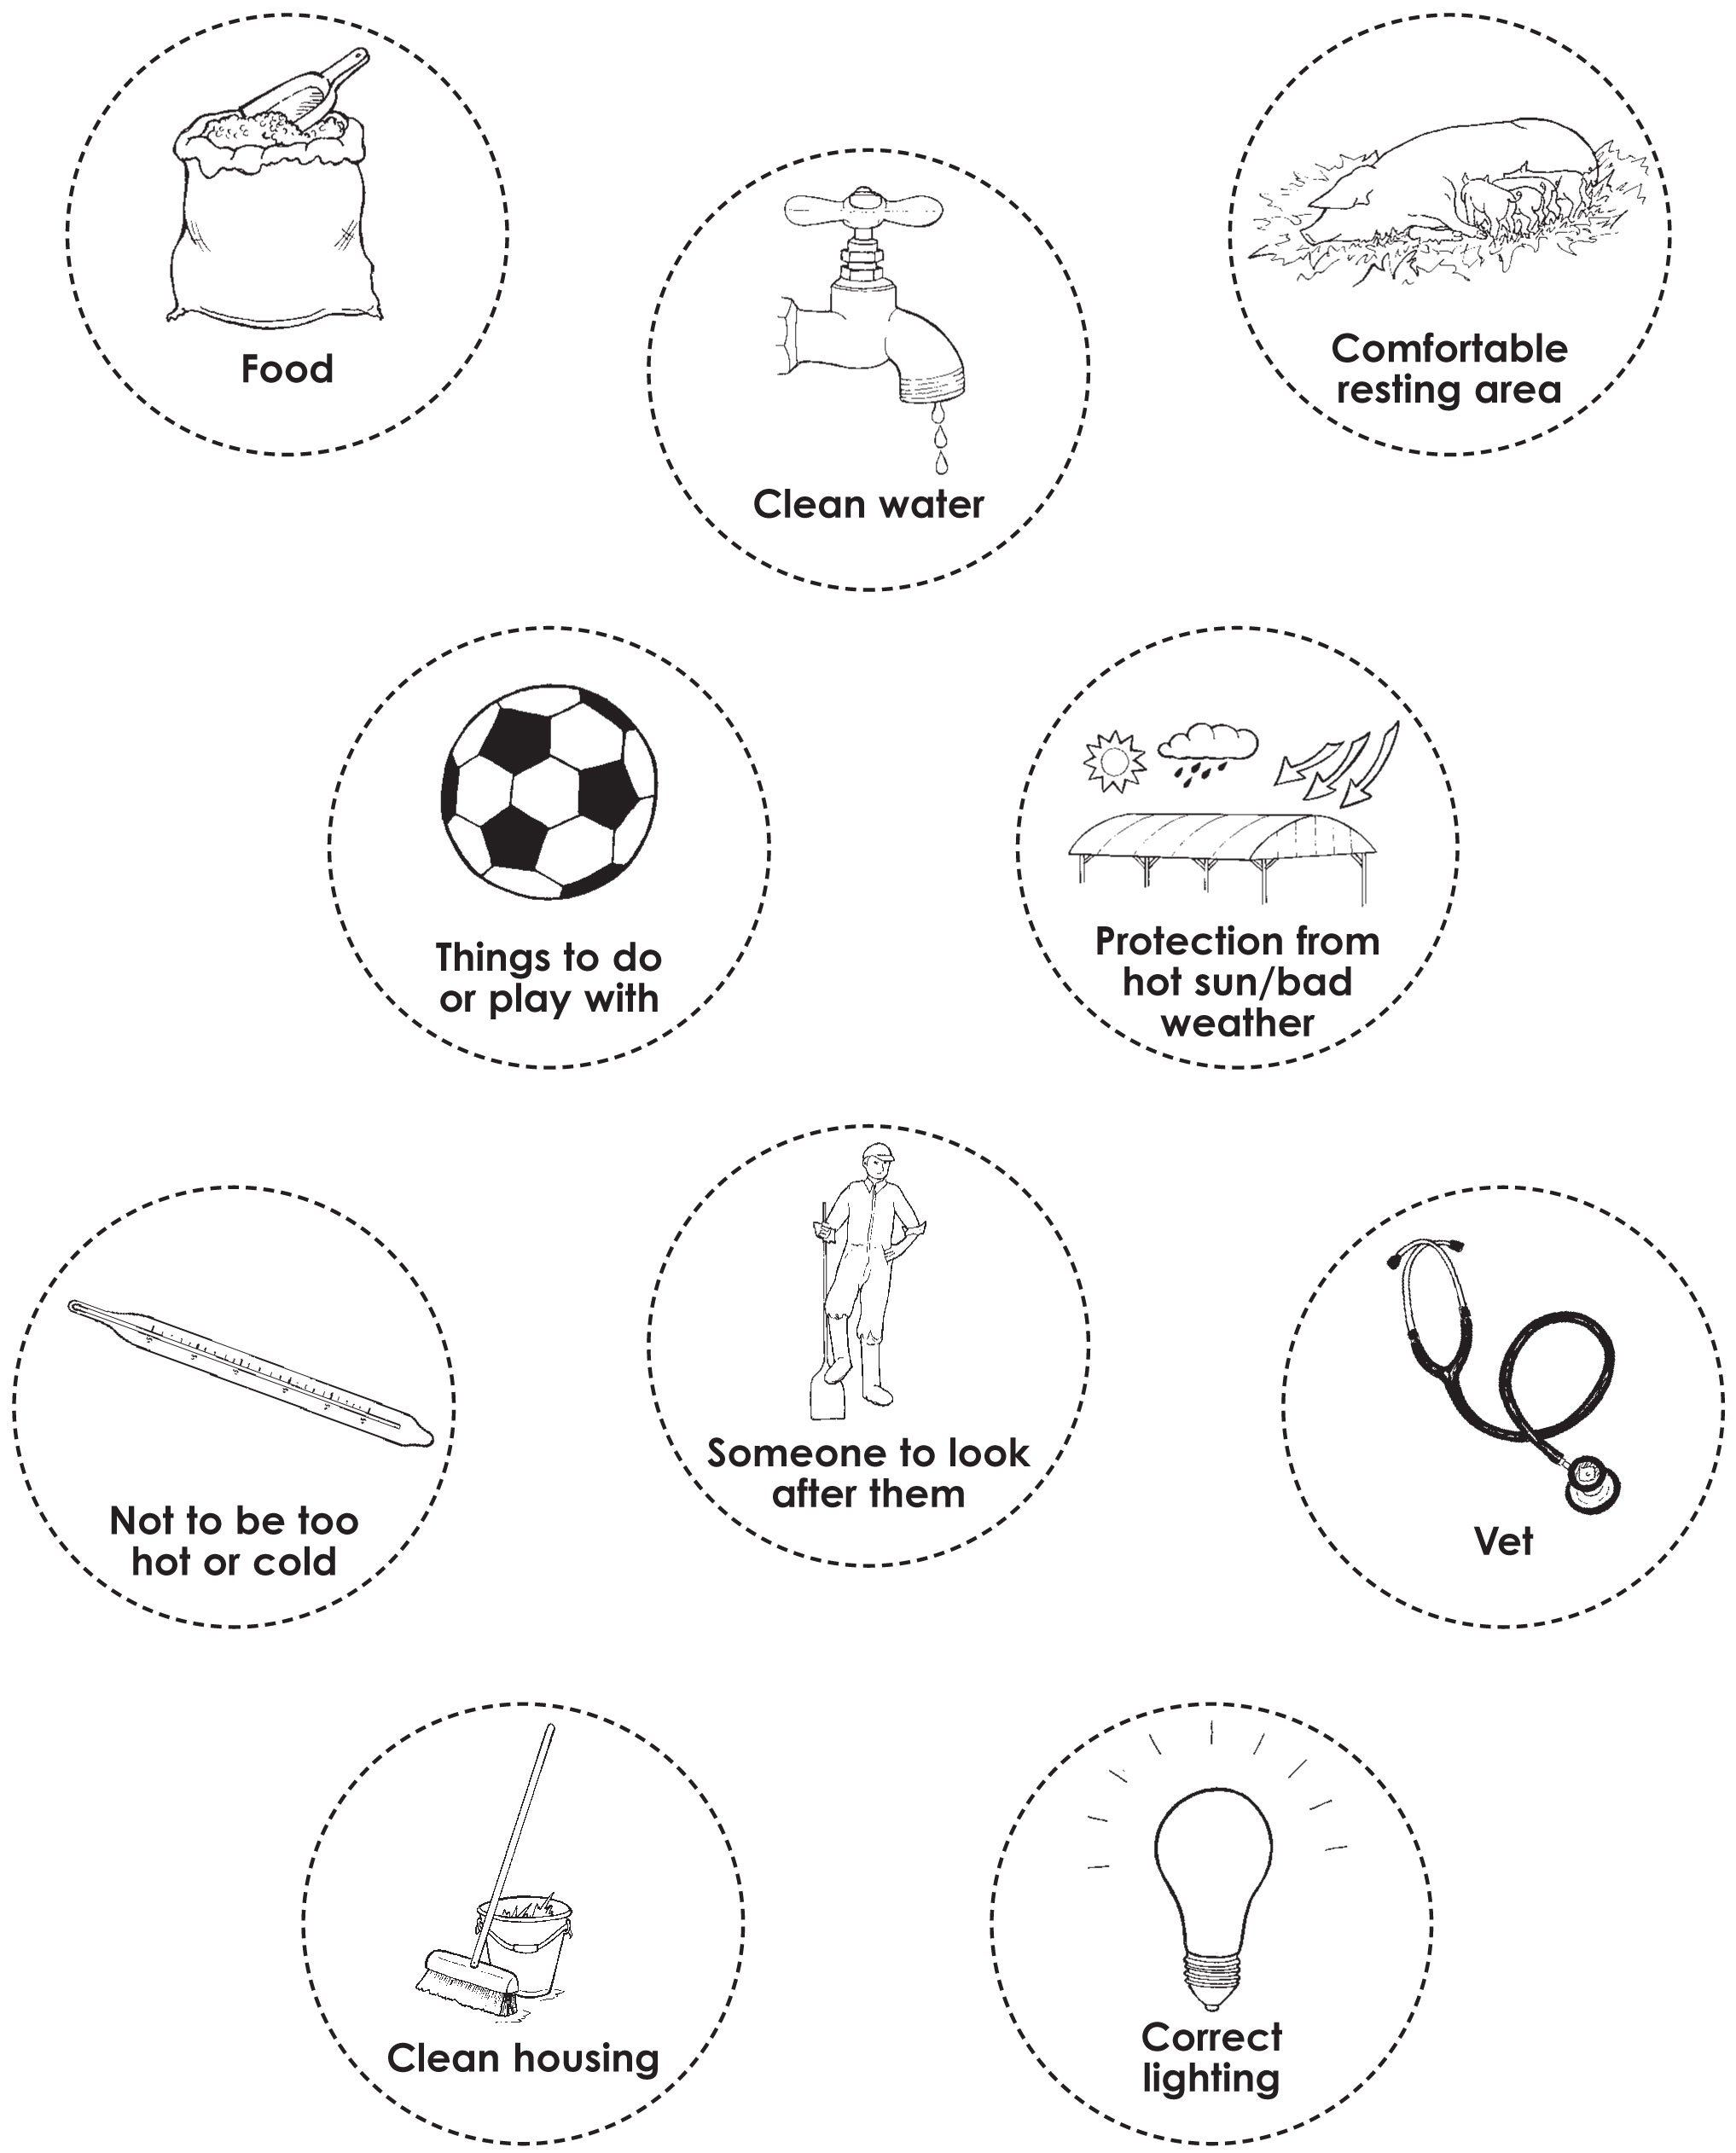

Worksheet – A cow needs

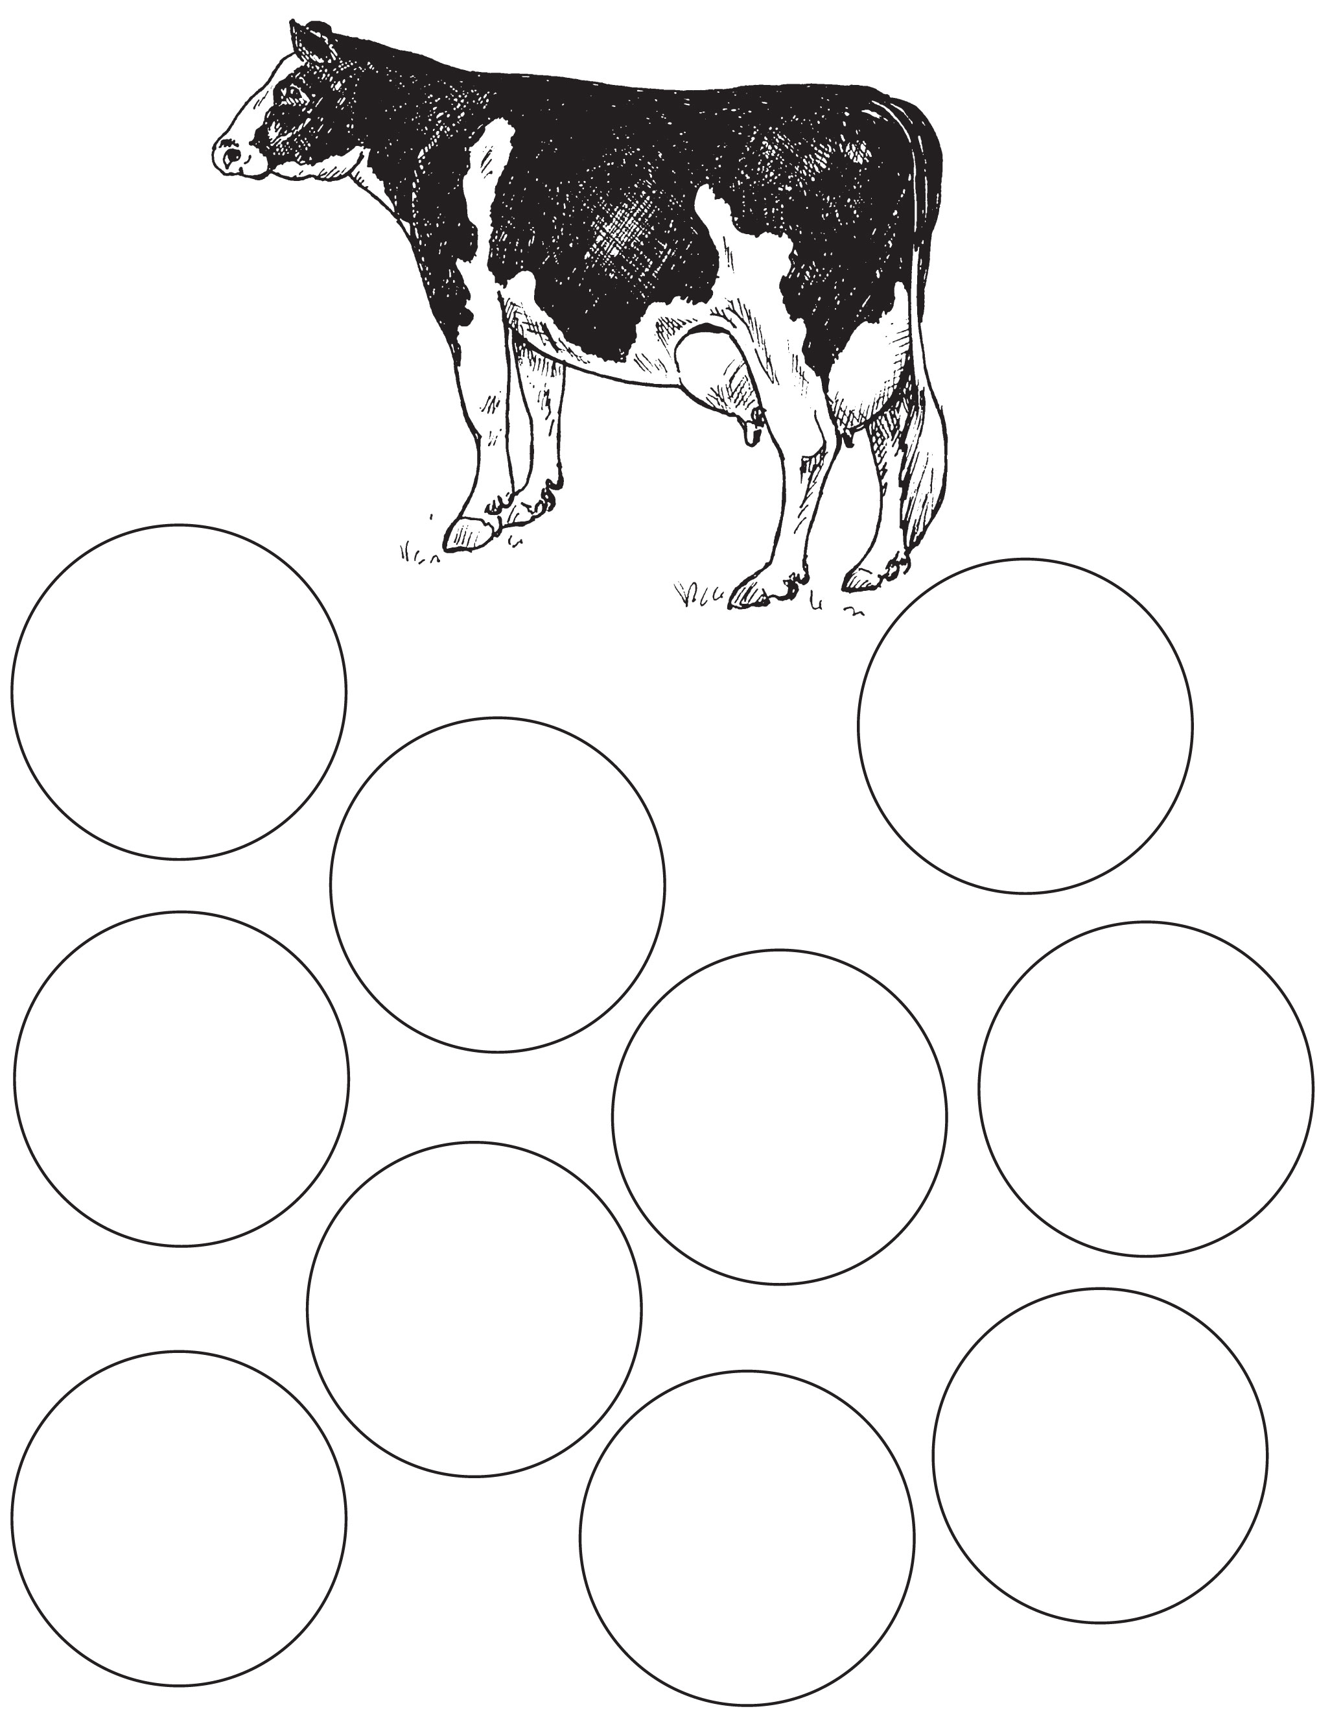

Worksheet – A duck needs

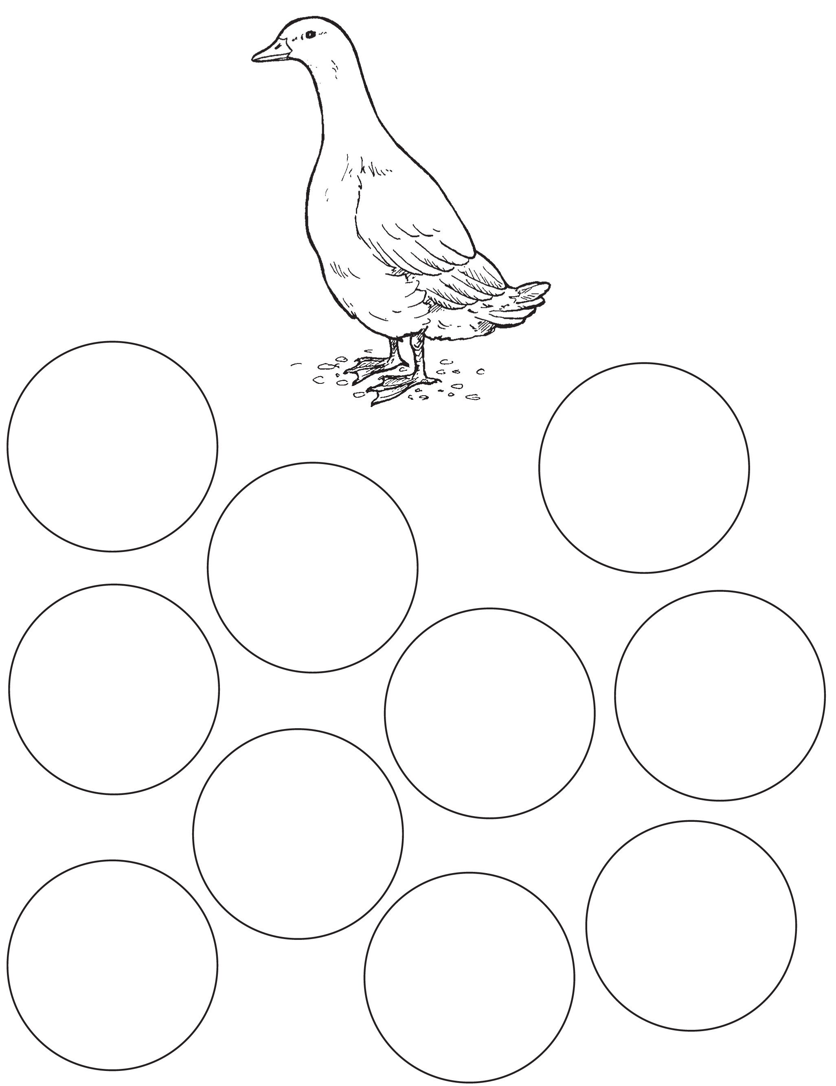

Worksheet – A hen needs

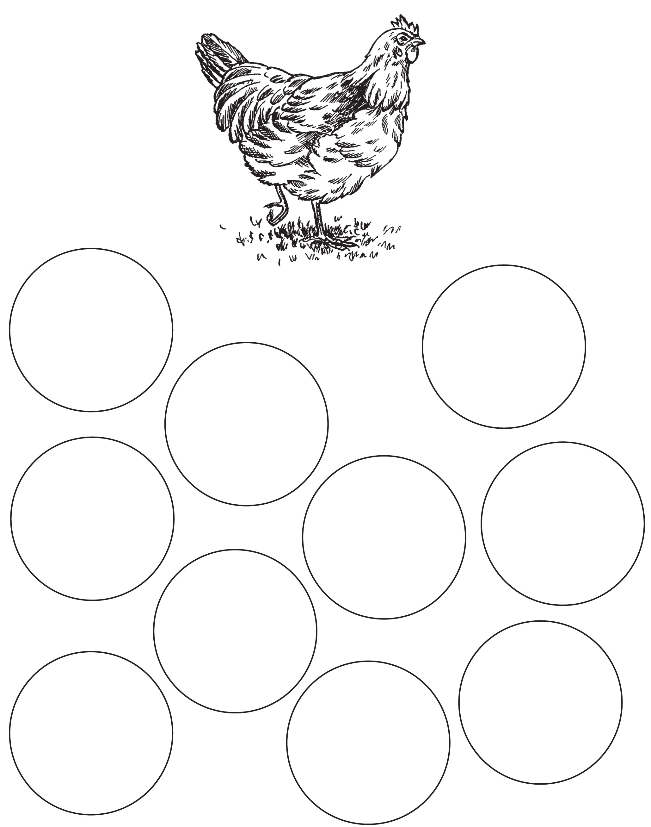

Worksheet – A sheep needs

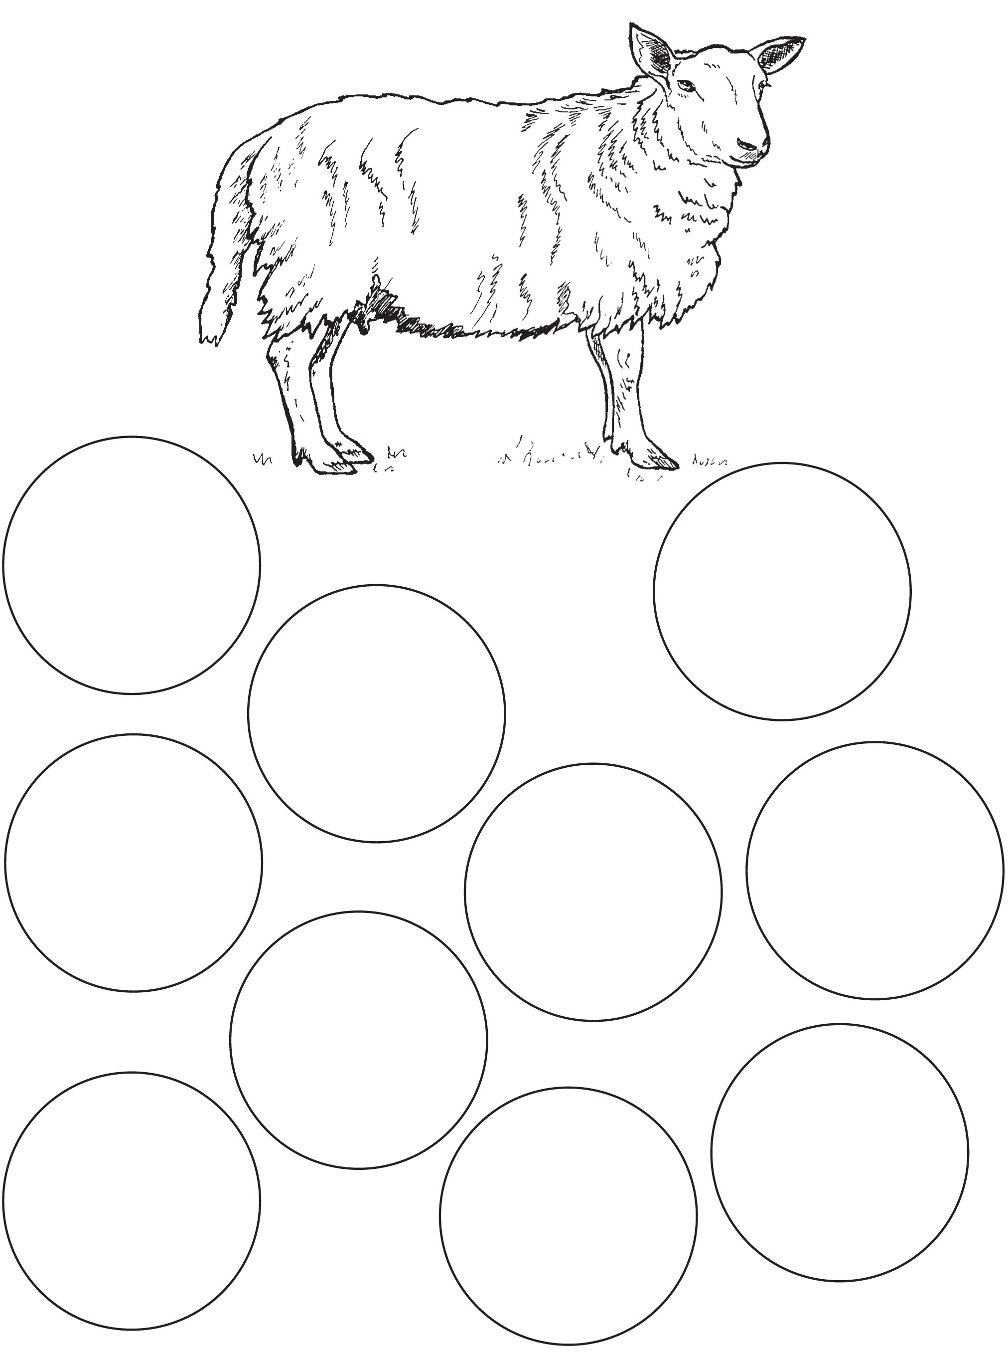

Worksheet – A pig needs

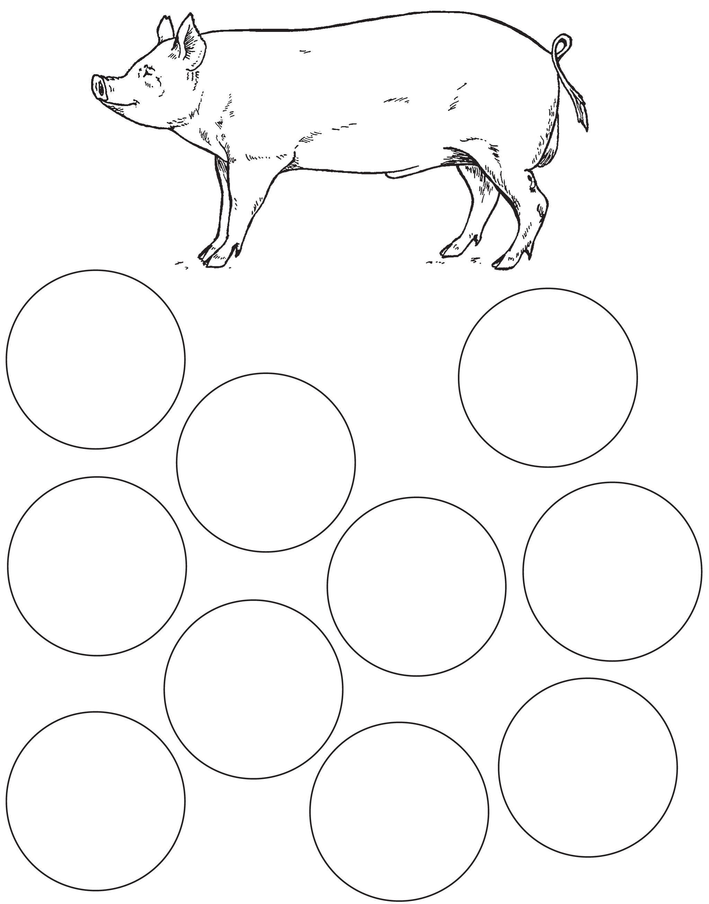
Worksheet – My farm animal needs


Teachers' notes – Farm animal needs – answers A

Food (All)
All farm animals need to be fed a wholesome diet that is appropriate to their species and which is fed to them in sufficient quantity to maintain them in good health and to satisfy their nutritional needs.

Clean water (All)
All farm animals need continuous access to an adequate supply of clean, fresh drinking water each day.

Comfortable resting area (All)
All farm animals need to be housed in a suitable environment that protects them from discomfort and provides them with a comfortable place to rest. For example, dairy cattle should have an adequate bed of straw or wood shavings or a soft cow mat to lie on.

Interesting things to do/things to play with (All)
All farm animals need environmental enrichment to keep them active, prevent boredom and allow them to carry out their natural behaviours.
- Ducks should have access to water facilities for preening and bathing. Straw bales can also help to encourage activity.
- Cattle should have access to a well-managed exercise area. Some farmers give the cows brushes (attached to walls) to rub against.
- During the grass-growing season, if the climate is suitable, sheep should have access to outdoor grazing, which allows them to carry out natural grazing behaviours.
- Pigs need access to straw or other suitable material to allow rooting, pawing, mouthing and chewing behaviours.
- Hens need access to perches, and suitable litter to allow dustbathing, pecking and scratching at the ground.

Protection from hot sun/bad weather (All)
All farm animals should be kept in a suitable environment with access to shelter to protect them from inclement weather.
For example, to avoid sunburn, free-range pigs should be provided with access to shade and well-managed wallowing areas.
Free-range hens need overhead shade/shelter to protect them from rain or hot sun.

Not be too hot or cold (All)
All farm animals should be kept at a suitable temperature. For example, sheep that are sheared during winter should be kept in draught-free indoor housing for two months after shearing to avoid cold stress.

Someone to look after them (All)
All farm animals need to be regularly checked by competent stock-keepers to make sure that they are ok.

Vet (All)
All farm animals should be kept free from pain, injury or disease by prevention or rapid diagnosis and treatment.

Clean housing (All)
Good hygiene is important to prevent infection and reduce the risk of disease.

Enough space (All)
All farm animals should have sufficient space to move around, exercise, express their natural behaviours and avoid other animals if they choose to do so.

Friends/company (All)
Many farm animals would naturally live in a herd or a flock and find it stressful to be kept alone. They therefore need to be kept with other animals of their own kind.

Place to make a nest (Hens and pigs)
Hens need to have a suitable place and suitable material for laying their eggs. Pregnant sows (female pigs) have a strong instinct to build a nest a few days before they farrow (give birth), and should be provided with materials (e.g. straw) to enable them to carry out this behaviour.

Perches (Hens only)
Free-living hens roost on perches at night, and use them during the day to move away from other hens, so providing perches or other platforms enables the hens to express normal behaviour.

Not be frightened (All)
All farm animals should be kept free from fear and distress.

No loud noises (All)
Loud noises can scare farm animals.

Not be in pain (All)

Handled gently (All)
All farm animals should be handled carefully by a trained animal-handler to prevent them becoming scared, distressed or injured.

Bathing facilities (Ducks only)
Ducks need access to water facilities for preening and bathing.

Correct lighting (All)
All farm animals that are kept indoors need periods of light (of a suitable brightness) and a suitable dark period so that they can carry out daylight behaviours and rest.

