This science investigation of animals in their habitats can be carried out over several lessons. It is important to consider the needs of animals and avoid moving them into the classroom. Pupils’ attention should also be drawn to the code of conduct Ground rules worksheet

Starter activity
Where do woodlice like to live?
Show pupils the photo of a woodlouse from the Image collection or observe them in the school habitat. Given its features, what type of place would the pupils predict that the woodlouse would like to live - light and open or dark and damp? Have the pupils got any ideas about how to test their predictions?

Learning styles: visual, auditory.

Main activity
Habitat investigation
- The children are going to find out what type of material woodlice would like to live under. They can do this by placing squares of different materials - paper, clear plastic, dark plastic and carpet - on an area of earth. Ask the pupils to think what conditions the different materials create.
- Ask the pupils how they think they can make a fair test. The squares should all be the same size and on the same type of earth in roughly the same area.
- After a couple of weeks, go back to the squares and record how many woodlice have moved in. The carpet should be the most effective. Leave the successful habitats in place as the beginning of a minibeast city.
Learning styles: kinaesthetic.

Plenary activity
Drawing conclusions
What do the results tell us about where woodlice like to live? How could the pupils use their results to encourage woodlice to live in the school grounds?
Learning styles: auditory.

Differentiation
You can support children by providing a list of suggested predictions, a template for recording results or a word frame.

Extension activities
Create a minibeast city to encourage wildlife to the school grounds.

Curriculum objectives
Pupils should learn:
- to make predictions about animals and their habitat or feeding preference
- to record information accurately
- to carry out a fair test
- to draw conclusions from results
- to suggest further investigation.

Learning outcomes
At the end of this session:
- most pupils will: identify some local habitats, name some of the organisms that live there, state the food source of some animals and plan how to investigate some of the preferences of small animals found in the habitat
- some pupils will not have made so much progress and will: identify some local habitats, name a few of the organisms that live there and, with help, make observations of animals and plants
- some pupils will have progressed further and will also: represent feeding relationships within a habitat by food chains and explain why it is necessary to use a reasonably large sample when investigating the preferences of small invertebrates.

Vocabulary
casgliad / conclusion prawf teg / fair test
arsylliad / observation proffwydoliaethau / predictions

Useful links
Free ‘Habitats’ image pack
Worksheet – Ground rules

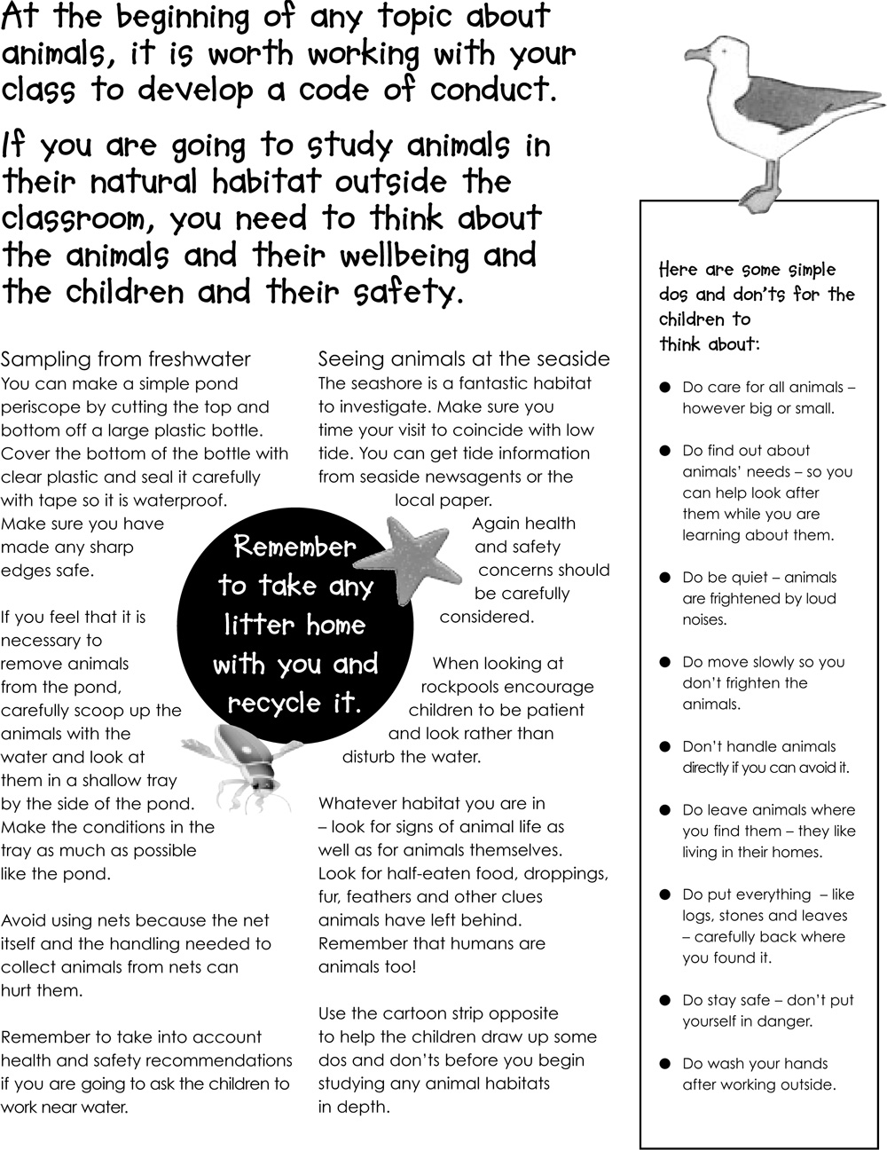
Worksheet – Rheolau sylfaenol

