Activity sheets
How to make a hedgehog home How to make a bird table
How to make a toad box How to make a bird cake
How to make an insect hotel Making animal homes and feeders
Minibeast homes How to make a nest box for birds

Aims and objectives
- This activity is just one part of a range of resources addressing the needs of young people who have been involved, or who are at risk of being involved, in cruelty to animals. Our online assessment tool Developing a suitable intervention programme (Word 17KB) will help you create individualised intervention programmes from these resources.
- In this group of activities, specifically aimed at young people who have been involved in cruelty to animals, they find there are ways that they can make amends for what they have done.

What to do

- If you can, arrange a restorative conference, or some way for the owner of the animal to communicate to the young person how the crime has affected them.
- Establish whether the animal involved is a pet, wild or farm animal.
- Where possible, encourage the owner to make suggestions for the young person’s reparation, depending on the type of animal. Check the relevant facilitators' notes How can I make a difference to the lives of… animals for ideas, or select a variety of activities from more than one sheet if it would be more appropriate.
- Some of these activities could also be used in the Making a positive contribution section.
- We have also developed three interactive activities - Was it cruel?, Consequences and Triggers - that help young people think through what happens when people are cruel to animals (see right). However, before you attempt to use these, we suggest that you explore some of the activities in the other sections - What is animal cruelty?, What triggers animals cruelty and how it can be avoided, Consequences of cruelty to animals and The incident.

Useful websites

RSPCA Advice and welfare – Farm animals
RSPCA Advice and welfare – Our pets
RSPCA Assured
RSPCA – Get involved
RSPCA – All about animals – Laboratory animals
RSPB – The Royal Society for the Protection of Birds
FACE – Farming and Countryside Education
Federation of City Farms and Community Gardens
Defra – farm animals
RSPCA – In your area

Facilitators’ notes – Practical ideas further information (1)

We suggest the following times as a guide, but they are designed to be flexible

Facilitators’ notes – Practical ideas further information (2)

The items you will need vary with each activity, but here are some suggestions

Facilitator’s Notes - How can I make a difference to the lives of pet animals? (1)
The following ideas are suggestions for reparation ideas where a young person’s offence has involved a pet animal. All the activities give young people the chance to do something positive for pet animals, while some also promote general animal welfare and involvement in the local community.

1. What do pets need?
The young person can find out about pets’ needs by doing one or both of the following.
- Go through some of the activities in the Basic welfare needs and sentience section of this resource or use the internet to find out what pets need. There’s advice on how to keep pets happy and healthy at
http://www.rspca.org.uk/adviceandwelfare and click on pets.
b. On the same page there are links to some of the RSPCA’s concerns about caring for pets. There are links to:
• fireworks
• microchipping
• neutering
• buying a puppy
• going on holiday
- Vaccinations
- pet obesity
The young person could think about ways of sharing what they’ve found out with other people, to encourage responsible pet care.
Who would benefit from knowing it?
• Family?
• Friends?
• Other young people they know?
• Others in the local community?
How can the young person share the information?
• By talking to people they know?
• By creating a poster or a leaflet to put up at home or leave in the local library?
• By putting a display in a vets or youth centre?
• By applying what they’ve learned to their own pet, or asking friends or family to do so?

2. Practical pet care
Find out whether there is an opportunity for the young person to get first-hand experience of what it means to look after a pet animal by helping a friend or relative with the day-to-day care of their pet. First, the young person will need to understand the needs of the animal and how to meet those needs appropriately. Go to http://www.rspca.org.uk/adviceandwelfare and click on pets to find information about basic pet needs. There are also some Ground rules for pet animals in the Who is responsible? section of this resource.

3. Campaign for the RSPCA
Young people could make a real difference to the lives of pet animals by supporting an RSPCA campaign. They can find details of current campaigns by going to http://www.rspca.org.uk/getinvolved and clicking on Campaigns. They can check out how campaigning makes a difference, and could find out how to:
• collect signatures for a petition to support a current RSPCA campaign
• write a letter to their MP or Assembly Member
• promote RSPCA campaigns on personal social networking pages.

4. Litter pick
The young person could do a litter pick in a local area where pet animals might go, for example near a pond, in a park, field or open space. They could do it on their own initiative; or community groups or the local authority might be organising one that they could join. RSPCA inspectors regularly rescue pet animals trapped or hurt by discarded litter, as everyday objects can become hazards to animals. In a survey by the charity Environmental Campaigns (ENCAMS), 95 per cent of vets had treated an animal with an injury caused by litter. They reported treating an average of 20 animals per surgery in the previous year.
The risks
• Glass - Glass bottles and jars break easily, leaving sharp pieces that can cause serious injury to animals or even death.
• Cans- Animals such as cats may get their heads trapped inside cans – a half-open lid can cut.
• Plastic bags- Plastic bags can trap and suffocate pet animals, such as cats.
See the factsheet Litter stories for specific incidents of litter harming pet animals.

5. Raise money for the RSPCA
There are many ideas for fundraising activities on the main RSPCA website. Go to www.rspca.org.uk, select the Get involved tab, and then Get fundraising.

6. Collect for a local animal centre
Animal centres rely on local volunteers to help them look after rescued pet animals, so there may be opportunities for the young person to support the work of a centre in their own community. Contact your local centre to ask whether there are any items they need, such as food or blankets, which the young person could collect. You can find local RSPCA animal homes by going to the RSPCA website www.rspca.org.uk and selecting the home then the In your area tab.

7. Support a local RSPCA branch
There may be other activities available through the young person’s local RSPCA branch. Each branch has different needs, but possible activities could include:
• helping with gardening or maintenance work at an animal home
• working in a charity shop
• helping to raise funds
• creating and/or distributing posters to charity shops, libraries, vets and other venues for an event, scheme, recruitment drive or campaign.
Get in touch with your nearest branch to ask what they can offer. You can find it by going to the RSPCA website www.rspca.org.uk and selecting the home then the In your area tab.

Facilitators’ notes – How can I make a difference to the lives of farm animals? (1)

The following ideas are suggestions for reparation ideas where a young person’soffence has involved a farm animal. All the activities give young people the chance to do something positive for farm animals, while some also promote general animal welfare and involvement in the local community.
1. Raise awareness of the RSPCA Assured scheme
Ask the young person to go to www.rspca.org.uk and select Welfare and Advice, then Farm animals to check out some of the RSPCA’s concerns about farm animal welfare.
After the young person has explored the concerns and looked at some of the basic needs and behaviours of farm animals, he or she can then go back to the home page and click on the RSPCA Assured section. This shows how the RSPCA Assured scheme supports animal welfare.
Discuss what the young person could do with this information.
Who would benefit from knowing it?
• Family?
• Friends?
• Other young people they know?
• Others in the local community?
• Local shops or supermarkets?

How can the young person share the information?
• By talking to people they know?
• By creating a poster or a leaflet to put up at home or leave in the library
• By putting a display in a vets or youth centre?
• By writing to shops and supermarkets in the area to ask if they stock RSPCA Assured products?

2. Practical farm animal care
Try to find an opportunity for the young person to get first-hand experience working alongside a local farmer, to help care for his or her animals. This would bring home what it means to care for farm animals. First, the young person will need to understand the animals’ needs and how to meet them. Click on the Advice and welfare tab on the RSPCA website home page www.rspca.org.uk and select the Farm animals section for information on basic farm animal needs. To prepare for going to a farm, do the Farm animal ground rules activity in the Who is responsible? section of this resource.
3. Campaign for the RSPCA
Young people could make a real difference to the lives of farm animals by supporting an RSPCA campaign. They can find details of current campaigns by going to www.rspca.org.uk and clicking on Campaigns. They can check out how campaigning makes a difference, and could find out how to:
• collect signatures for a petition to support a current RSPCA campaign
• write a letter to their MP
• promote RSPCA campaigns on personal social networking pages.
4. Litter pick
The young person could do a litter pick in a local area where farm animals might go, for example in a hedgerow, field or open space. They could do it on their own initiative; or community groups or the local authority might be organising one that they could join.
RSPCA inspectors regularly rescue pet animals trapped or hurt by discarded litter, as everyday objects can become hazards to animals. A recent survey* found that 95 per cent of vets had treated an animal with an injury caused by litter. They reported treating an average of 20 animals per surgery in the previous year.
The risks
• Fishing tackle
Animals can become entangled in fishing line. Hooks can cut into skin and muscle.
• Plastic bags
Plastic bags can remain intact after being swallowed and cause problems.
• Glass
Glass bottles and jars break easily, leaving sharp pieces that can cause serious injury to animals or even death.
• Balloons
Once balloons burst, animals may mistake them for food and can die if they eat them.
See the factsheet Litter stories for specific incidents of litter harming farm animals.
5. Raise money for the RSPCA
There are many ideas for fundraising activities on the main RSPCA website. Ask the young person to go to the Get involved tab on the home page and select Get fundraising.
* Survey by the charity Environmental Campaigns (ENCAMS)

How can I make a difference to the lives of wild animals?

The following ideas are suggestions for reparation ideas where a young person’s offence has involved a wild animal. All the activities give young people the chance to do something positive for wild animals, while some also promote general animal welfare and involvement in the local community.

- Make nest/bat boxes

In young woodlands, in plantations and in many parks and gardens there may be plenty of food for small birds, but nowhere for hole-nesting birds to nest. Young people can help birds in their area by making nest boxes that provide excellent substitutes for the holes in old trees that they usually nest in. Bat boxes can provide safe places for bats to roost during the day. The RSPB website has instructions on making, siting and cleaning nest boxes for birds at: www.rspb.org.uk/advice/helpingbirds/nestboxes/smallbirds/index.asp
There are instructions for bat boxes at: www.rspb.org.uk/wildlife/wildlifegarden/atoz/b/batbox.aspx
Involve the young person in creating a code of conduct for siting a nest box so that the birds or bats using them are protected. It is important to leave them and their young alone.

- Feed garden birds
Birds will benefit from being fed all year – not just in the winter months, so the young person can support garden birds by giving them food throughout the year. The list below shows how feeding during each season helps them.
• Spring – helps provide good food for adults while they’re working hard to find insects and grubs for their growing young.
• Summer – helps birds when the ground begins to get hard and ground-dwelling prey often goes deeper underground.
• Autumn – helps birds with their autumn moult - when they renew their feathers – and the oncoming winter.
• Winter – provides food for birds during freezing conditions, floods and strong winds when natural food sources may be scarcer.
See the activity sheets How to make bird cake and Making animal homes and feeders for ideas and recipes.

- Make a bird table
Bird tables keep birds’ food off the ground and away from other animals. The young person can make their own bird table – see the activity sheet Bird table for instructions on how to do this. Decide on a suitable location for the bird table, and then start to use it. The RSPB website gives guidance on this at: www.rspb.org.uk/advice/helpingbirds/feeding/birdtables/whereshoulditbe.asp Remember to remove surplus food from the surrounding area daily and to clean your bird table and feeders thoroughly every week with a mild disinfectant, rinsing carefully afterwards with fresh water. This will avoid the spread of disease.
Care and use of the bird table
• Encourage the young person to find out how to care for the bird table
• It is important to provide the right foods for the birds that visit the bird table. There is information about suitable food types on the RSPCA website at: www.rspca.org.uk/allaboutanimals/wildlife/inthewild/feedinggardenbirds
• Once the bird table is up and in use the young person could watch once it has been put up, and to create a care plan. This will minimise the spread of disease to the birds. There is information about this on the RSPB website at: www.rspb.org.uk/advice/helpingbirds/feeding/birdtables/hygieneandmaintenance.asp
NB Some bird diseases can be transmitted to people. Although the risk is small, it is always worth taking sensible hygiene precautions.
UFAW publish guidelines about the best way to feed garden birds for their welfare and conservation. You can see more about this at: www.ufaw.org.uk/gbhi.php
- Take part in the RSPB Bird Watch, to monitor whether the bird table is making a difference for birds in the locality. Information about the RSPB Bird Watch can be found at: www.rspb.org.uk/birdwatch/

- Conserve or create habitats

The young person could support wild animals by helping to repair and replace their habitats. Activities could include:
• voluntary work for local organisations that are involved in renewing or protecting habitats – contact them to see if there are opportunities for voluntary work
• creating habitats locally for other wild animals and creatures, such as hedgehogs (see activity sheet Hedgehog home), toads (see activity sheet Toad box) and minibeasts (see activity sheets Insect hotel and Minibeast homes 1 and 2).
Involve the young person in creating a code of conduct for these activities so that the animals using them are protected. They are wild animals and will need to be left alone.

- What do wild animals need?

Encourage the young person to explore the wild animal section of the RSPCA website by clicking on the Advice and welfare tab on the RSPCA website homepage and selecting Wildlife.
RSPCA concerns about wildlife include:
• the dangers of litter (see activity 7 below for examples)
• what to do about orphaned animals.

Having explored the issues around caring for wildlife, the young person could think about how to share this information with others, to raise awareness of wildlife concerns.

Who needs to know the information?
• Family?
• Friends?
• Other young people they know?
• Others in the local community?

How can the young person share the information?

• By talking to people they know?
• By creating a poster or a leaflet to put up at home or leave in the
• By putting a display in a vets or youth centre or local library?
- Social media

- Campaign for the RSPCA

Young people could make a real difference to the lives of wild animals by supporting an RSPCA campaign. They can find details of current campaigns by going to http://www.rspca.org.uk/getinvolved and clicking on Campaigns. They can check out how campaigning makes a difference, and could find out how to:
• collect signatures for a petition to support a current RSPCA campaign
• write a letter to their MP
• promote RSPCA campaigns on personal social networking pages.

- Litter pick

The young person could do a litter pick in a local area where wild animals might go, for example near a pond, in a park, field or open space. They could do it on their own initiative; or community groups or the local authority might be organising one that they could join.
RSPCA inspectors regularly rescue wild animals trapped or hurt by discarded litter, as everyday objects can become hazards to animals. In a survey by the charity Environmental Campaigns (ENCAMS), 95 per cent of vets had treated an animal with an injury caused by litter. They reported treating an average of 20 animals per surgery in the previous year.
The risks
• Plastic can holders
Animals can get entangled in discarded plastic can holders, which may cause sores or choking.
• Fishing tackle
Fishing line can get caught around a bird’s wings, neck and beak. Hooks can cut into skin and muscle.
• Plastic bags
Animals may climb inside plastic bags and suffocate, or eat them and choke. Unfortunately, these bags can remain intact after being swallowed, which means that a single bag can cause the death of more than one animal.
• Glass
Glass bottles and jars break easily, leaving sharp pieces that can cause serious injury to animals or even death.
• Balloons
Once balloons burst, animals may mistake them for food and can die if they eat them.
• Cans
Small animals such as hedgehogs may get their heads trapped inside cans – a half-open lid can cut.
• Containers
Attracted by leftovers, animals will forage inside food containers and can get trapped.
• Elastic bands
Elastic bands can get caught around the necks of small animals and the beaks of birds. They can also be swallowed, causing the animal to choke.
See the factsheet Litter stories for specific incidents of litter harming wild animals.

8. Raise money for the RSPCA
There are many ideas for fundraising activities on the main RSPCA website.
Go to www.rspca.org.uk, select the Get involved tab, and then Get fundraising.

Fact sheet – Litter stories (1)

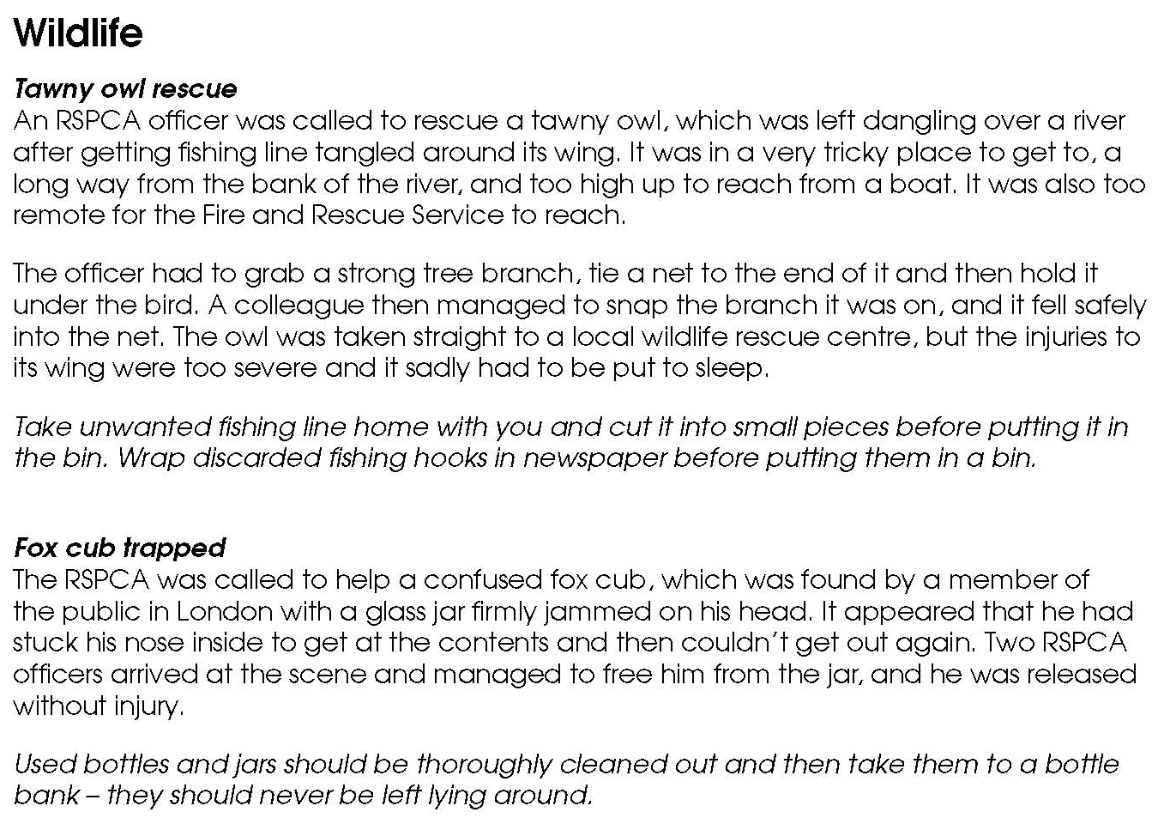

Fact sheet – Litter stories (2)

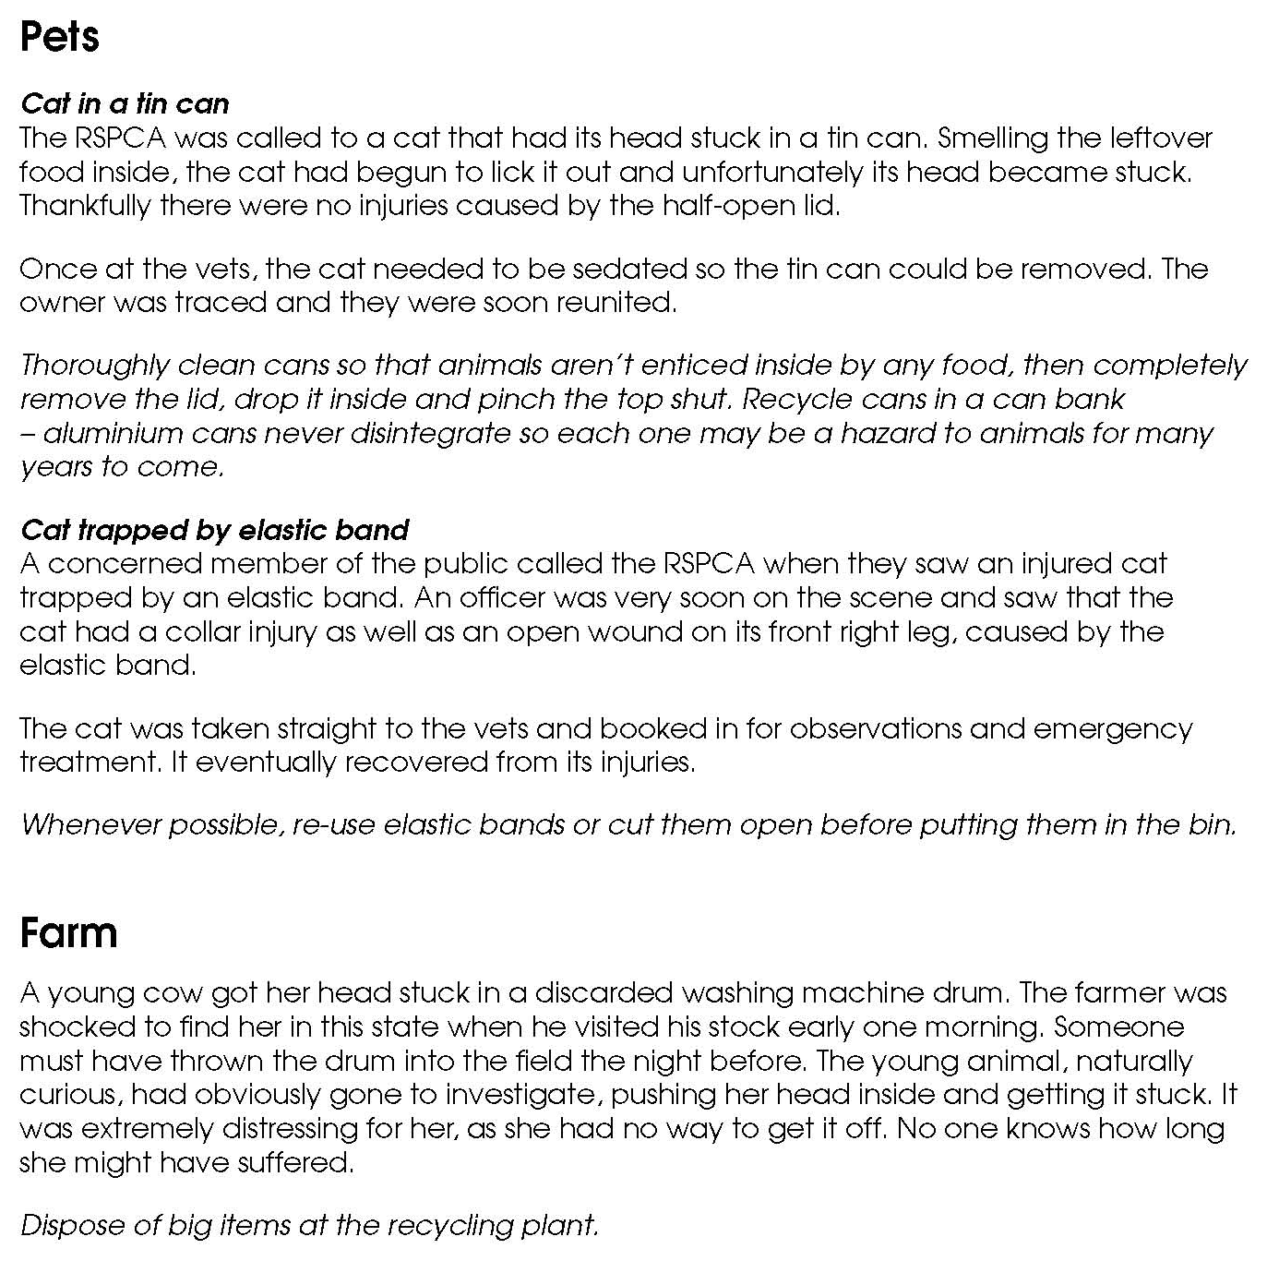

Activity sheet – How to make a hedgehog home (1)

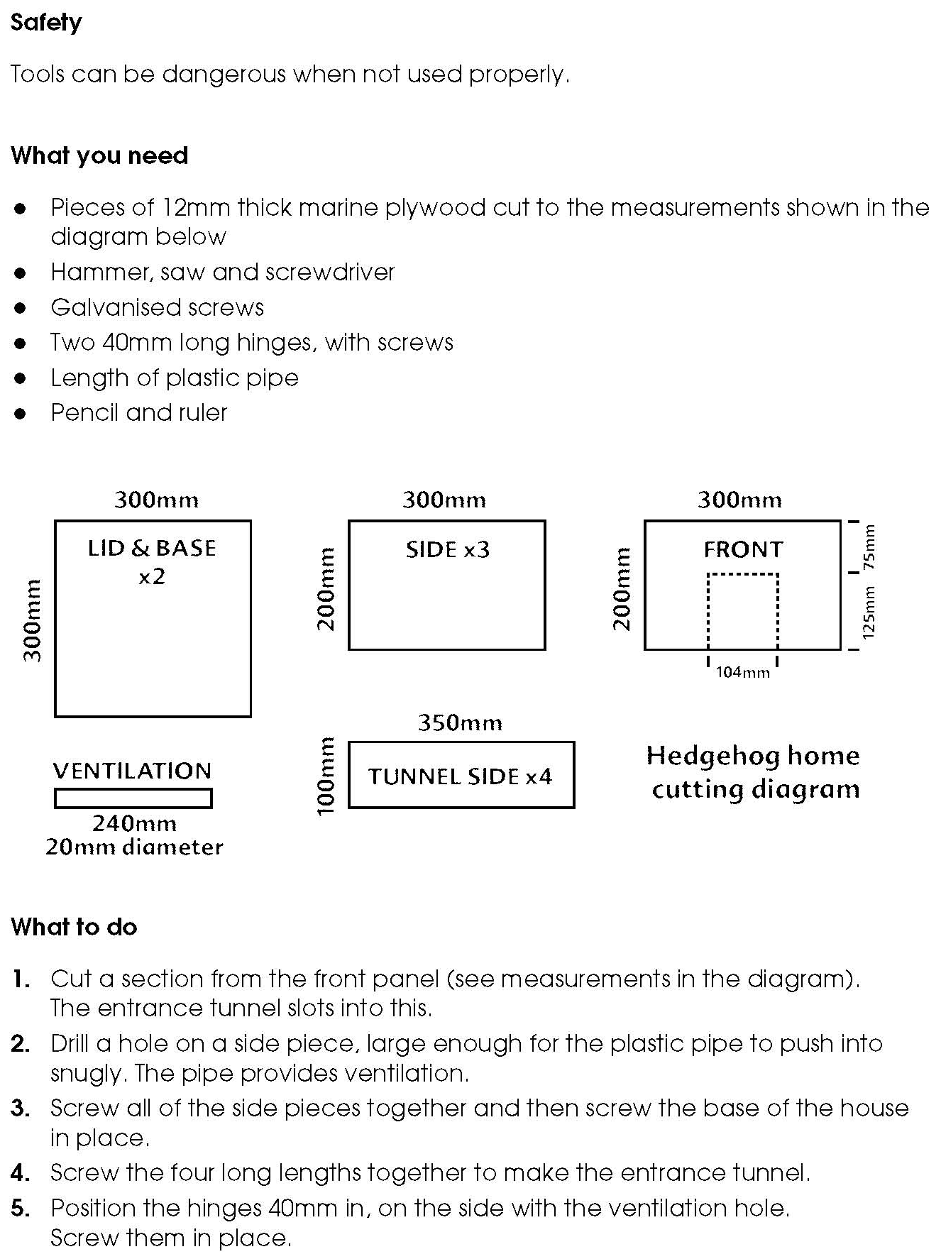

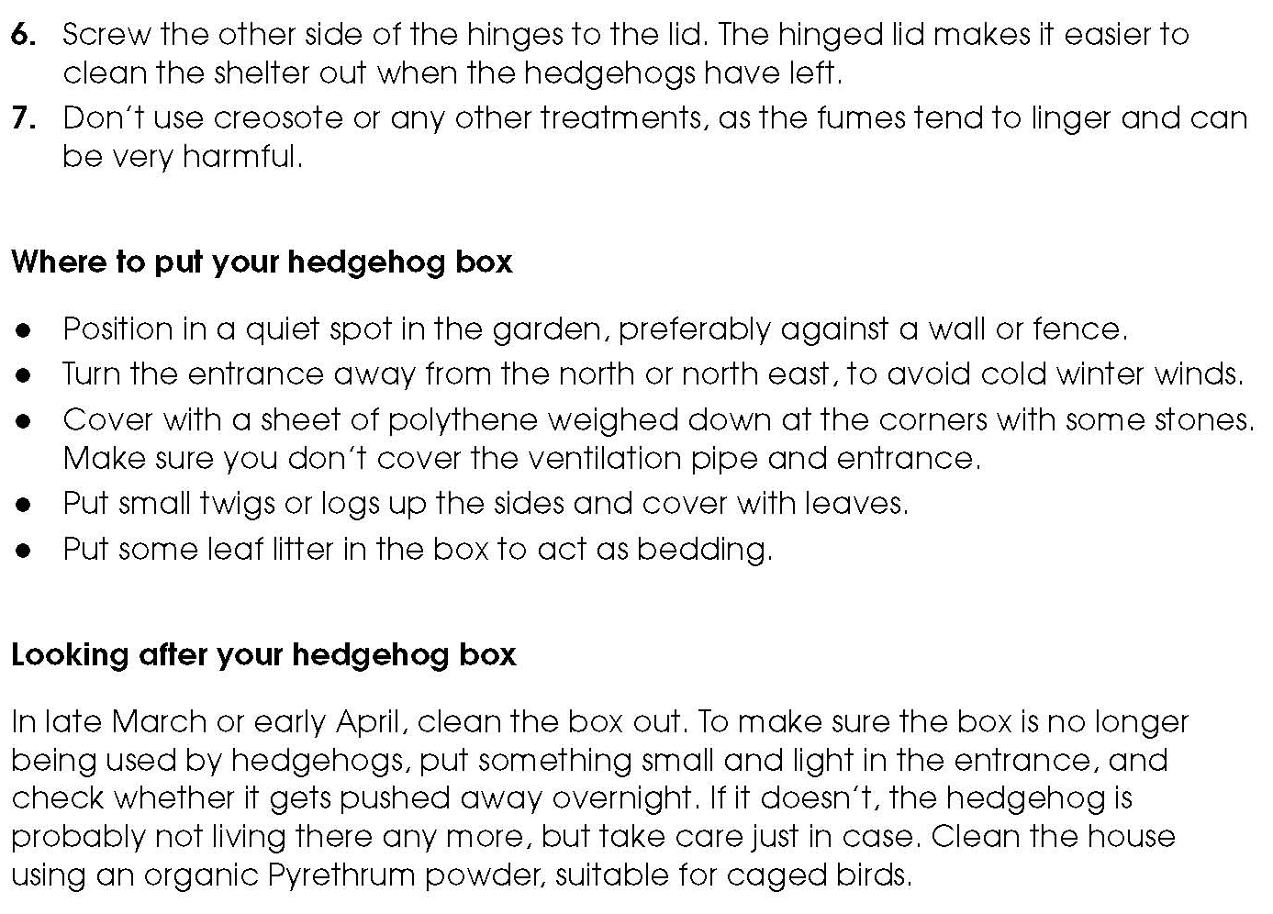
Activity sheet – How to make a hedgehog home (2)

Activity sheet – How to make a toad box (1)

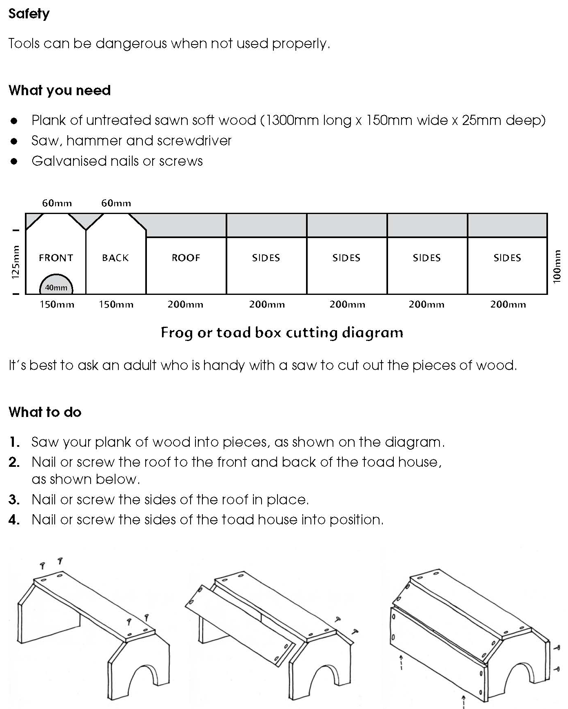

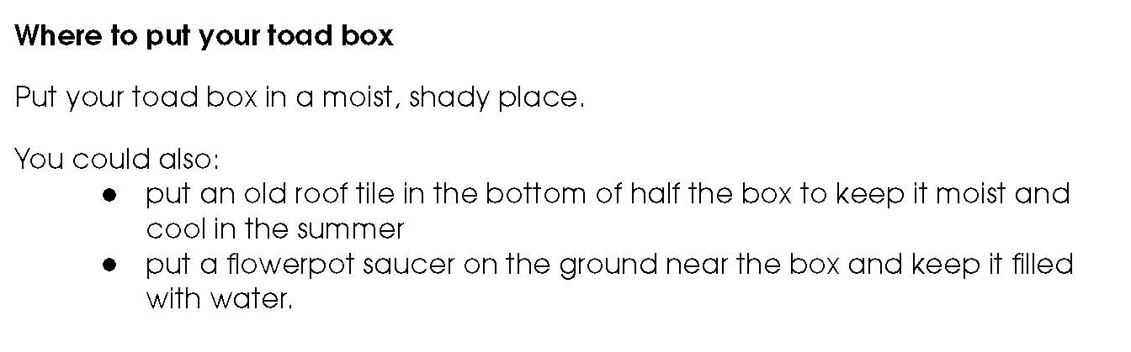
Activity sheet – How to make a toad box (2)

Activity sheet – How to make an insect hotel (1)

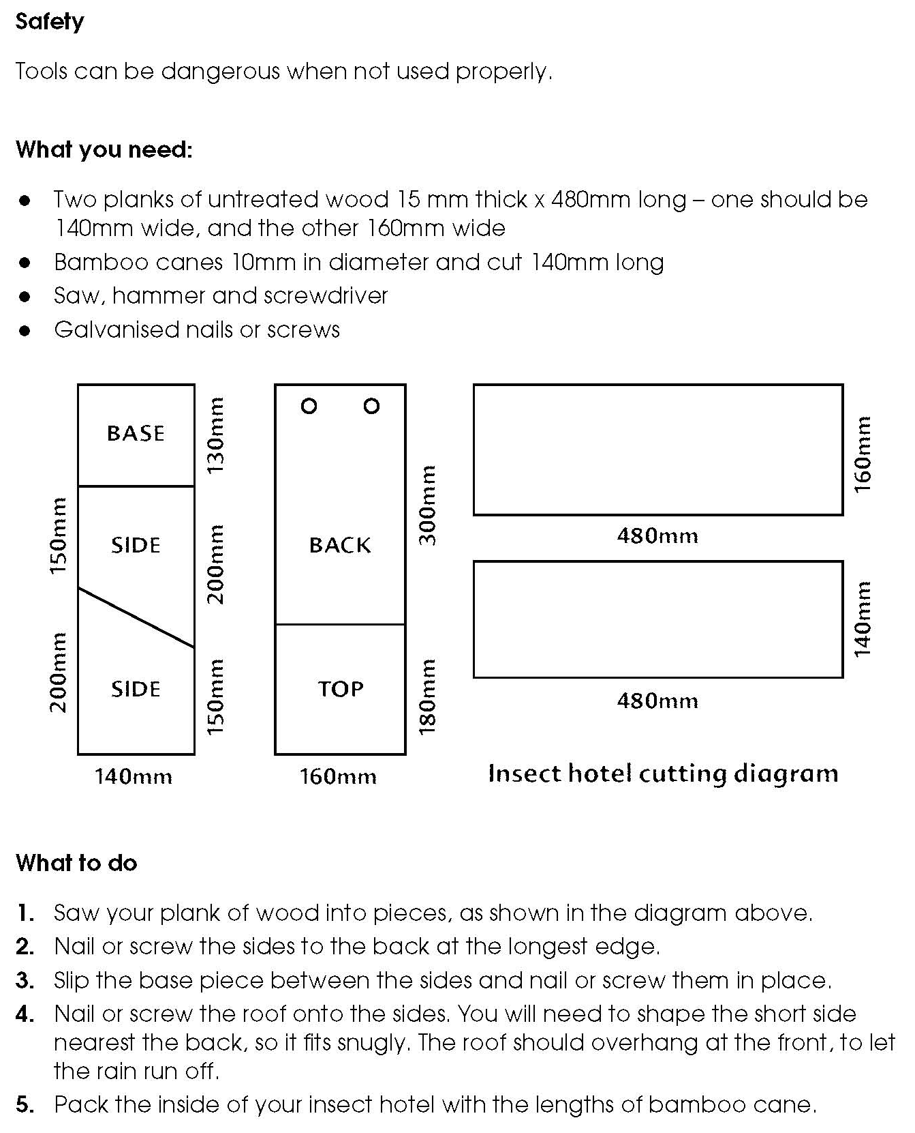

Activity sheet – How to make an insect hotel (2)

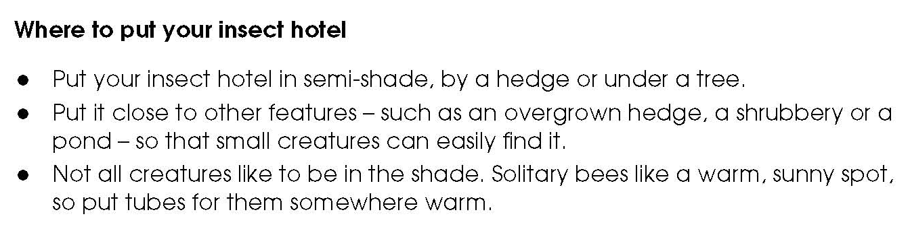

Activity sheet – Minibeast homes (1)

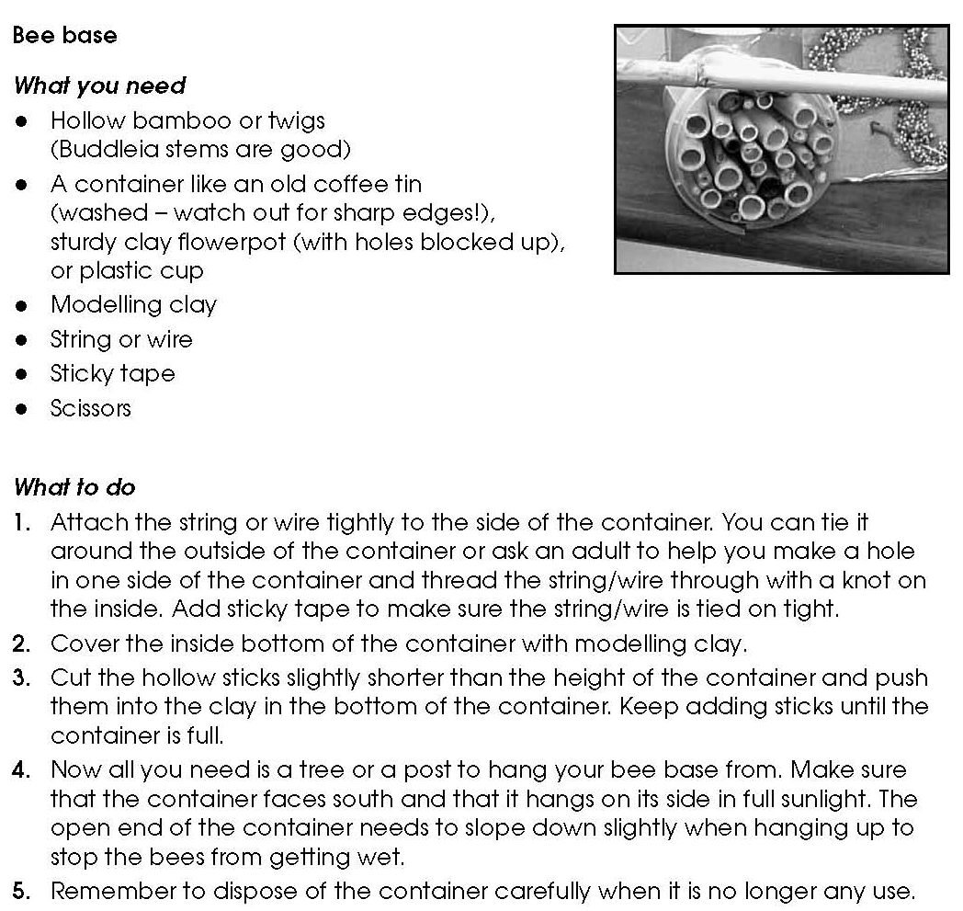

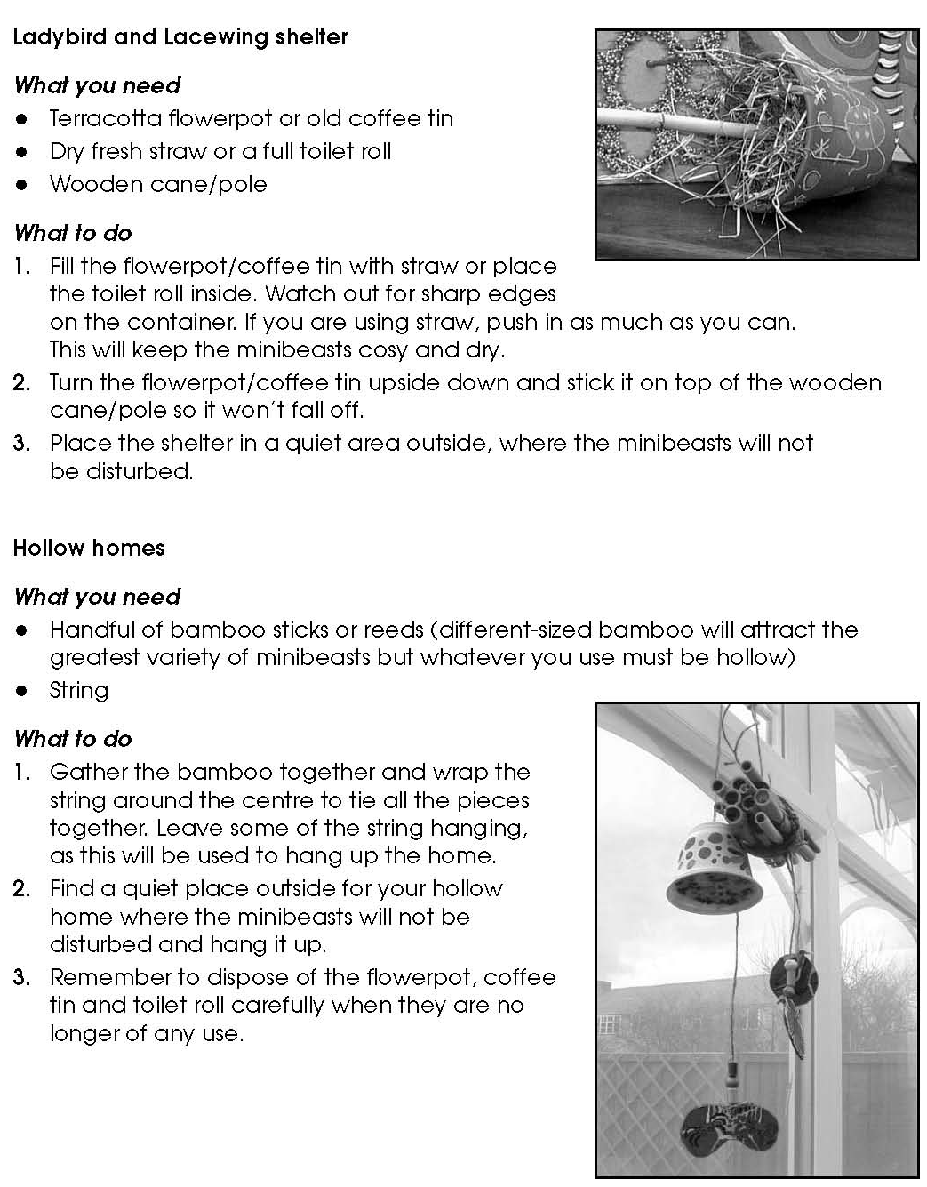
Activity sheet – Minibeast homes (2)

Activity sheet – How to make a bird table (1)
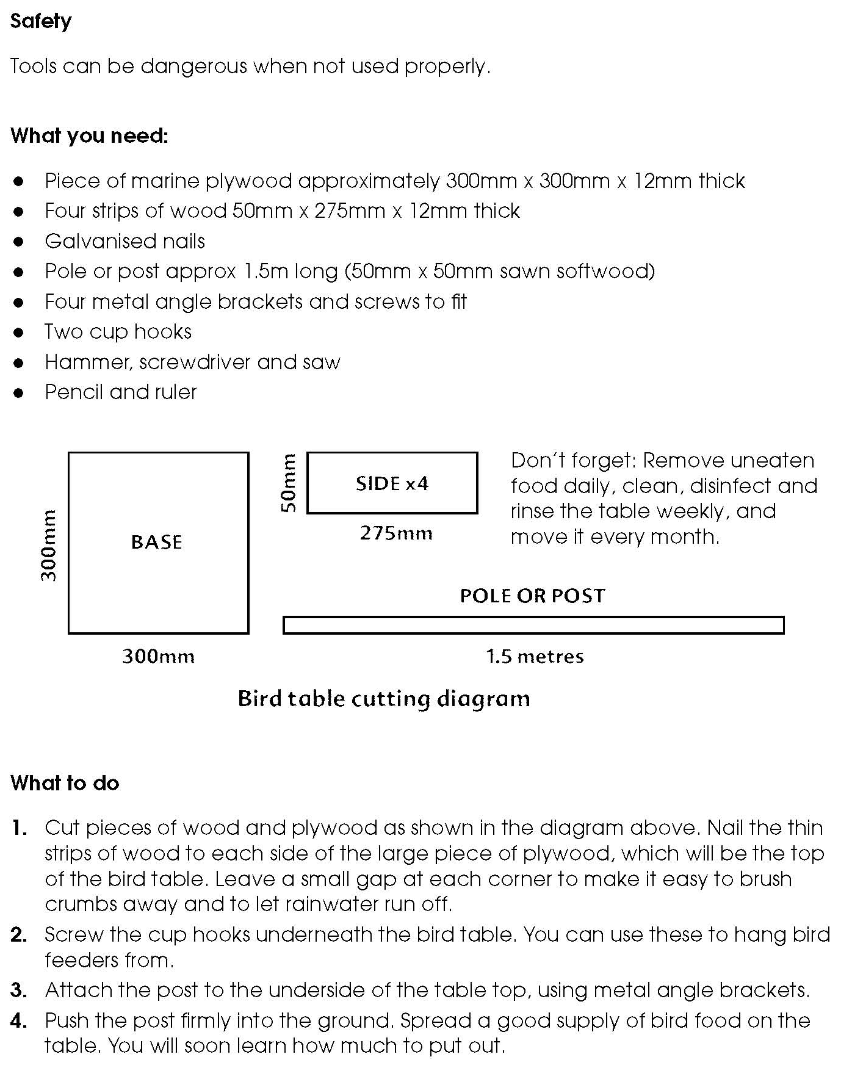

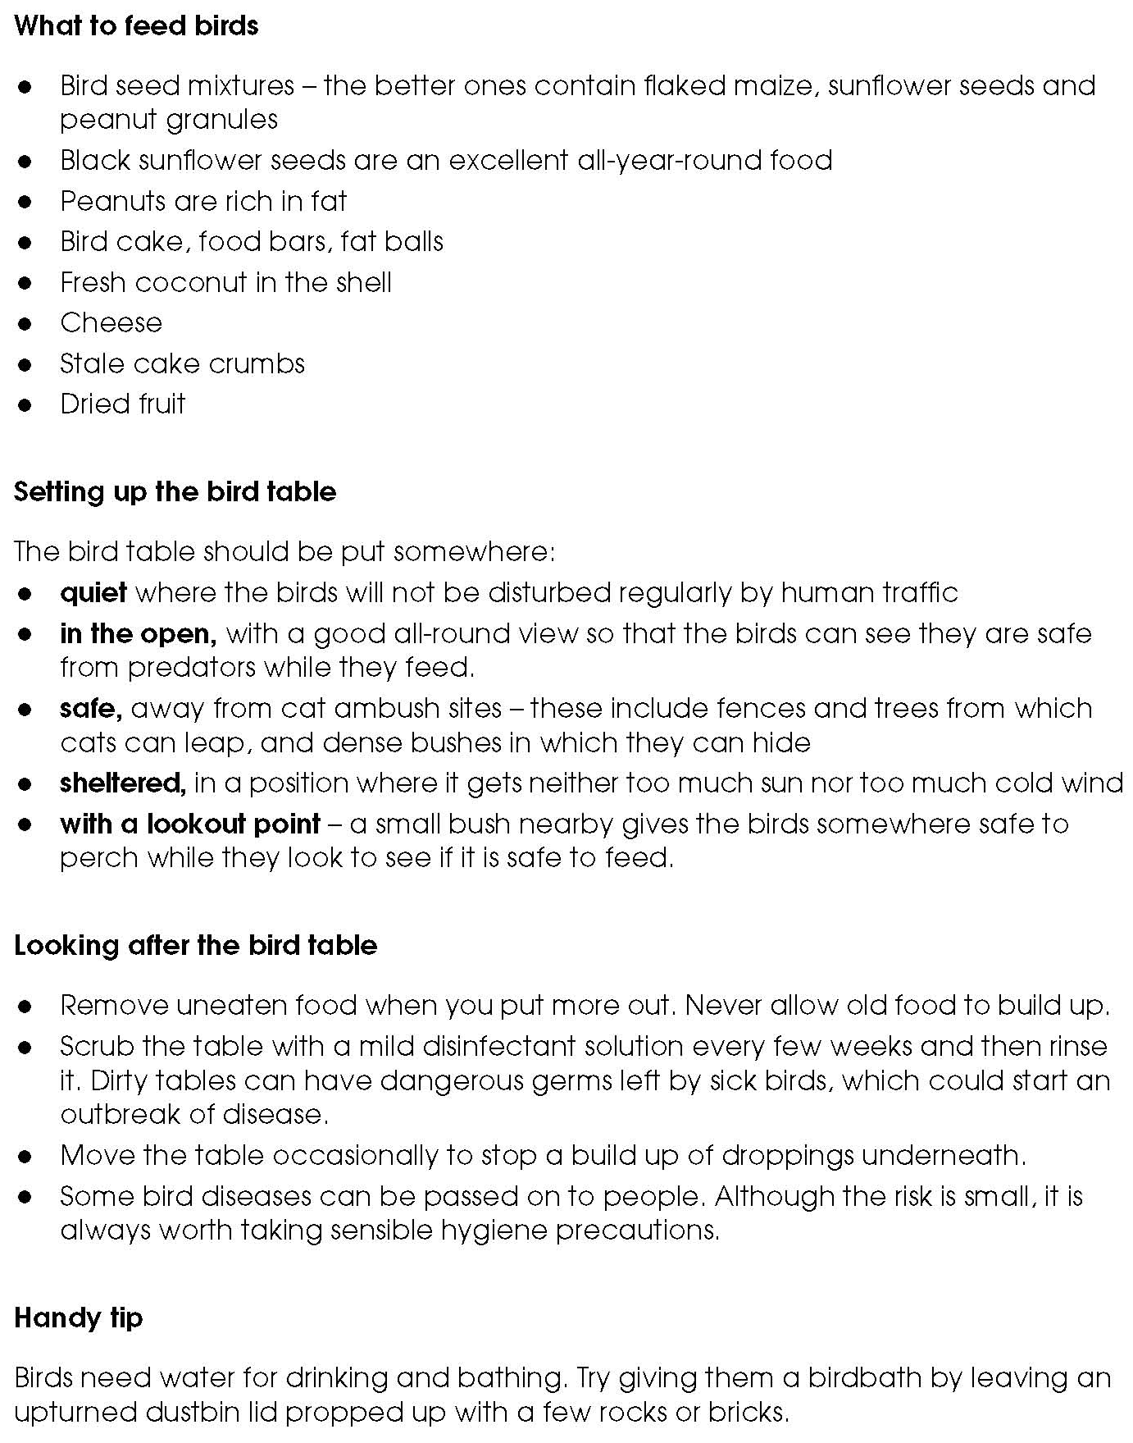
Activity sheet – How to make a bird table (2)

Activity sheet – How to make a bird cake (1)

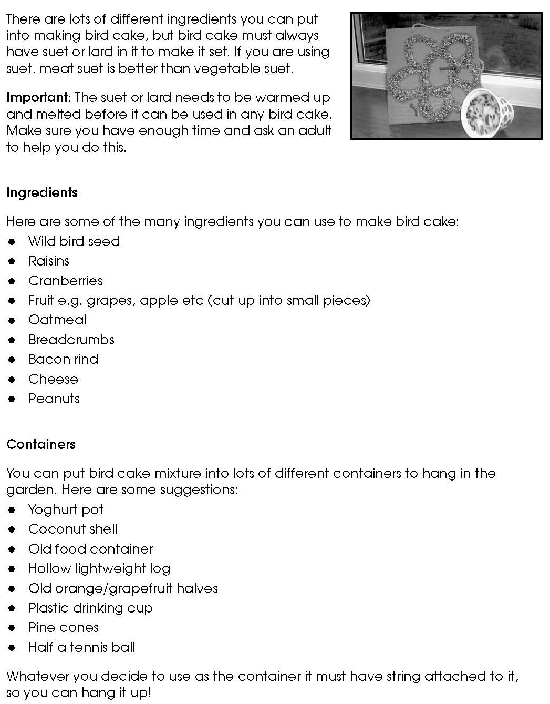

Activity sheet – How to make a bird cake (2)

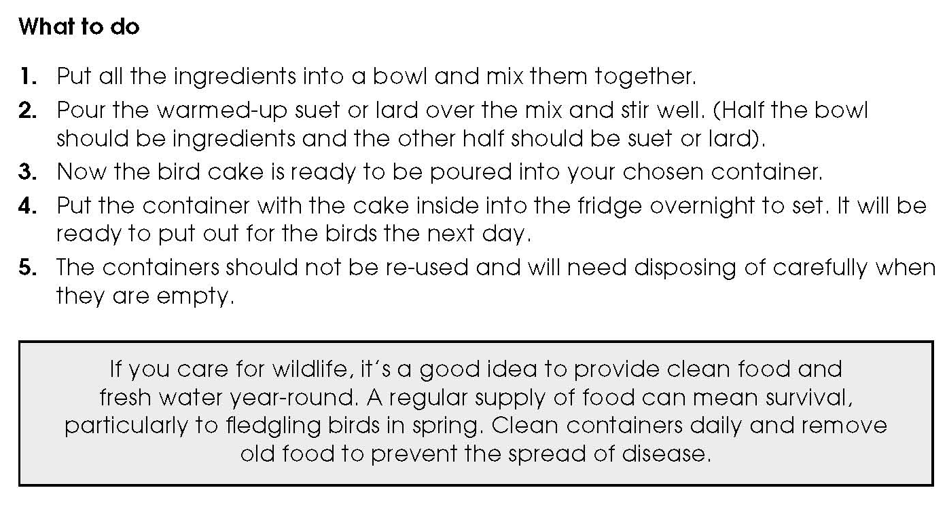

Activity sheet – Making animal homes and feeders (1)

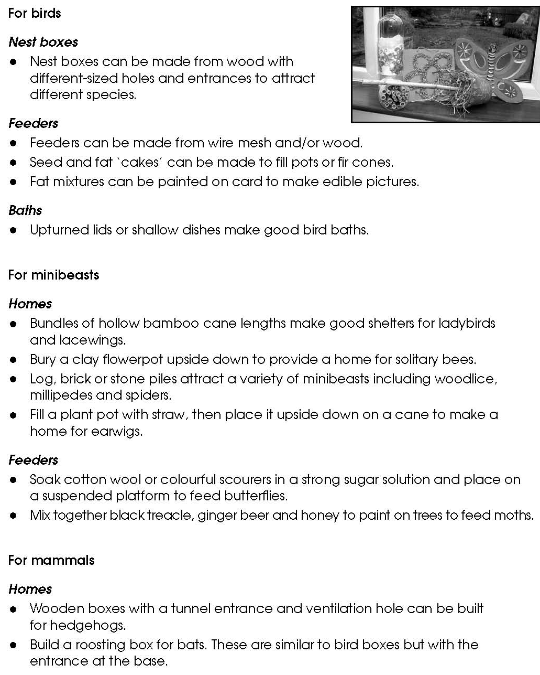

Activity sheet – Making animal homes and feeders (2)

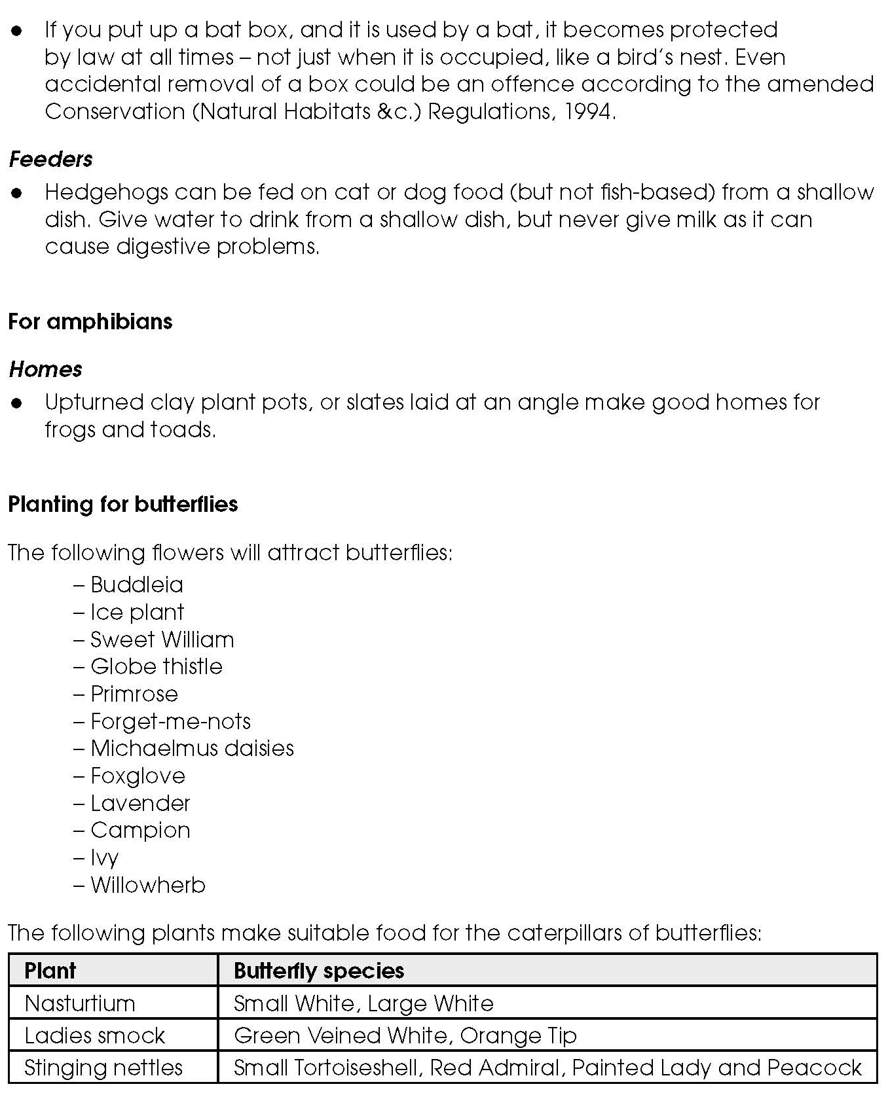

Activity sheet – How to make a nest box for birds (1)

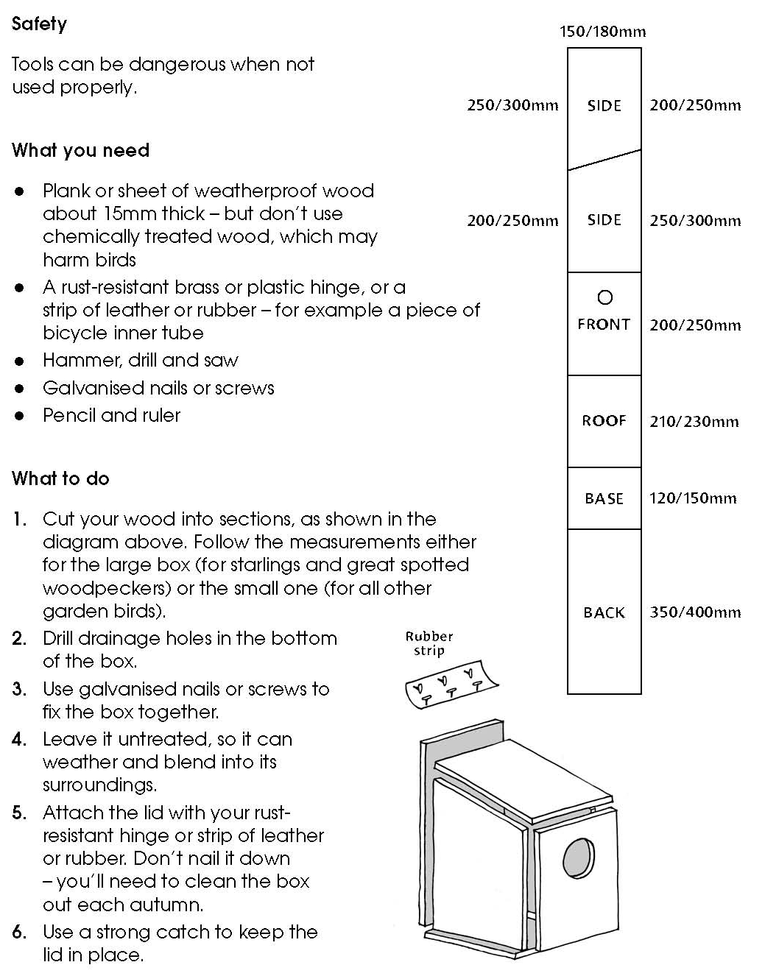

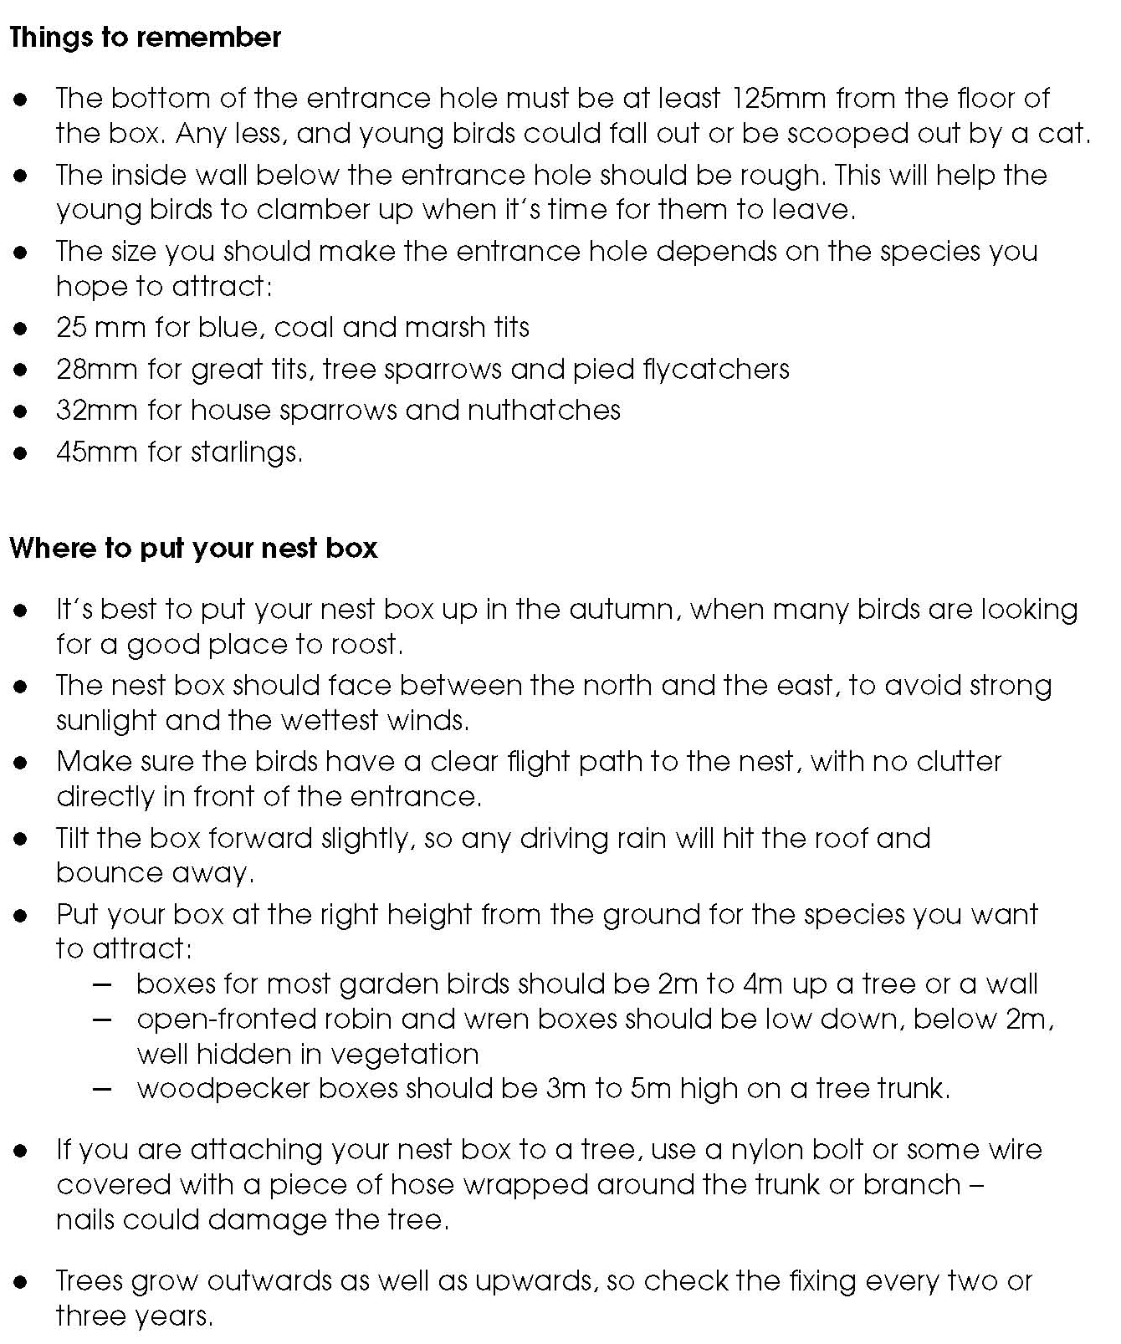
Activity sheet – How to make a nest box for birds (2)

Activity sheet – How to make a nest box for birds (3)
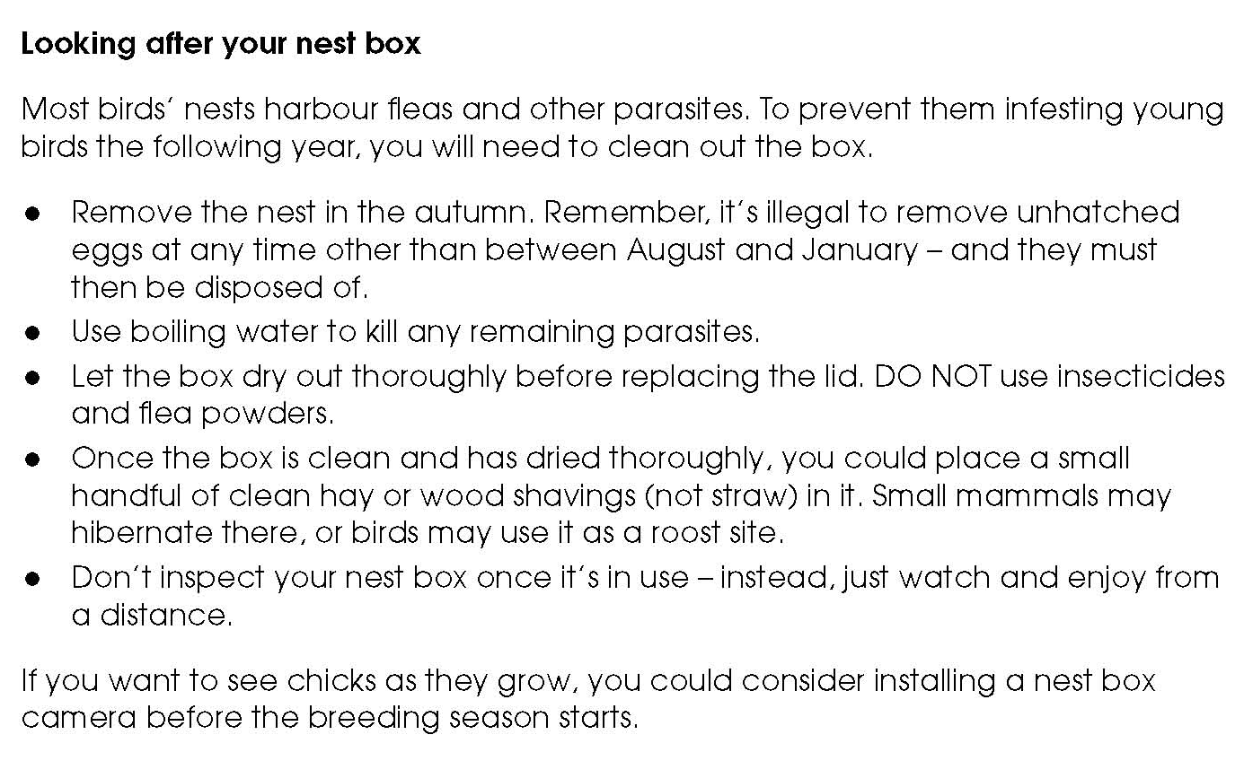

.

Activity sheet – How to make a bat box (1)

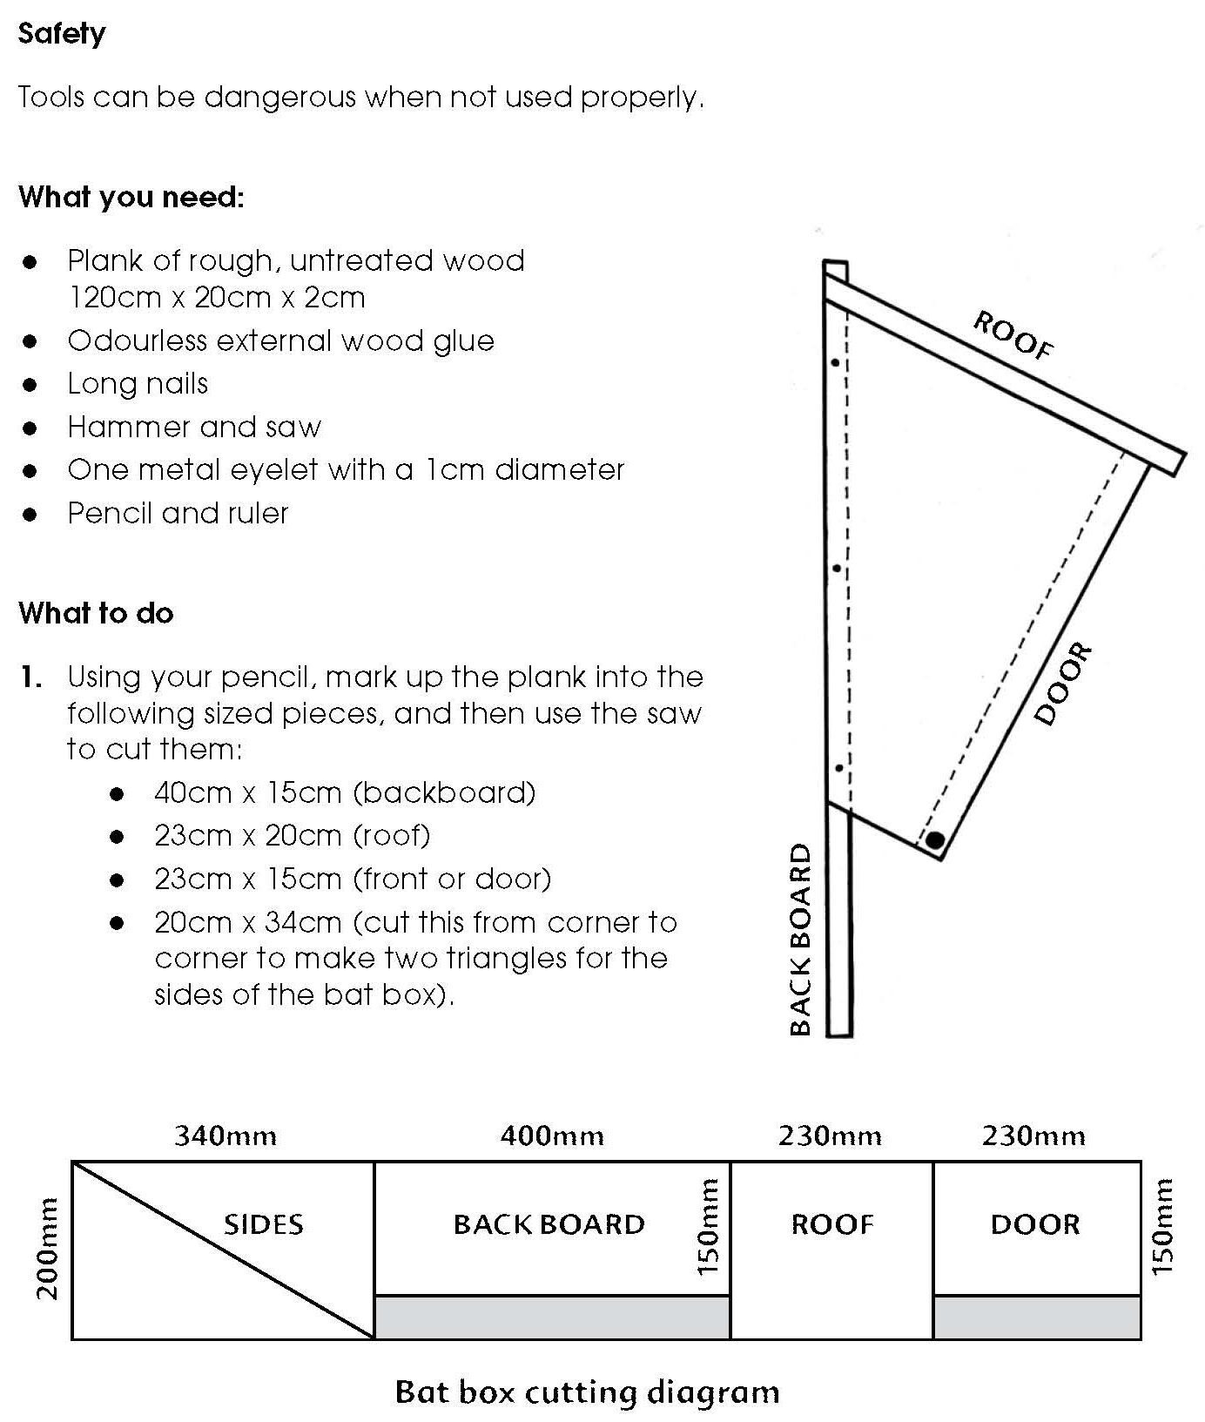

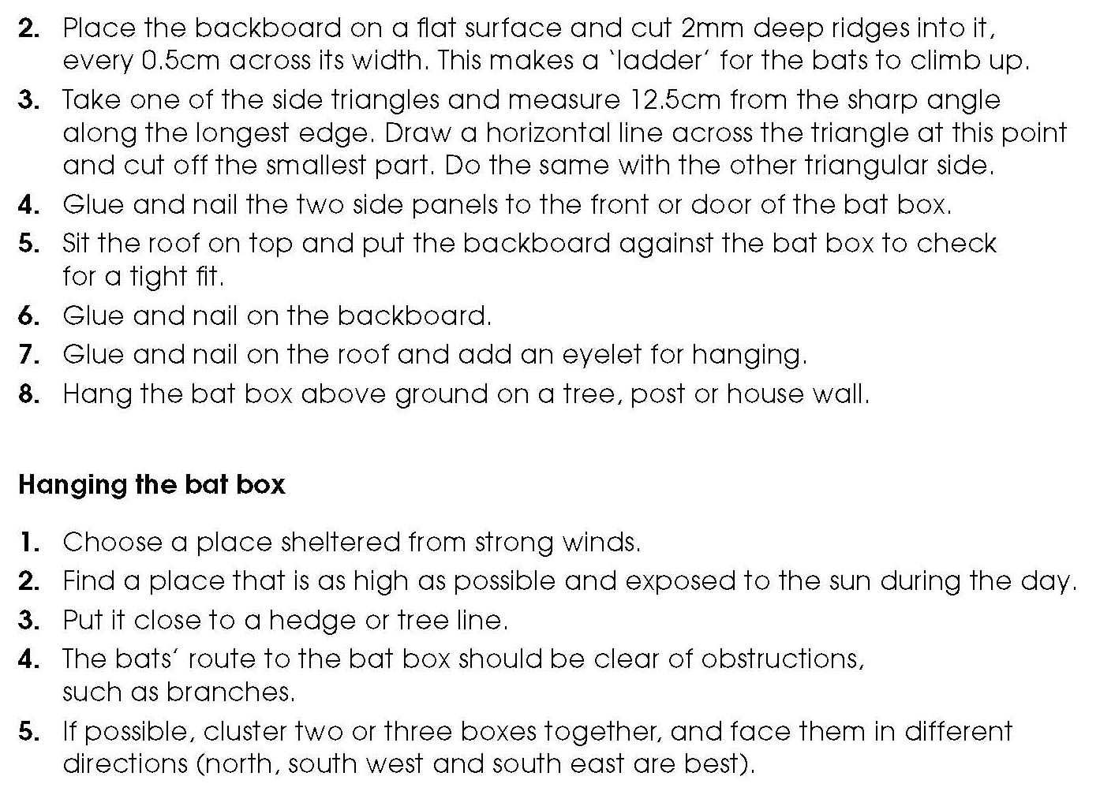
Activity sheet – How to make a bat box (2)

