Aims and objectives
In this activity the young person will explore their motivations for owning or wanting to own a dog.
Young people will:
- think about the reasons why they own a dog, or
- think about the reasons about why they want to own a dog, and
- explain why owning a dog is important to them.
It is extremely important that the information gathered in this session is used throughout all of the activities related to dogs. This will ensure that the intervention programme is suited to the needs of the young person and will provide a stronger basis for challenging unacceptable attitudes and behaviours.
What to do

- Prepare the statements for the activity as described in the Useful information section.
- Explain to the young person that you are interested to hear about why dog ownership is important to them, and you want to find out why they decided to get a dog or why they want to get a dog.
  - Make sure that this is done in a non-confrontational way and tell them that they can be honest because there is no right or wrong answer.
  - You could say: "Tell me why you decided to get a dog" or "Why do you want a dog?”
- Record each of their answers on a separate card, in their own words. You may find it useful to use the facilitators’ notes Motivations for dog ownership if they are struggling to think of anything.
- Ask them to rank their motivations in order of importance. If they find it difficult to do this, the discussion below will help you.
- You need to find out more about their reasons, especially the ones they consider to be the most important, for owning or wanting a dog.
N.B. You will need some way of recording the information they share with you so that you can tailor any further discussions to the young person’s experiences.
- Ask the young person why each of these motivations are so important to them.
- Encourage them to give you as much detail as they can about their own individual circumstances. For example, they may tell you that they have a dog for protection and personal safety. In this case, you might want to explore:
  - Why they feel they need a dog for protection
  - Who or what they need protecting from
  - Whether this is a real or perceived risk or problem with a particular person/group
  - If other people have used dogs to intimidate them
  - What type of dog they feel offers them the protection they want. What characteristics does the dog have/need to have? Is there a particular breed or type of dog that they feel offers this? Has this affected their choice of dog?
  - How the dog protects them.
- This activity is appropriate if the young person is an existing dog owner or has shown an interest in getting a dog.
- It is essential that you run this session before doing any of the other activities related to dogs. It is important that you have a full understanding of the young person’s motivations for dog ownership so that you can tailor any further activities to the young person’s experiences.
- A central theme running through all these resources is the concept of the five freedoms. We hope that, by introducing this to the young people and then reinforcing it in a number of other sessions, we will provide them with a code of conduct to apply to every situation in which they encounter animals. The five freedoms are very similar to the duty of care criteria mentioned in the Animal Welfare Act.
Preparation for the facilitator
- Read the facilitators’ notes Motivations for dog ownership. Consider which of these might be relevant to the young person you are working with.
- Cut out the blank cards from the activity sheet Motivation statement cards and put them in an envelope ready for the young person to use at the start of the session.
- Ensure you have a means of recording the motivations identified by the young person and how they have ranked these.
- If after completing this activity and identifying a young person’s motivations for dog ownership, you think s/he has been involved in illegal dog fighting, you may want to refer to The incident section in the Breaking the chain facilitation guide.

Useful websites

Do –it volunteering
Volunteering England
RSPCA – Get involved
Volunteering Wales

Useful papers
- Burley, S. ‘My dog’s the champ: an analysis of young people in urban settings and fighting dog breeds’: Anthropology Matters Journal 2008, 10 (1).
- Crowell-Davis, S. L. ‘Motivation for Pet Ownership and Its Relevance to Behavior Problems’: Compendium 2008, Aug; 30(8), 423-4, 427-8.
- Harding, S. ‘Status dogs and gangs’: Safer Communities 2010, 9 (1), 30-35.
- Hughes, G, Maher, J and Lawson, C. ‘Status Dogs, Young People and Criminalisation: Towards a Preventative Strategy’, March 2011.

Facilitators’ notes – Motivations for dog ownership (1)

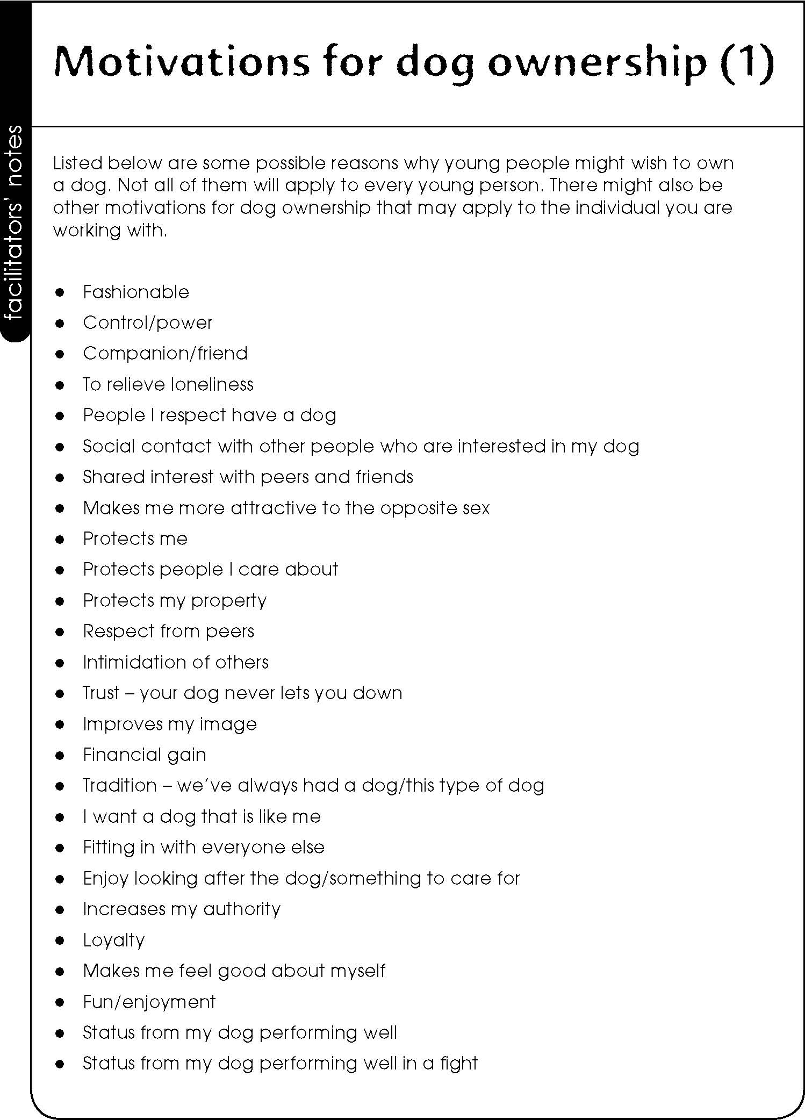

Facilitators’ notes – Motivations for dog ownership (2)

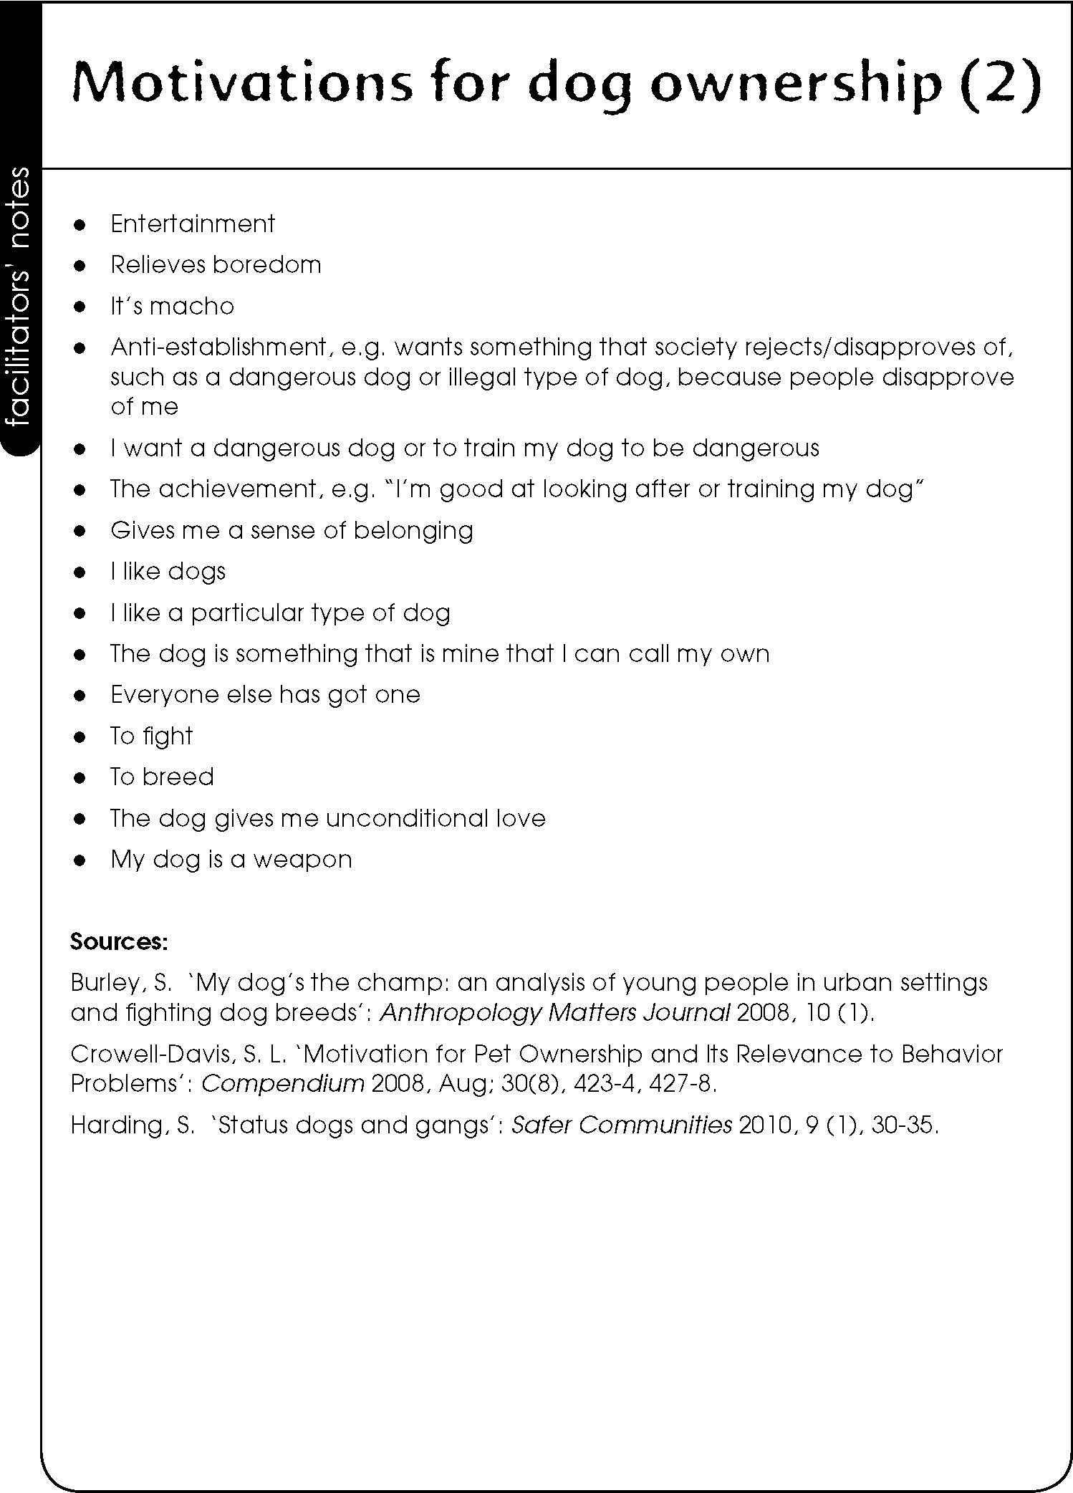

Activity sheet – Motivations statement cards

