Aims and objectives
- This activity is just one part of a range of resources addressing the needs of young people who have been involved, or who are at risk of being involved, in cruelty to animals. Our online assessment tool Developing a suitable intervention programme (Word 17KB) will help you create individualised intervention programmes from these resources.
- This is a good activity to do before you look at the young person’s own incident. It allows him or her to investigate some of the triggers of animal cruelty in a non-judgmental, objective way.
- In this activity, young people investigate what types of feelings or events might trigger an animal cruelty incident. They think about how these might be managed to prevent one from happening in the future.
- Young people will develop the understanding that:
  - there is a range of events, feelings and emotions that may trigger an animal cruelty incident
  - there are ways to manage strong negative feelings

What to do
- There are two ways in which you can approach this activity. The first way shown below is the easiest and most straightforward. An alternative, more challenging, way can be found in the facilitators’ notes Triggers – why did they do it?.
- Select one or more cartoon strips from the activity sheet What triggers cruelty cartoon strips. The strips are:
  - Jarek buys a dog
  - Mark loses it
  - Jon tries to score
  - Tyrone gets it wrong
  - Jocelyn’s problem.
- Ask them to look at each story carefully and think about the following.
  - Is this right or wrong?
  - Why? You will need to establish that the animal has suffered and that, regardless of species, it is not acceptable to hurt an animal, because it feels pain and can suffer just like we can
  - At what point did the cruelty start?
  - What triggered the cruelty? You may need to explain what you mean by ‘triggered’. You could use phrases such as ‘set off’, ‘sparked off’, ‘set the ball rolling’ or ‘kicked off’ instead
  - Why do they think the cruelty incident happened?
  - Why did that person choose to harm that particular animal or type of animal? The facilitators’ notes Animal cruelty research findings provide information about some of the reasons why young people are cruel to animals.
- Ask the young person to tell you what they think different characters in the stories are feeling. You can use the activity sheet Human feelings cards to match the feelings to some of the characters in the story. Get them to put the appropriate feelings card next to the character and discuss what they are feeling or thinking.
- It is essential that you ask them what they think the animal is feeling. They can use cards from the activity sheet Animal feelings cards if they want to. You must help the young person begin to empathise with the animal in the cartoon. Explain that animals feel pain and fear, and try to get the young person to describe how the animal is suffering. Ask them about how they feel about what is happening.
Note – if the young person fails to empathise at all with the animal, we recommend that you stop this activity. It would also be worth asking them to complete some more activities in the Basic needs and sentience and What is animal cruelty? sections.
- Some of the stories give an indication of what happened after the cruelty event. Ask the young person the following questions.
  - What happened afterwards?
  - How is the character feeling about what has happened?
  - What do you think they are feeling or thinking now?
- Some of the stories finish at the incident. If you use these stories, ask the young person the following questions.
  - What do you think happened next?
  - How do you think the character feels about what has happened?
  - Was what the person did against the law?
- Now ask the young person to look at the story again and think about the following.
  - At which point in the cartoon could the cruelty incident have been avoided/stopped/prevented? Ask them to point to the correct picture in the cartoon
  - How could the cruelty have been stopped? Who could have said or done something? What could they say or do? This may be someone explaining that something is wrong or against the law. It might be someone who is standing up to someone else and not giving in to peer pressure. It might be an individual who chooses to think about things first and act afterwards, or who gives themselves time to calm down or go and talk to someone they trust. You may be able to suggest some additional strategies you have used effectively before.
- Repeat the above points for as many cartoons as you wish to examine and discuss.
- With the young person, choose one of the cartoons for which he or she will draw an alternative ending. Recap by saying something like: “Let’s go back and unpick this story. Let’s see where things went wrong.” Explain that you want an ending that has a positive/good outcome for everyone involved. The animal will not get hurt, be scared or suffer. The young person will not break the law by doing something that hurts another living thing, and that they will regret.
- To start, cut out and keep the sections of the cartoon that are acceptable, up to the point where the cruelty begins.
- Ask the young person to draw one or more new picture boxes showing the alternative ending that has been discussed. They can include pictures and speech/thought bubbles where appropriate, and new feelings words for the characters if they want to. Connect it to the beginning of the story with sticky tape.
- Ask the young person to talk though the new incident with you and ask about the triggers again. Ask how the triggers have been dealt with in their new story, and what was the key thing that changed the outcome of the story from very poor to positive. Explain that they have the power to make choices and affect other people’s choices for a more positive outcome for themselves, their friends and family, and for animals.
- This activity will only be effective if the young person accepts their involvement in the incident.
- This is a good activity to do BEFORE you look at the young person’s own incident. It allows the young person to investigate some of the triggers of animal cruelty in a non-judgmental, objective way.
- After you have completed this activity with a young person who has been involved in an animal cruelty incident, we suggest you complete the activity My triggers and action plan.
- You will also find this activity in the section What triggers animal cruelty and how can it be avoided.
- We strongly recommend that you complete some of the activities in the Basic needs and sentience and What is animal cruelty? sections before attempting this activity. They will help the young person begin to empathise with animals, understand their needs and develop the understanding that animals have feelings and feel fear and pain.
- This activity is not recommended for young people who do not empathise with animals, including both pets and wild animals. It is essential that you stimulate the young person’s empathy with the animals represented in these cartoons.
- You will need to make a choice about the appropriate cartoon scenarios to use with each young person. Your choice might be based on their age and individual circumstances, for example, they may need support with peer pressure, substance misuse or anger issues. Some young people may only empathise with pet animals and not wild animals. In that case, only use the scenarios involving pets. Some of the scenarios might be unsuitable for young children, or those who may be too emotionally immature to deal with the subject matter and/or images.
- If you feel the images in the cartoons would not be appropriate for the young person you are working with, then consider reading them the text-only versions from the activity sheet What triggers cruelty stories.
- You may choose to look at more than one cartoon for discussion initially, and then choose one cartoon to look at in detail and storyboard an alternative ending.
- There is an alternative, more challenging method for exploring the triggers in these cartoons. The young person examines each story in two parts, in reverse order, so they are not given all the information at one time. They have to explore the reasons why the character in the story took part in an act of animal cruelty, without being given all the clues or the back-story. This involves higher-level thinking skills. If you want to use this method, the instructions are found in the facilitators’ notes Triggers – why did they do it?
- To complement the ideas in this session, we have developed three interactive activities - Was it cruel?, Consequences and Triggers - that help young people think through what happens when people are cruel to animals. To access each of them, click on the titles, right.

Facilitators’ notes – Animal cruelty research findings (1)

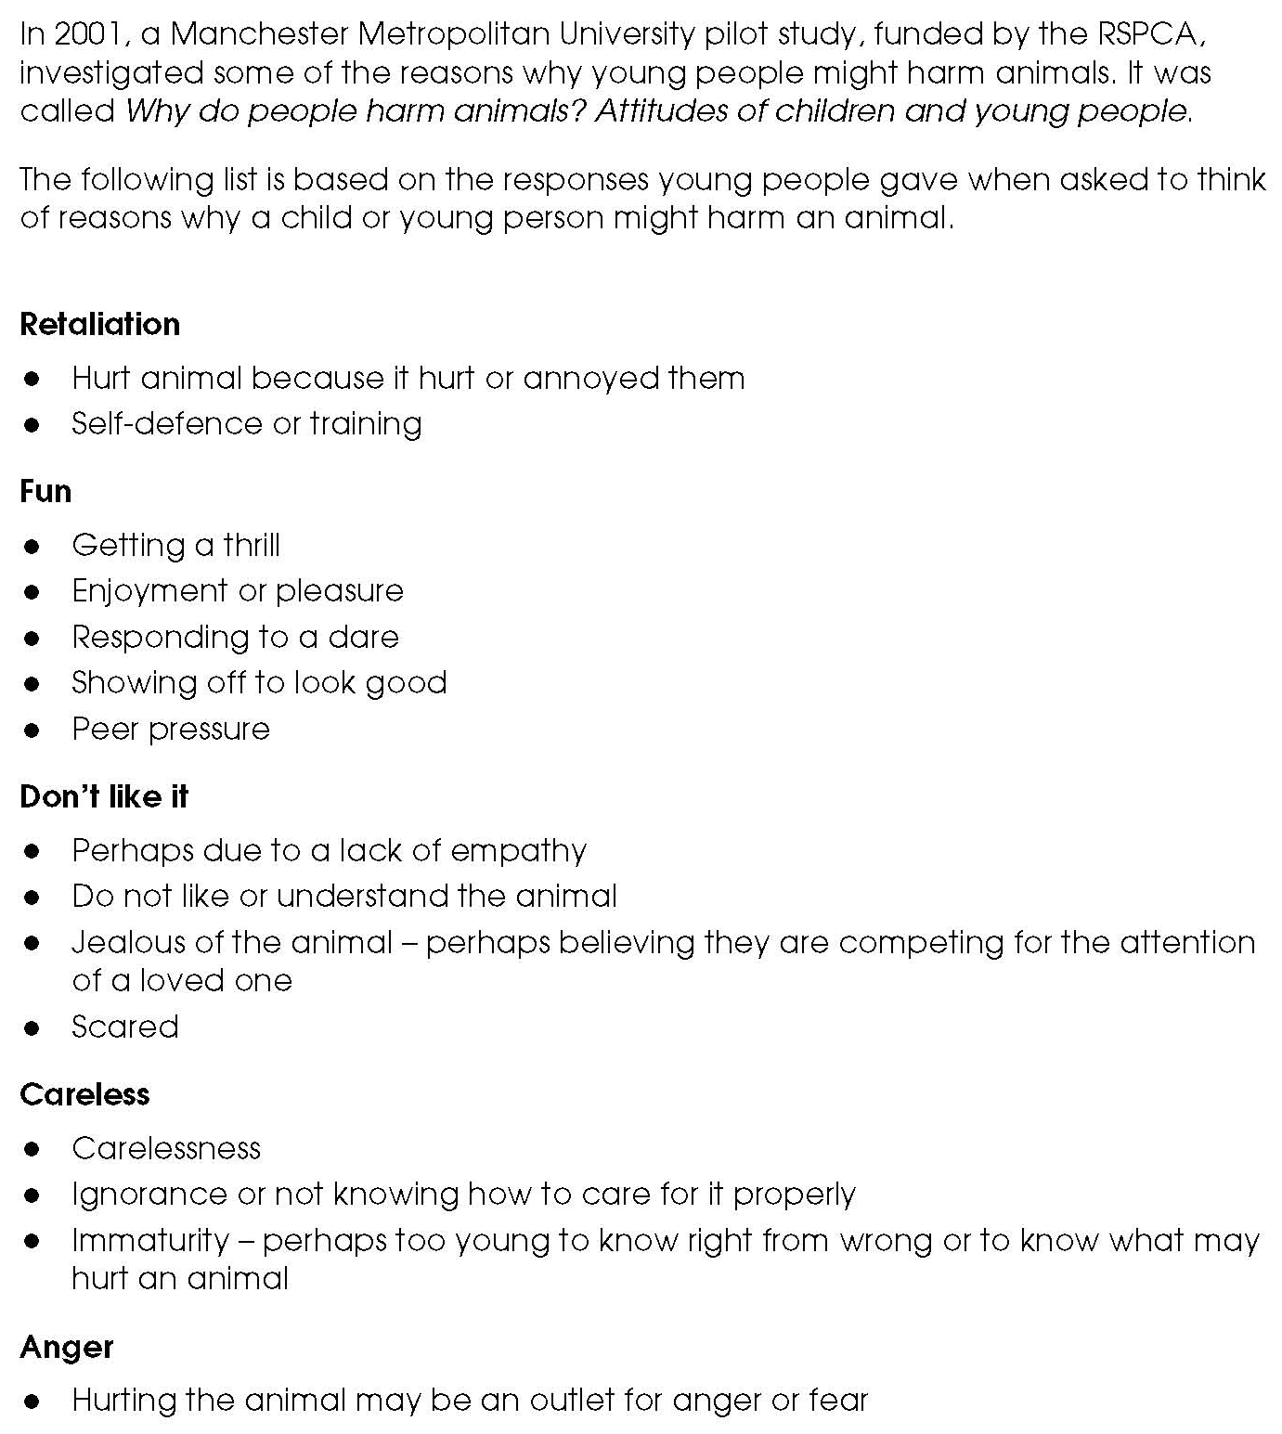

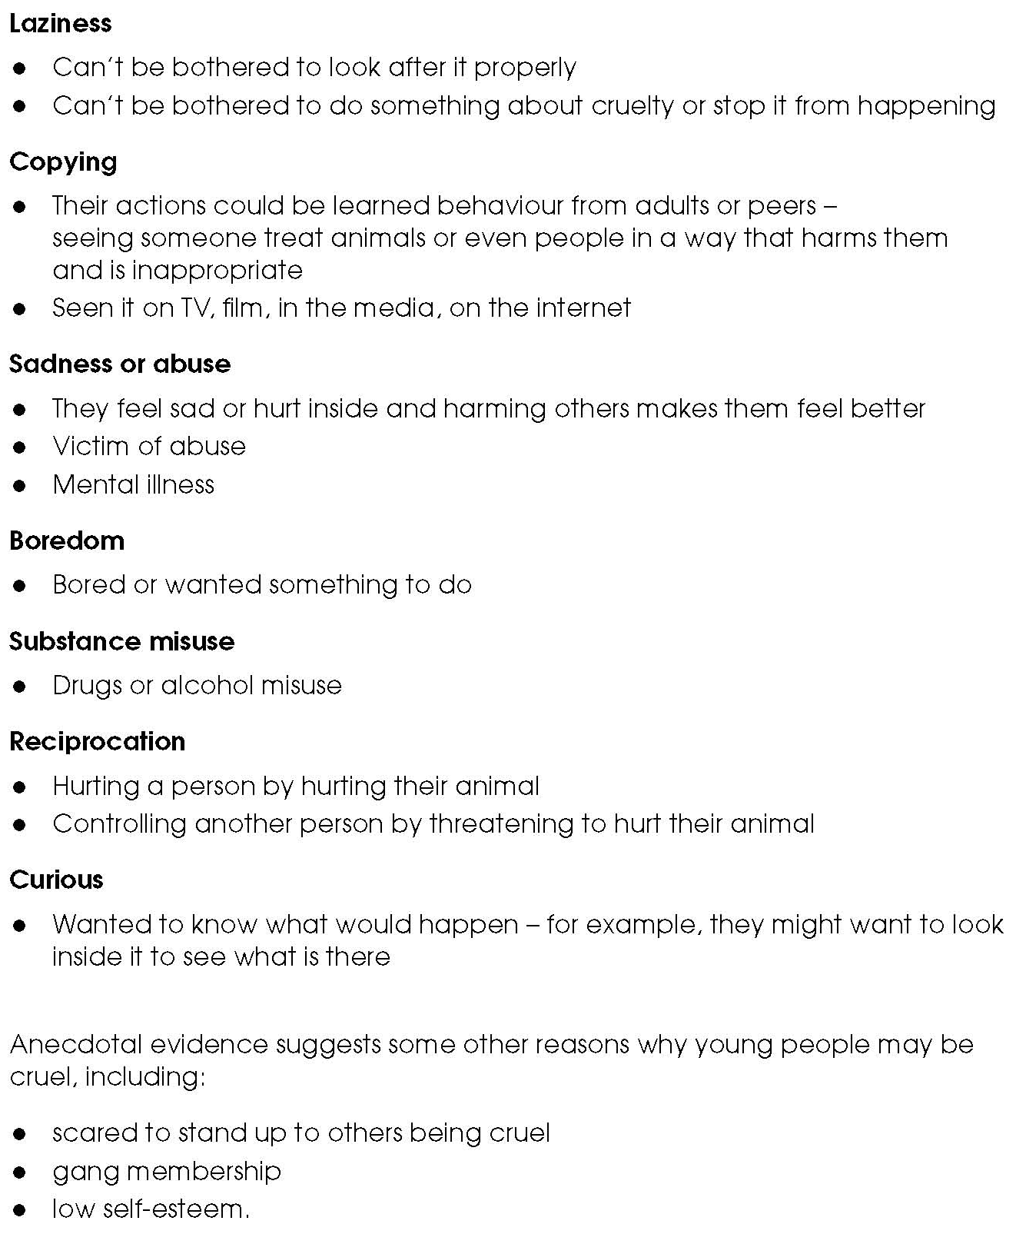
Facilitators’ notes – Animal cruelty research findings (2)

Facilitators’ notes – Triggers – why did they do it? (1)

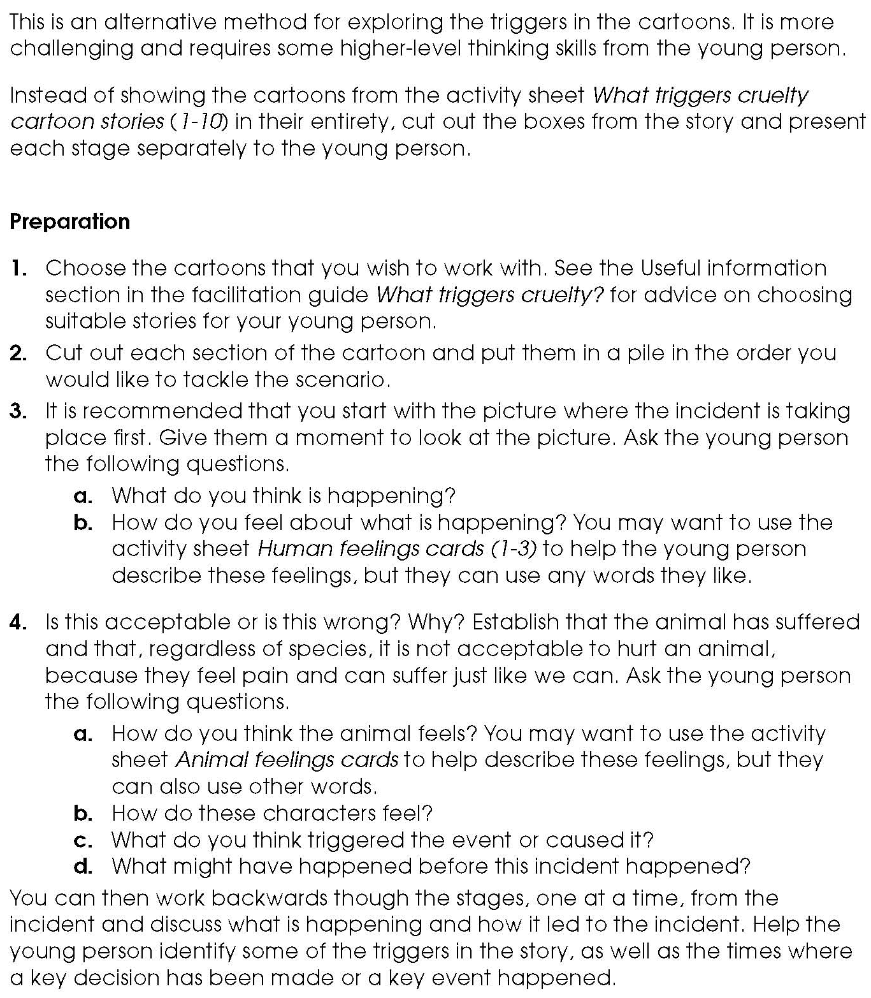

Facilitators’ notes – Triggers – why did they do it? (2)

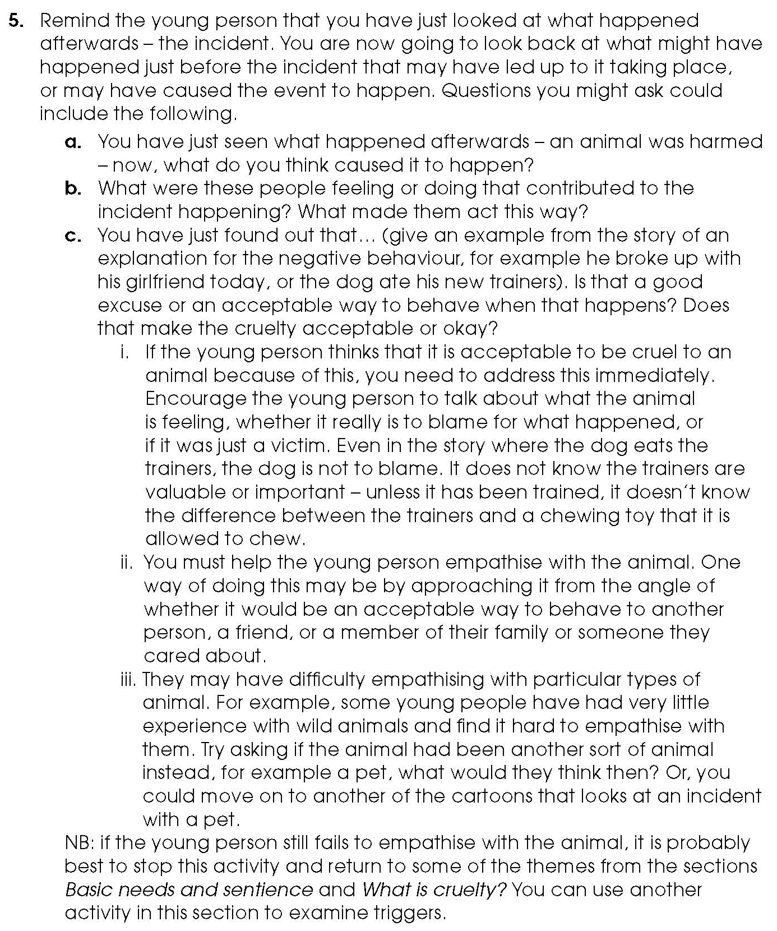

Facilitators’ notes – Triggers – why did they do it? (3)
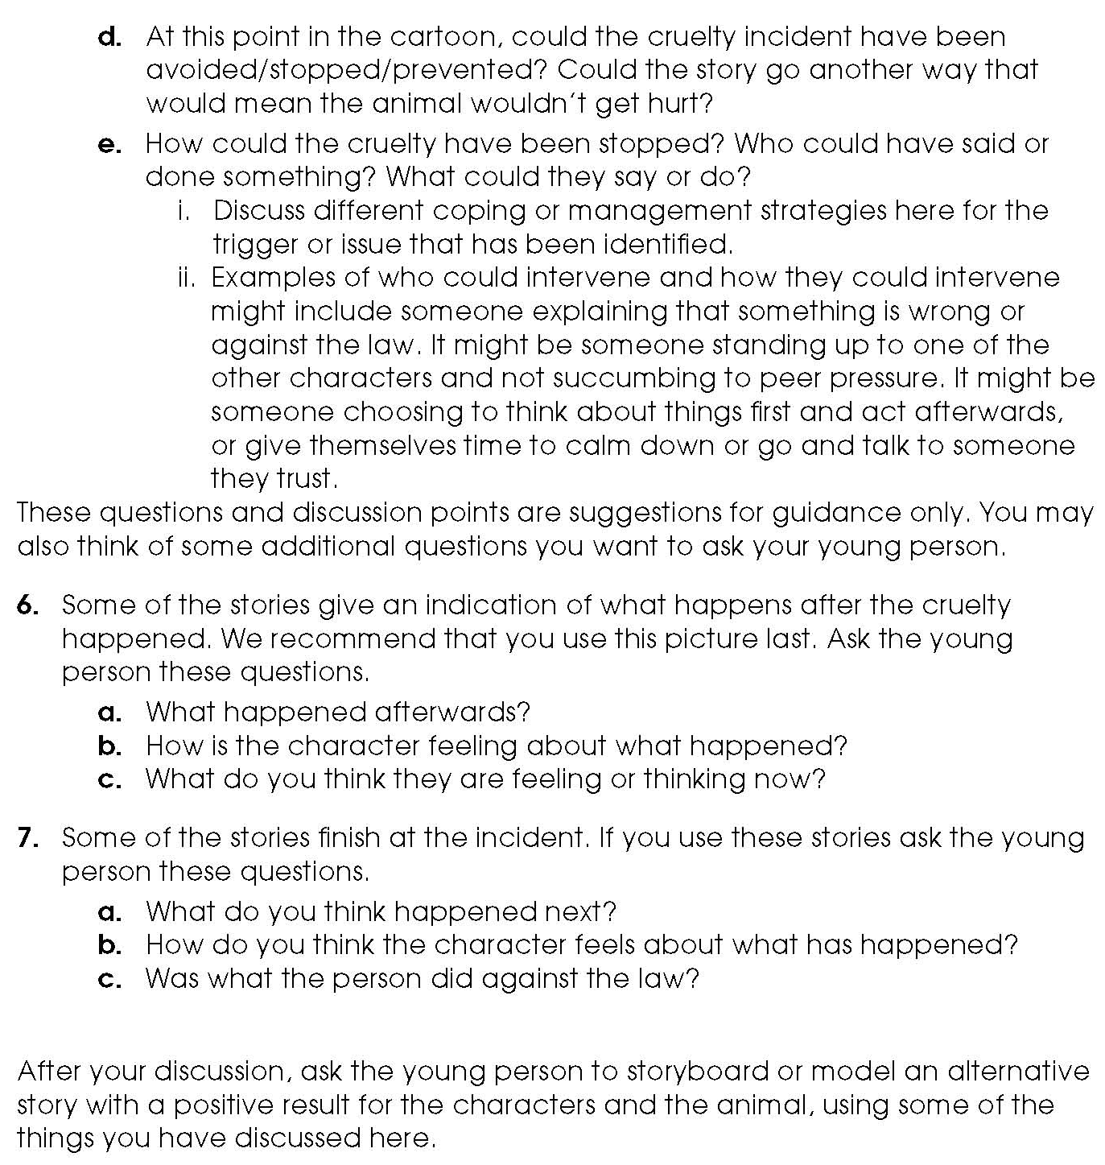

Activity sheet – What triggers cruelty? Cartoon strips
Jon tries to score (1)

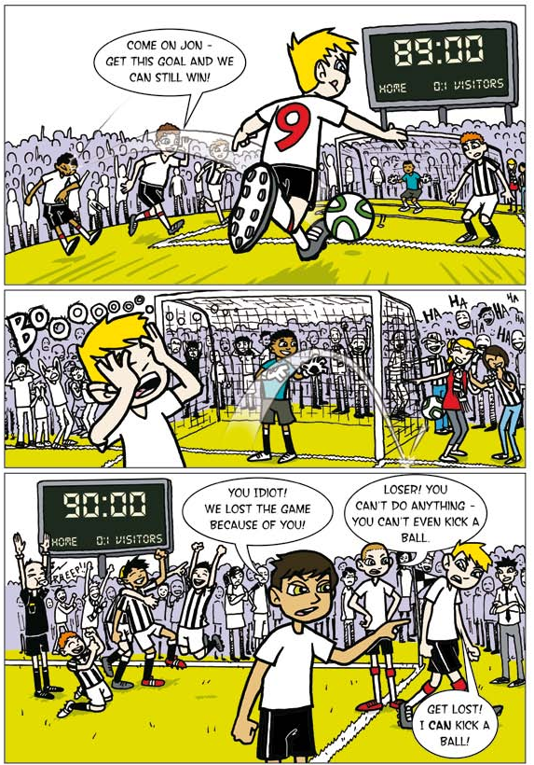

Activity sheet – What triggers cruelty? Cartoon strips
Jon tries to score (2)

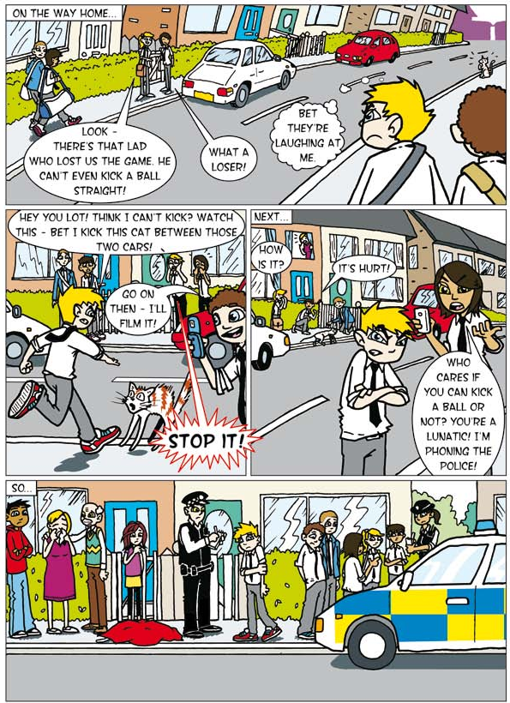

Activity sheet – What triggers cruelty? Cartoon strips
Jarek buys a dog (1)

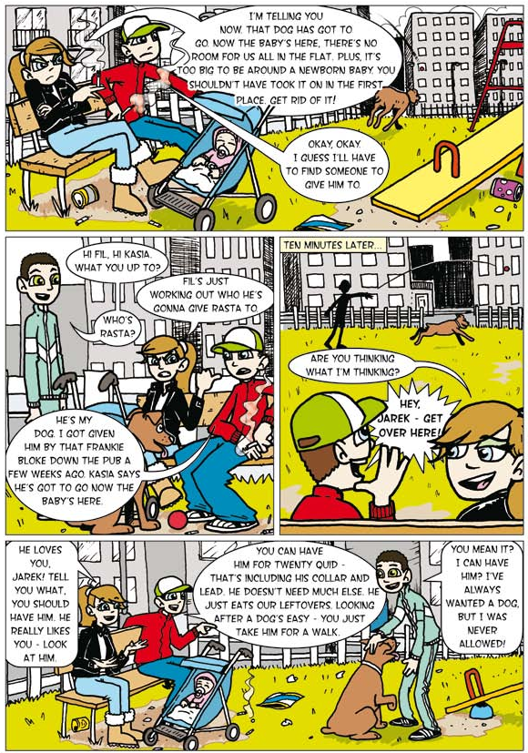

Activity sheet – What triggers cruelty? Cartoon strips
Jarek buys a dog (2)

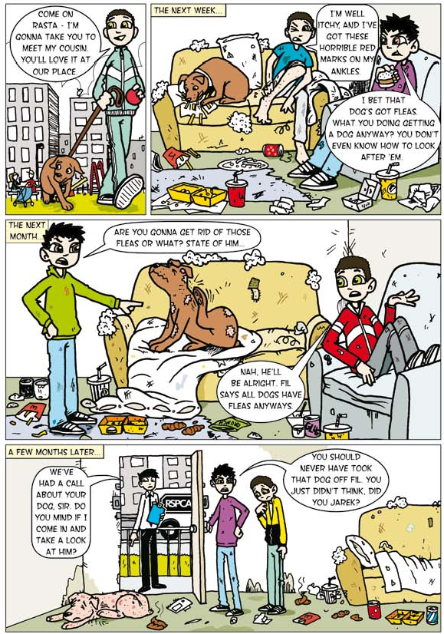

Activity sheet – What triggers cruelty? Cartoon strips
Mark loses it (1)
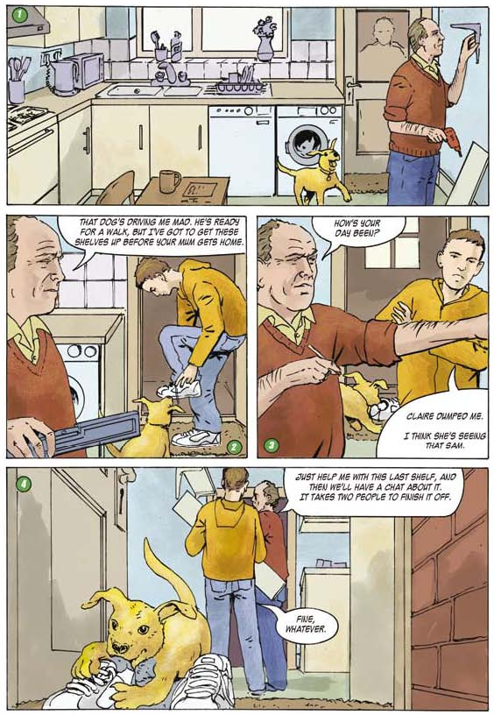

Activity sheet – What triggers cruelty? Cartoon strips
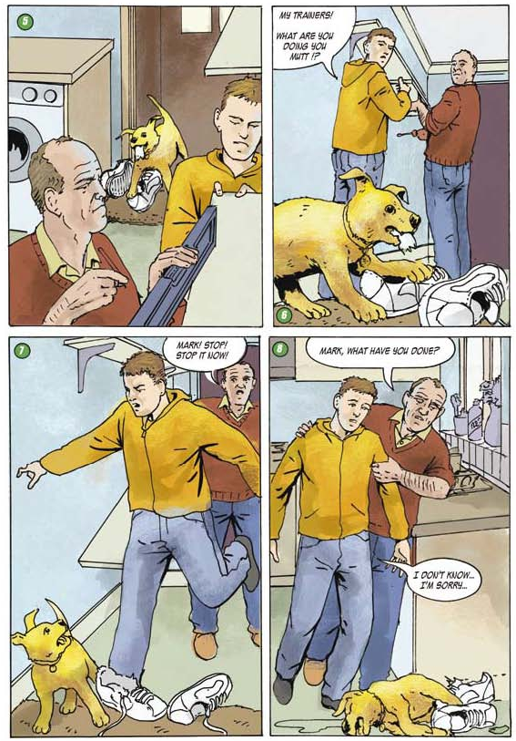
Mark loses it (2)

Activity sheet – What triggers cruelty? Cartoon strips
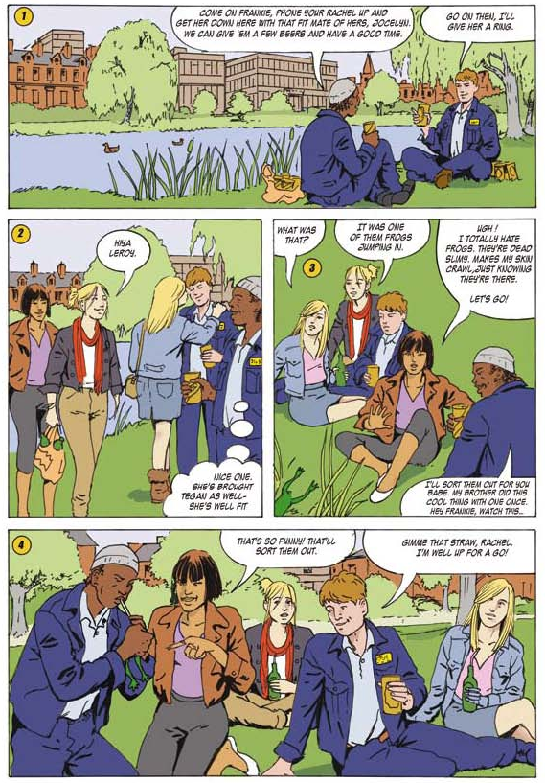
Jocelyn’s problem (1)

Activity sheet – What triggers cruelty? Cartoon strips
Jocelyn’s problem (2)
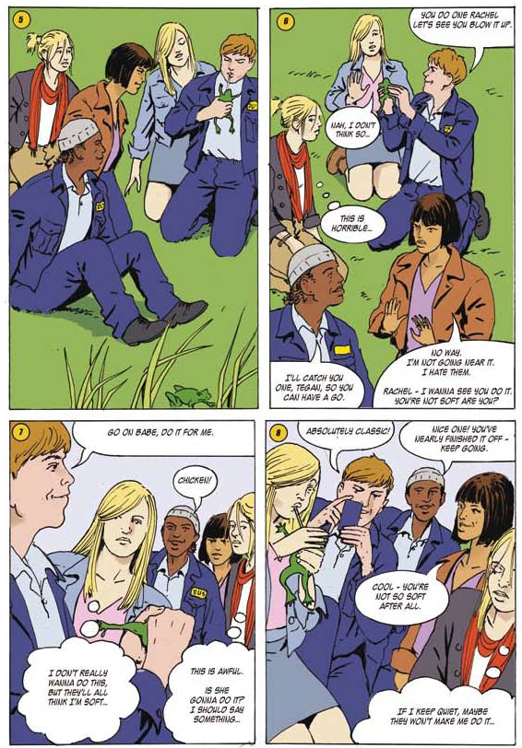

Activity sheet – What triggers cruelty? Cartoon strips
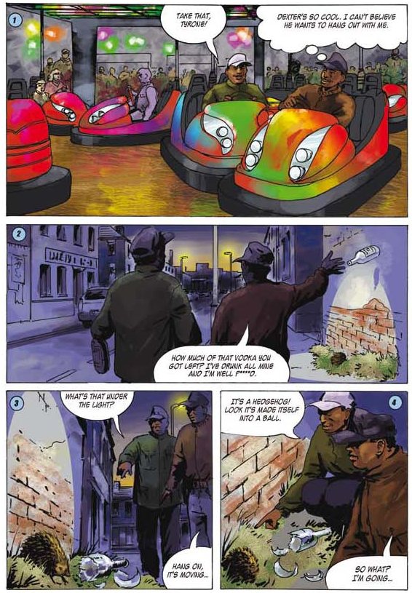
Tyrone gets it wrong (1)

Activity sheet – What triggers cruelty? Cartoon strips
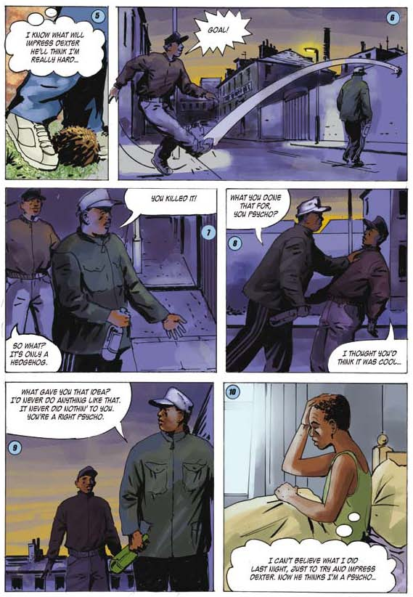
Tyrone gets it wrong (2)

Activity sheet – What triggers cruelty? Stories (1)

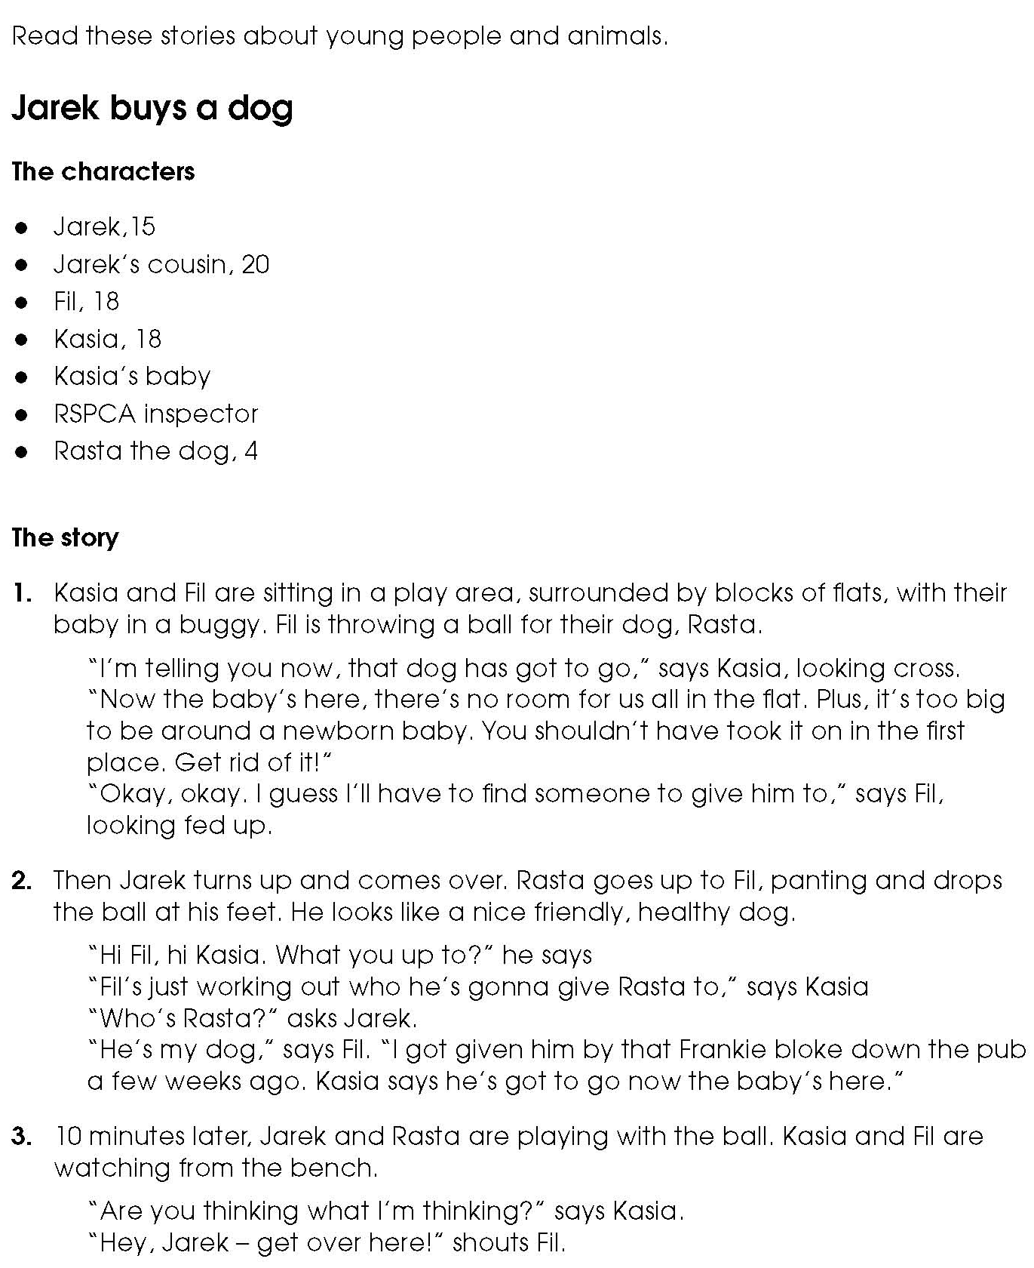

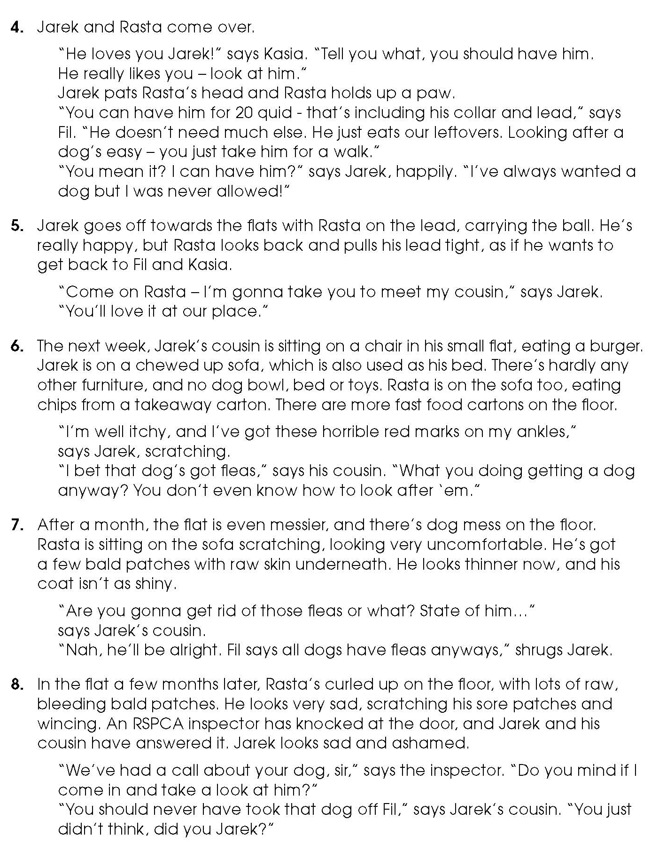
Activity sheet – What triggers cruelty? Stories (2)

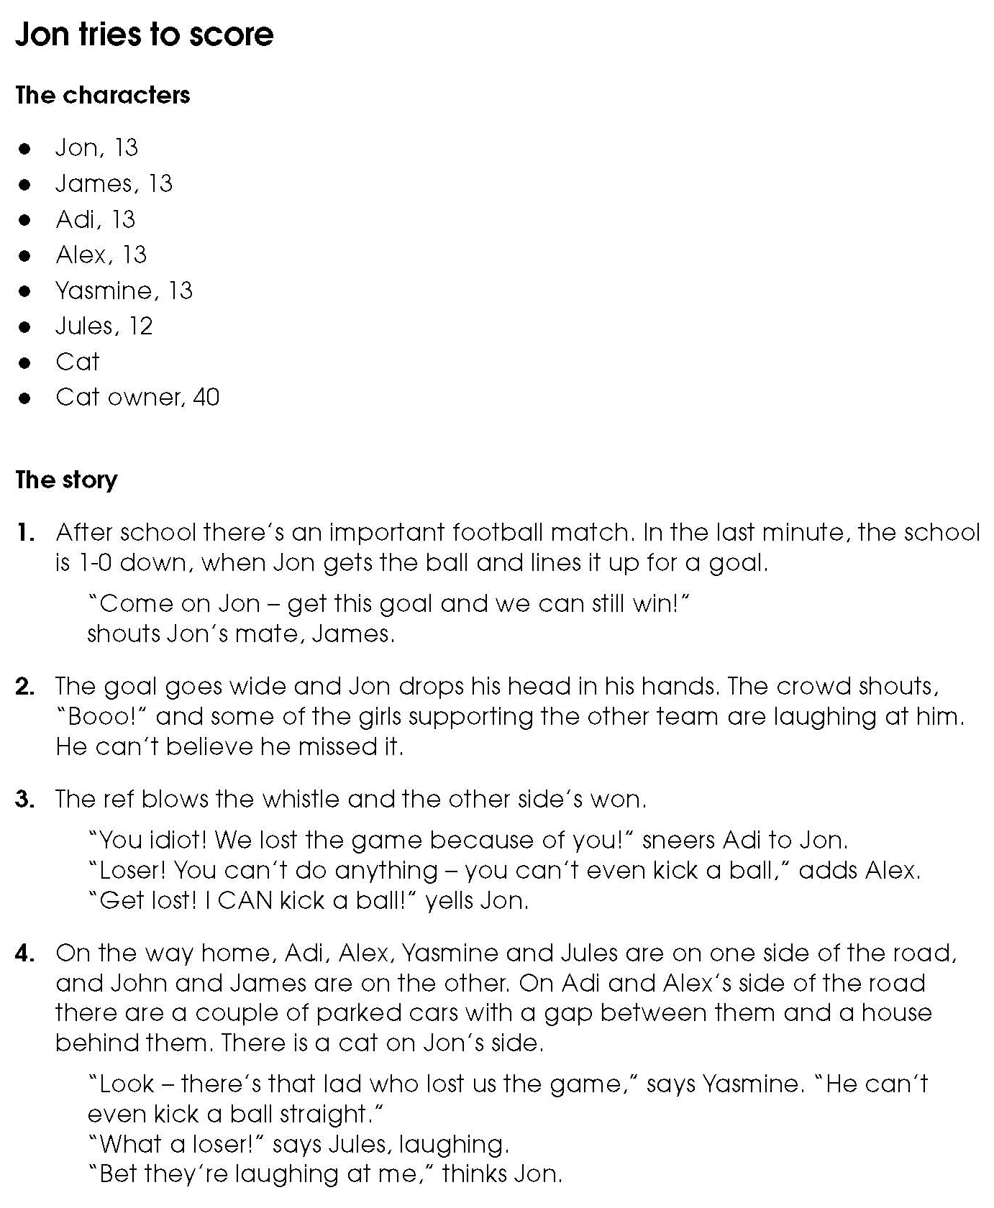
Activity sheet – What triggers cruelty? Stories (3)

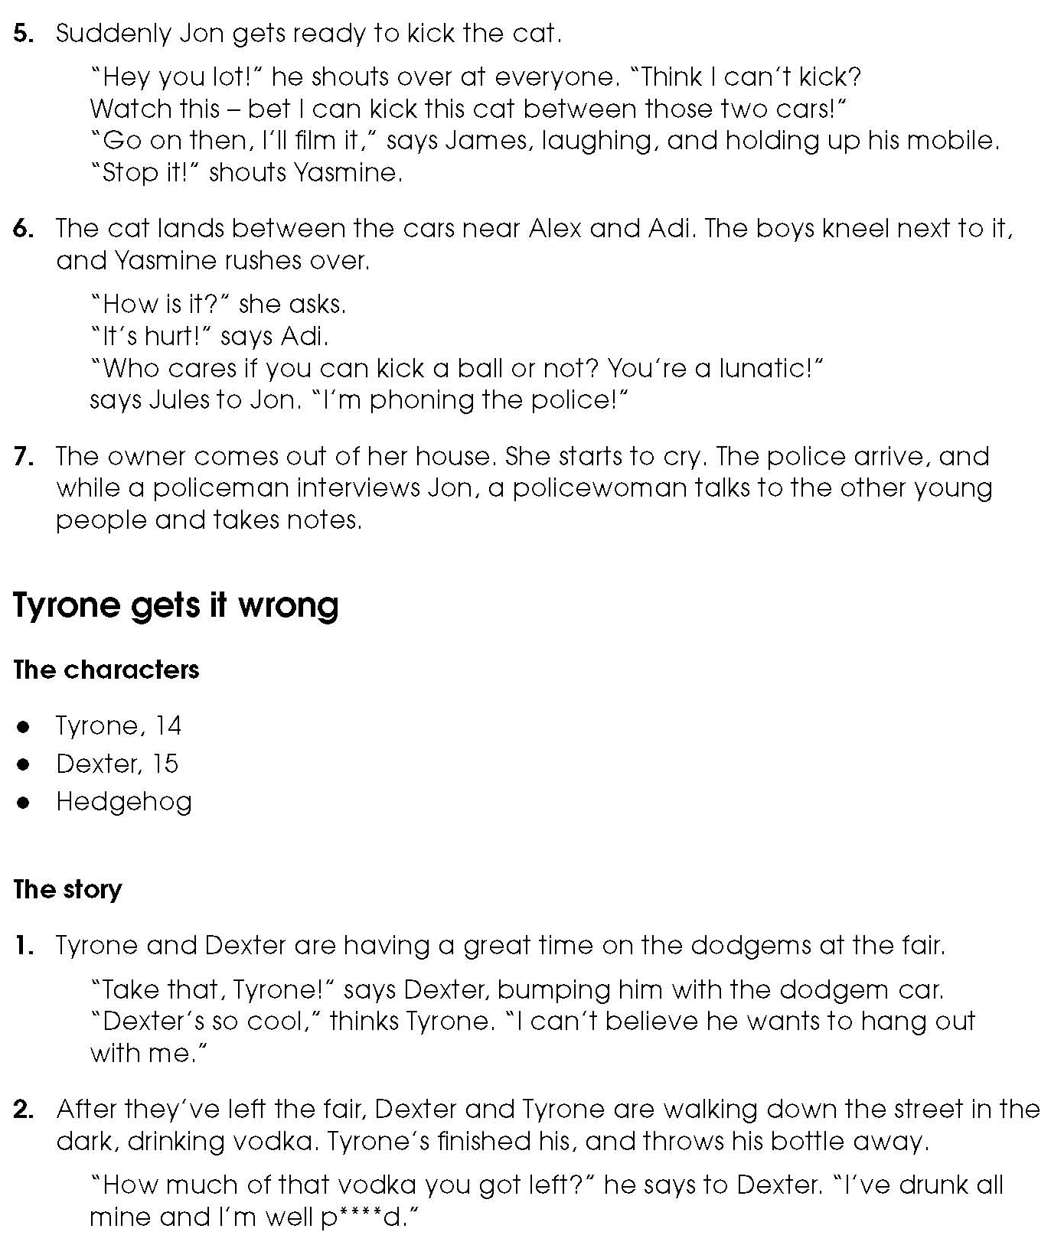
Activity sheet – What triggers cruelty? Stories (4)

Activity sheet – What triggers cruelty? Stories (5)
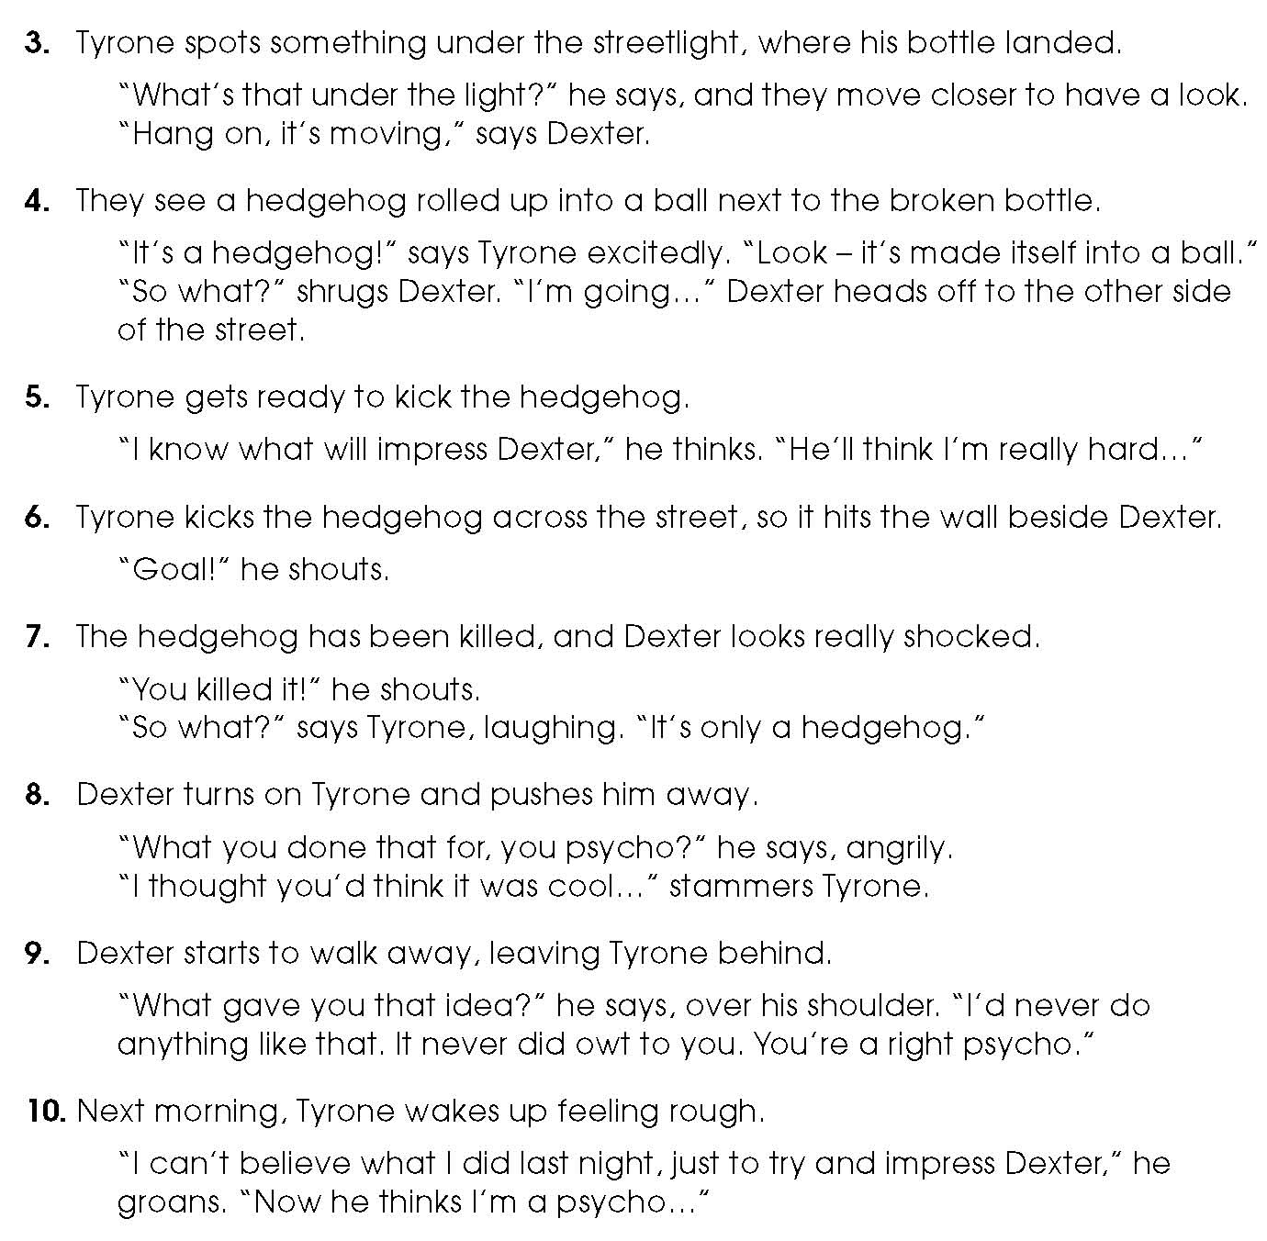

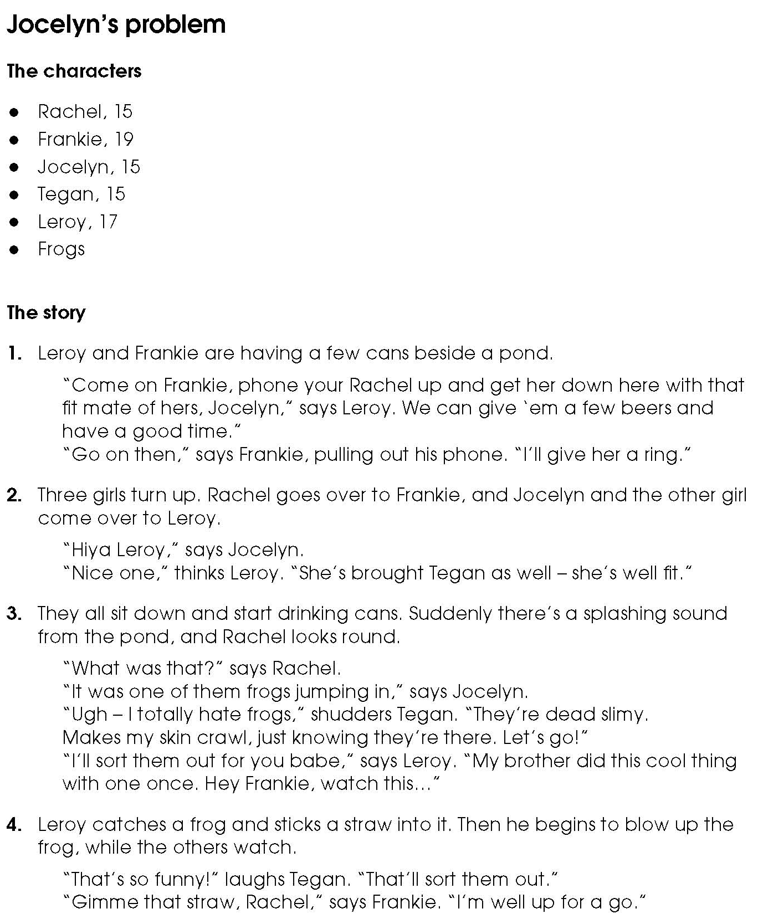
Activity sheet – What triggers cruelty? Stories (6)

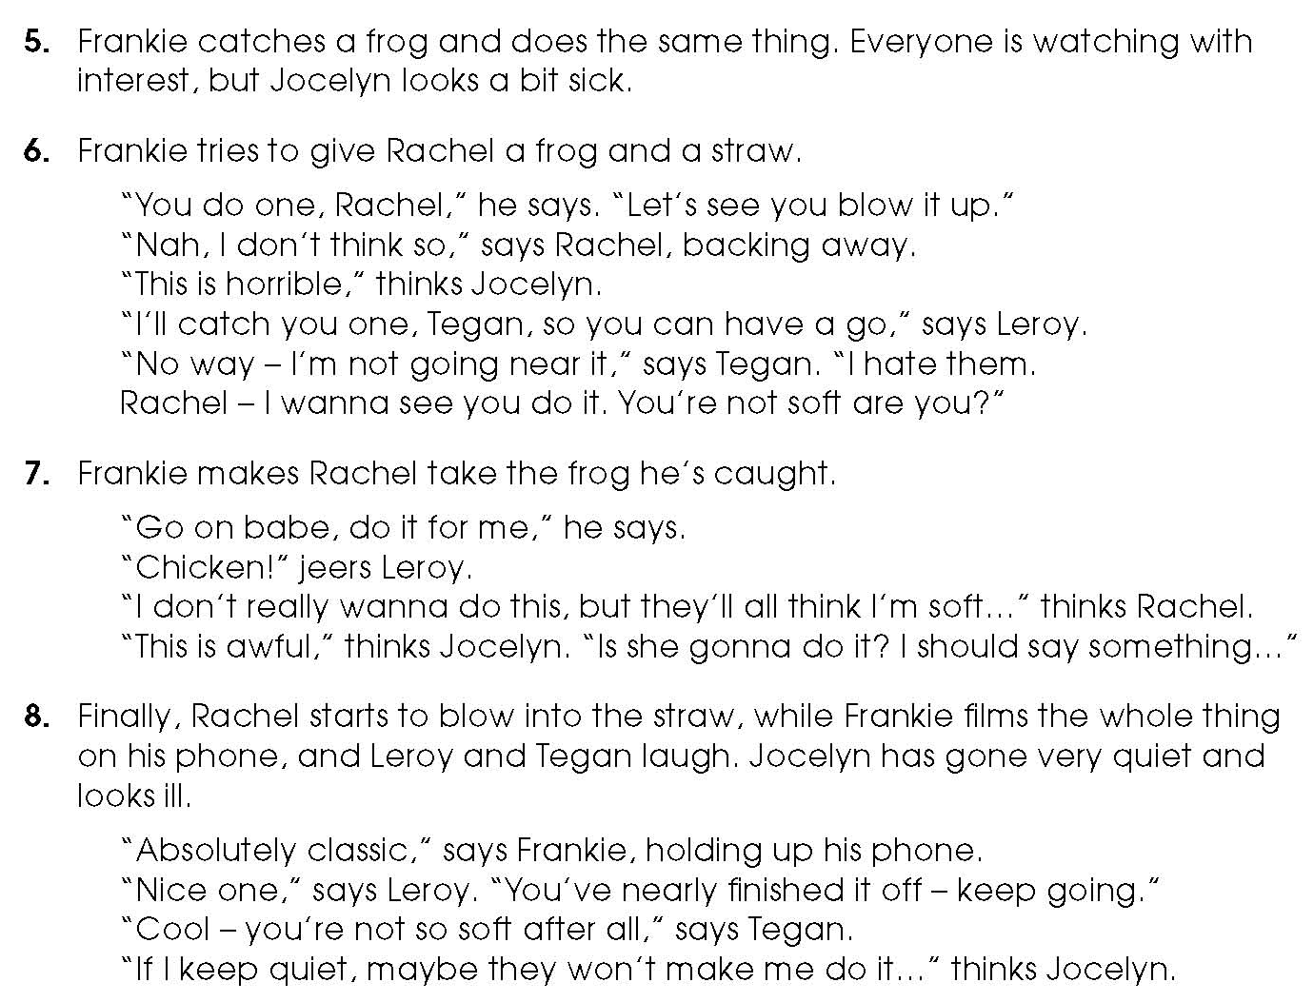
Activity sheet – What triggers cruelty? Stories (7)

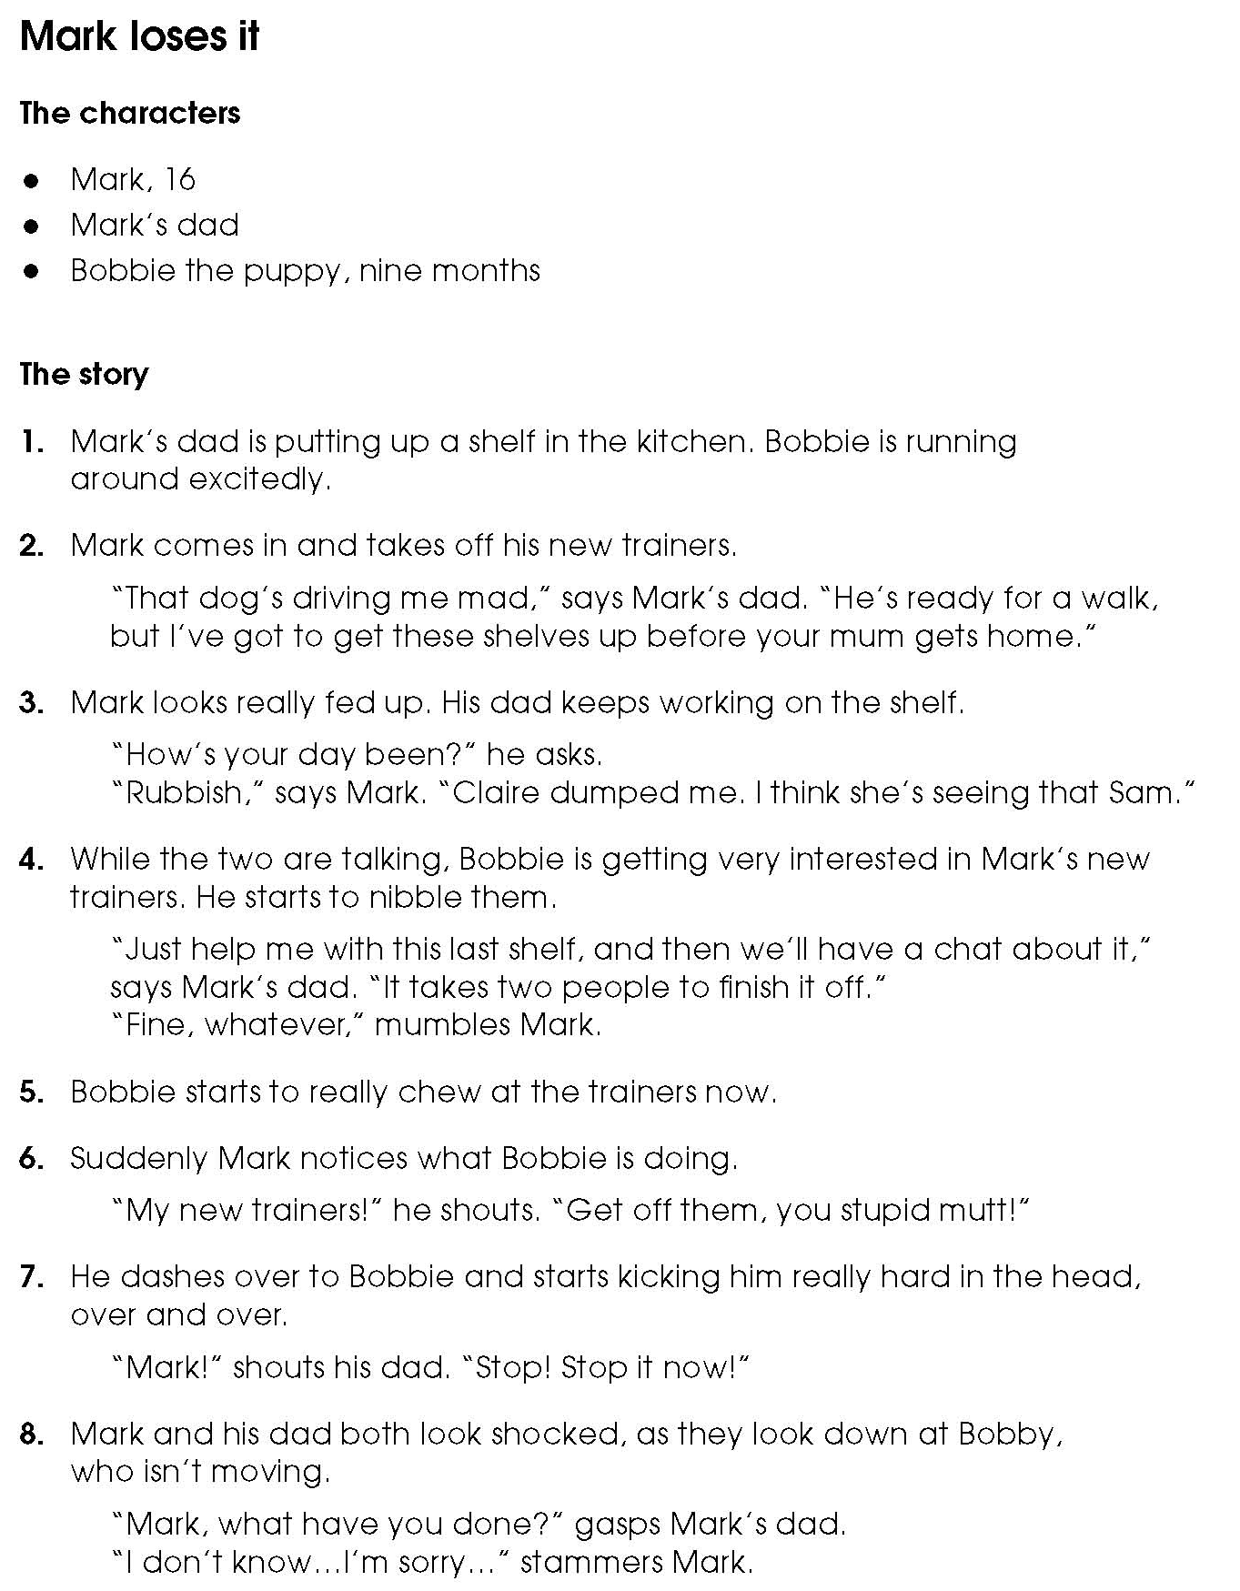
Activity sheet – What triggers cruelty? Stories (8)

Activity sheet – Human feelings cards (1)

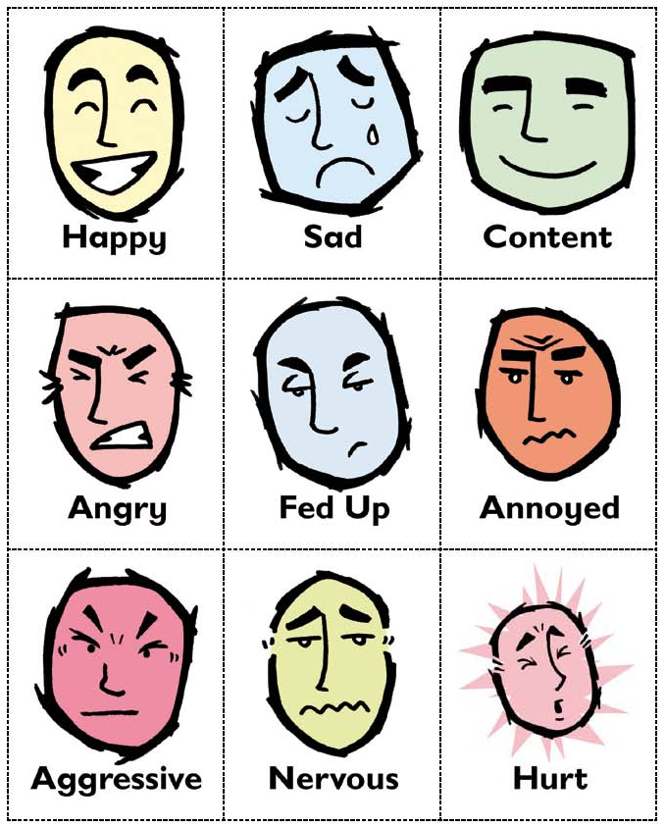

Activity sheet – Human feelings cards (2)

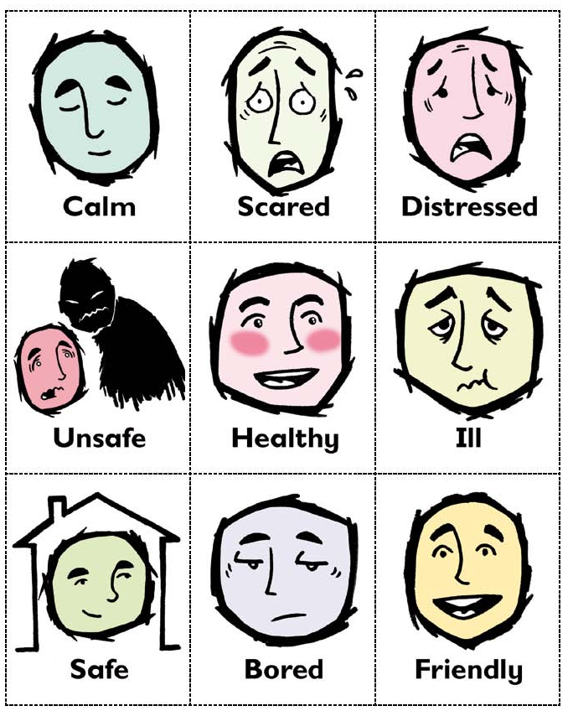

Activity sheet – Human feelings cards (3)
