Aims and objectives
- In this activity, young people discover the role an RSPCA officer has, and get the opportunity to consider the type of advice that an officer would give in two different situations.
- By the end of this session the young person will:
  - understand that if you own an animal you are responsible for its needs.
- Before you run this activity, we recommend that you do the Smiley face activity in the Basic needs and sentience section and at least one of the activities from the What is animal cruelty? section.

What to do

Find out what RSPCA officers do
- Watch the short clip A day in the life of an RSPCA officer

- Print out and read together the factsheet RSPCA officers.
- Discuss and clarify what RSPCA officers do.
- Did the young person know how many different jobs RSPCA officers do?
- What are the options RSPCA officers have if they think an animal is suffering? The facilitators' notes What would you do? (answers) will give you some information.
- Do they always take people to court?
- Is it an easy job to do?
Be the officer
- Read through the activity sheet What would you do?.
- Help the young person fill in the officer’s notes. The RSPCA believes anyone responsible for looking after an animal should try to make sure they have the five freedoms. The factsheet The five freedoms explains these.
- Ask the young person: “Who is responsible for looking after this animal? If you were an RSPCA officer, what advice would you give them?” At this stage we are thinking about advice, rather than the consequences of a law being broken.
- Ask what the young person thinks the consequences of ignoring an officer’s advice might be, both for the animal and for the owner.
- Before you run this activity, we recommend that you cover at least one of the activities from the What is animal cruelty? section, and the Smiley face activity in the Basic welfare needs and sentience section.
- You can find out more about the actions an RSPCA officer would take in the Consequences of cruelty to animals section.
- A central theme running through all these resources is the concept of the five freedoms. We hope that by introducing this to the young people in the Basic needs section and then reinforcing it in a number of other sections, we will provide them with a code of conduct to apply to every situation in which they encounter animals. The five freedoms are very similar to the duty of care criteria mentioned in the Animal Welfare Act.
- We have also developed three interactive activities - Was it cruel?, Consequences and Triggers - that help young people think through what happens when people are cruel to animals (see right). However, before you attempt to use these, we suggest that you explore some of the activities in the other sections - What is animal cruelty?, What triggers animals cruelty and how it can be avoided, Consequences of cruelty to animals and The incident.

Activity sheet – What would you do? (1)

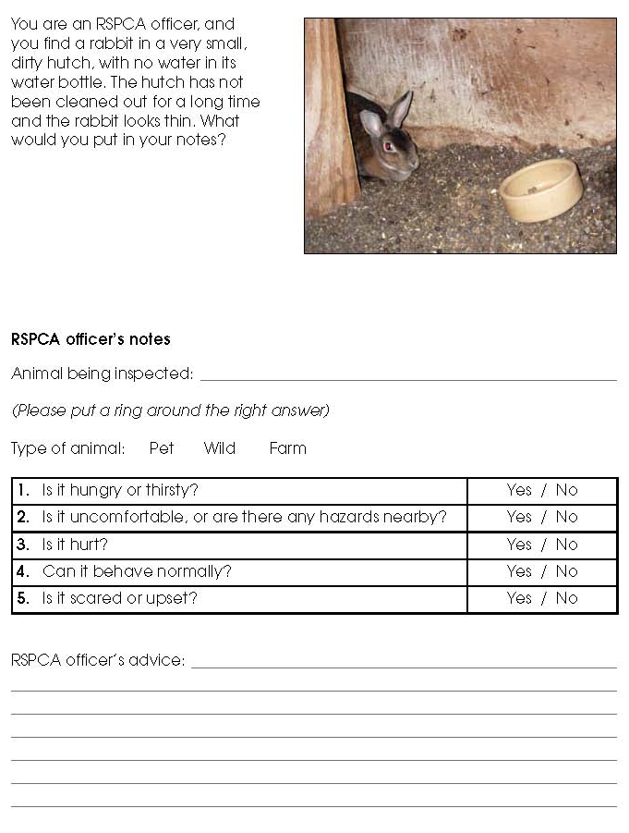
Activity sheet – What would you do? (2)

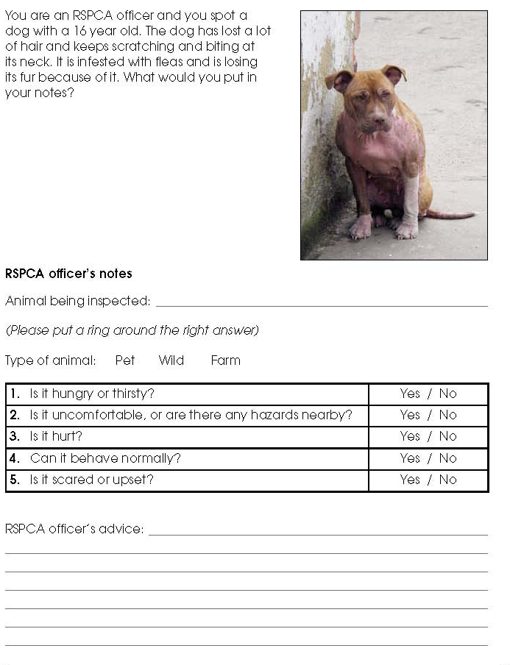
Fact sheet – RSPCA officers

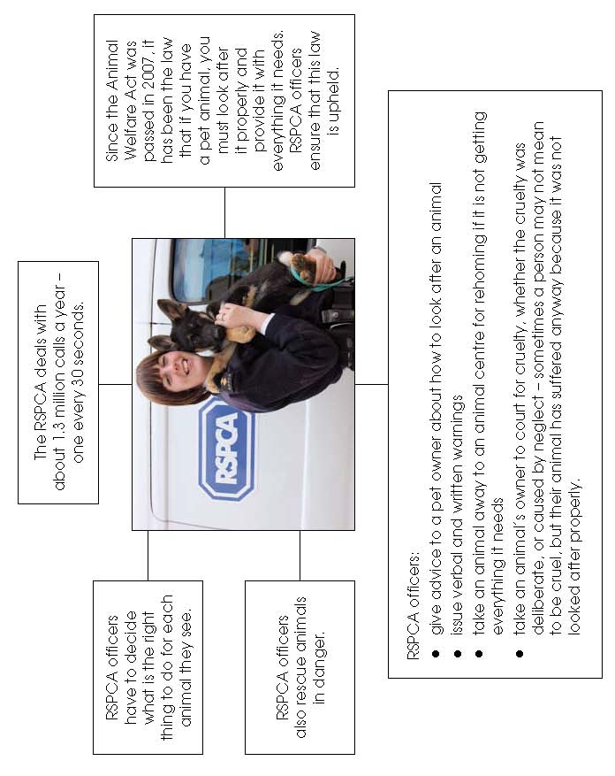

Fact sheet – The five freedoms

