Aims and objectives
- This activity is just one part of a range of resources addressing the needs of young people who have been involved, or who are at risk of being involved, in cruelty to animals. Our online assessment tool Developing a suitable intervention programme (Word 17KB) will help you create individualised intervention programmes from these resources.
- Before you do this activity, you should do What triggers cruelty? and Revisiting the incident in this section. You should follow it with My triggers and action plan.
- In this activity, the young person thinks about how their actions have affected them and others. They have the opportunity to empathise with the animal as the victim, as well as other people.
- The young person will develop the understanding that:
  - there are consequences to their actions
  - their actions have resulted in them entering the youth justice system and being put on an order
  - taking part in this incident has affected them in other ways as well
  - their actions have had a negative effect on other people, in a variety of ways
  - their actions have caused an animal or animals to suffer.
What to do

- Explain to the young person that you are going to think about the consequences of what they have done. You will look at how their actions affected others. Say that their actions not only caused an animal to suffer, but might have affected a range of people in many different ways.
- First ask them to tell you who was affected by their actions. They might talk about themselves, the animal, the animal’s owner, their family, an animal care assistant, nature ranger, vet, police officer, RSPCA inspector, witness to the incident or someone else.
- Ask who was affected most by their actions.
  - Guide the discussion towards the idea that they may well be the person who has been affected most, perhaps as much as the owner of the animal (if the animal had an owner).
  - Guide the discussion towards the idea that the animal was also most affected because their actions caused it to suffer (and be in pain). The animal is a victim of their crime or the incident they were involved in.
- Show the young person the activity sheet How have my actions affected others? (1).
- Explain that you are going to think about how their actions have affected others. They will think about:
  - How they have been affected
  - How the animal has been affected
  - They will also choose two other people or groups of people and think about how they have been affected as well. This could include the animal’s owner, a witness to the incident, a police officer who found the animal or investigated the incident, the young person’s mum, dad, carer, brother, sister, the vet who treated the animal, an RSPCA officer.
- The young person has to imagine they are the person or the animal, and try to understand from their point of view how they have been affected.
  - How did the incident affect me in the short term and in the long term?
  - How did the incident make me feel?
  - I wish that….. (complete the rest of the sentence).
- Complete the appropriate box on the activity sheet. The young person can write this, or you could do it for them, or you can just discuss what would go in each box. You could record the conversation on tape so the young person can listen to it again if this would be helpful. It is recommended that you use the suggestions for discussion points in the facilitators' notes Consequences discussion points.
- To explore more individuals or groups of people, use the activity sheet How have my actions affected others? (2). You can also use this sheet if you need more writing space for each person.
- Whoever you choose, it is important to discuss the short and long-term effects of the incident, and how it made that person or the animal feel. Explain that is important for us, as people, to think about others’ feelings, and about how our actions affect them.

- Go back to the points first explored in the session Revisiting the incident by asking the questions below. Ask them to reflect on the situation as a whole and their role in what happened. It is important to do this in a way that is non-confrontational.
  - What was your role in the incident?
  - Do you accept what has happened and take responsibility for your actions and behaviour? Is it your fault? If you had not done what you have just told me, would the animal have been hurt and would the law have been broken?
  - Can you face up to what you have done?
  - Do you want to try and make amends?

Extension activities
- Using the activity sheet Who has been affected the most? ask the young person to look at the diagram. Tell them the incident was like a stone thrown into some water, which created ripples around it. Ask the young person to put the animal and the different people affected by the incident onto the diagram. They can use a symbol or a drawing to mark each one’s position. Explain that the closer to the incident at the centre of the diagram, the greater the impact on that person or animal’s life. They can use the four examples of people and animals used in the previous activity, or they can add others.
- Ask them to explain why some people have been more affected than others.
- Finally, ask the young person how they feel about the fact that their actions have affected these people and the animal in all these ways.
- If they could change what happened, would they?
- This activity will only be effective if the young person accepts their involvement in the incident.
- You can choose to ask the young person to complete the activity sheets How have my actions affected others? (1 and 2) or you can complete them on their behalf.
- You may decide to just talk about how others have been affected, using the activity sheet as a guide. If you wish, you can record the young person’s voice talking about how others have been affected and play it back to them.
- Part of this activity asks the young person to empathise with the animal that was the victim in the incident in which they were involved. Completing some of the activities in the section Basic welfare needs and sentience will help them prepare for this.
- You could run this session before or after a reparation meeting. If you do it before, it will help prepare the young person for the reparation meeting. If you do it afterwards the young person may find it easier to empathise with those who have been affected.
- To complement the ideas in this session, we have developed three interactive activities - Was it cruel?, Consequences and Triggers - that help young people think through what happens when people are cruel to animals. To access each of them, click on the titles, right.

Useful websites

RSPCA – All about animals

Fact sheet – Consequences discussion points (1)

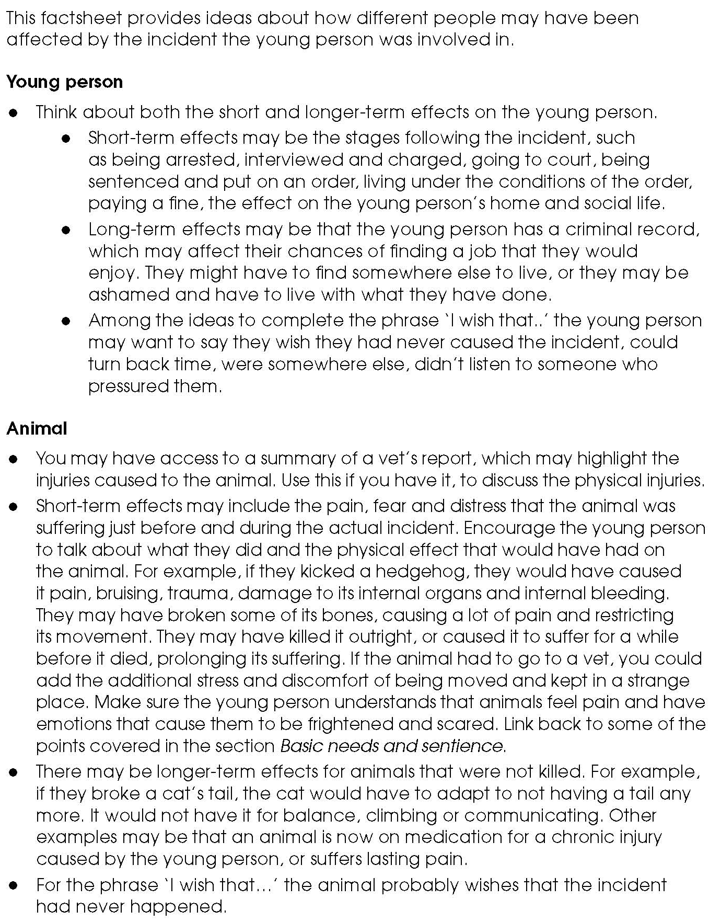

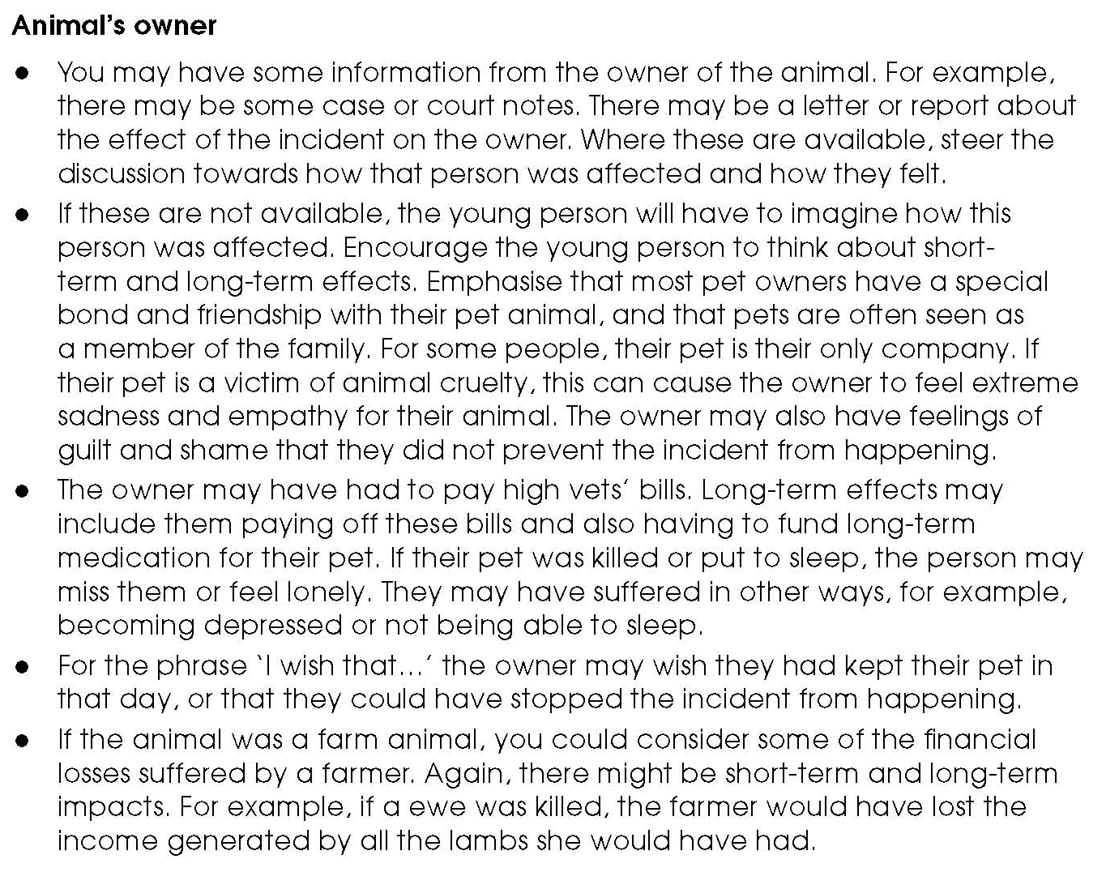
Fact sheet – Consequences discussion points (2)

Activity sheet – How have my actions affected others? (1)

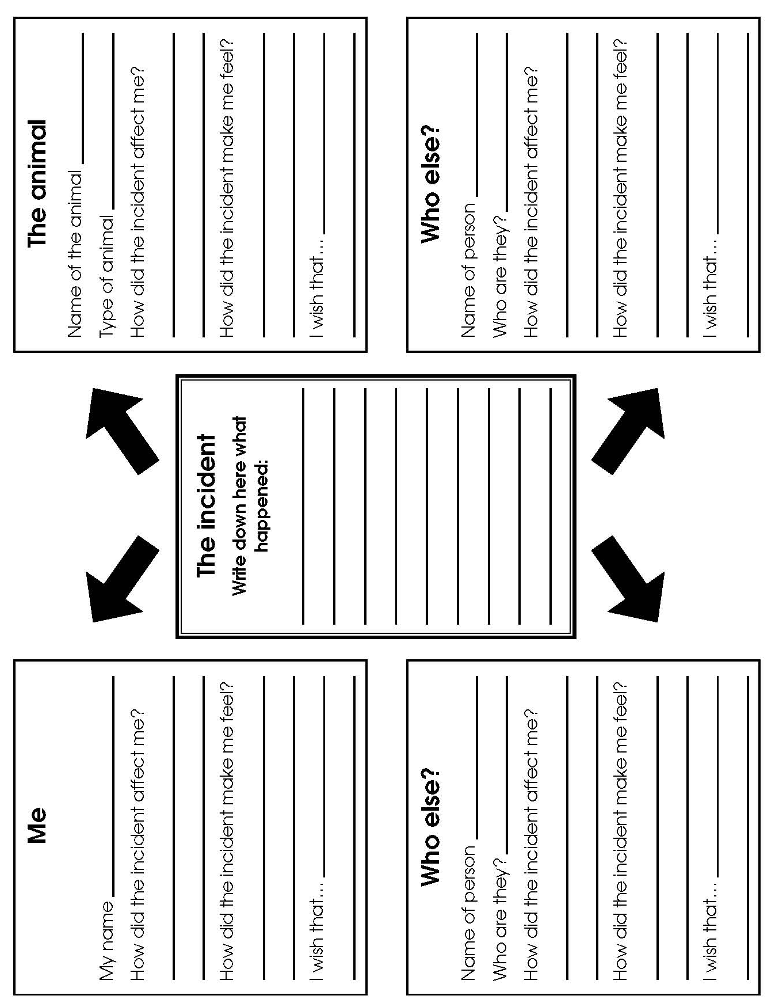

Activity sheet – How have my actions affected others? (2)

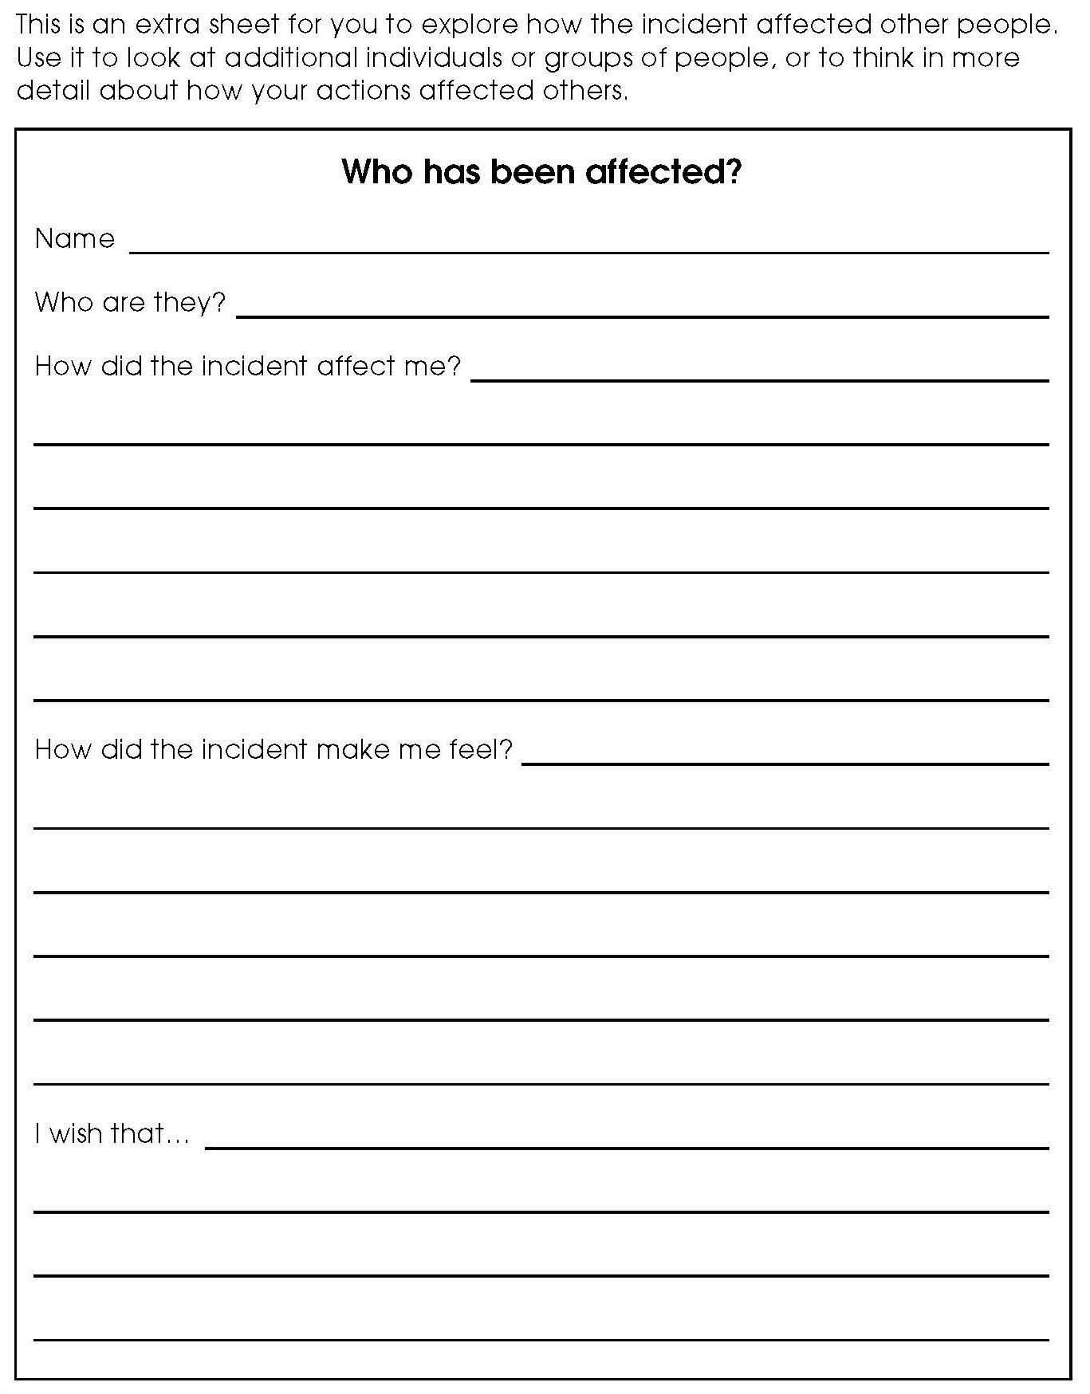

Activity sheet – Who has been affected most?

