Aims and objectives
In this activity, young people will begin to think about the consequences of having a dog that you encourage to be aggressive. They look at photos of people with injuries that have been caused by attacks by dogs of different types and breeds. They are asked to imagine what the person felt like during and after the dog attack. They are then asked to imagine that the person in the photo was someone they cared about, and to talk about their feelings and what they would say to the dog owner.
Young people will:
- explore what the consequences might be of having an aggressive dog
- understand that a dog you encourage to be aggressive can be very dangerous when he/she comes into contact with people, including yourself, your loved ones and other animals, especially when the dog is out of control
- know that dog attacks can cause serious injuries and even kill people
- learn that serious and fatal dog attacks can happen in the family home by the ‘family pet’
- understand that dog attacks can be caused by any type or breed of dog – not just banned types like pit bull terriers
- learn that the owner of a dog is responsible for that dog’s behaviour. If their dog attacks another dog or a person, it is the owner’s fault.

What to do

- Choose some images from the activity sheet Dog bites on people - these are photos of unprovoked attacks. Take care when choosing the photos as these may be distressing for some young people, or gratifying for others.
- Explain to the young person that you are going to show them some photos of people who have been attacked by dogs who were allowed to be out of control. With each photo, ask the young person the following questions:
  - What do you think happened before the picture was taken? (For example, the person was attacked by a dog and the dog must have bitten a particular part of their body. Perhaps the dog knocked them to the ground, etc.) See the RSPCA’s guidance on canine aggression in the Useful websites tab for more information
  - How do you think the person felt during the dog attack? (The young person may find it helpful to use the activity sheet Human feelings cards 2 which contains words to help them describe feelings associated with dog attacks)
  - What do you think the long-term impacts are for that person? For example, physical injuries and scarring, as well as emotional and behavioural effects
  - Do you think that the person in the photo was to blame for what happened to them? (Always encourage the young person to see the person in the photo as the victim. The person who is responsible for the attack is the owner who allowed the attack to happen by not keeping their dog under control)
  - What type of dog do you think caused the attack? (Encourage the young person to describe the characteristics of the dog, e.g. aggressive, dangerous, threatened, scared, strong, powerful jaws, sharp teeth, etc. rather than the breed. You could explain that any dog is capable of causing injuries to people, especially if he/she is aggressive or trained to be aggressive, and is allowed to be out of control. It is not just banned types of dogs that attack people. In fact, these were attacks by dogs including the Japanese Akita, Shar-Pei, Rottweiler and Staffordshire bull terrier and none of the attacks were by banned types of dog)
  - You could share some of the interesting comments from the BBC online news article about dog bites on people. It includes statistics about the rise in dog bites on people and comments from the public about dog bites from different breeds of dogs, including spaniels and chow–chows.
Emphasise that no matter what type of dog you have, he/she can still be aggressive. What is important is the ‘deed rather than the breed’ of the dog. In other words, it is the action of the owner and what they encourage or allow their dog to do that is important, rather than the type of dog. Irresponsible owners can own dogs of any type.
Although it might seem that some dogs are born aggressive, it is more accurate to say that they are born with inherited tendencies that might, if not controlled, make aggressive behaviour more likely. (For more information on this issue please see the RSPCA’s Canine aggression FAQ in the Useful websites section).
Source : Briefing on status dogs, RSPCA

The RSPCA believes that breed-specific legislation (BSL) is unfair and unjustifiable, and that the Government should adopt an approach recognising that any individual dog, irrespective of breed or type, can display aggression towards people, and the responsibility for this lies with the owners. Source: Response to Defra consultation on dangerous dogs

Imagine if an incident like this affected someone you care about…
- Ask them to imagine that in one of these photos was someone they care about. If you know that they are close to someone, for example their sister, brother or grandmother, you could use the photo that is the closest match to that person.
- Ask the young person to think about the following questions:
  - How would you feel if this happened to someone you care about?
  - What would you think about the owner of the dog that allowed this to happen?
  - What would you say to that person? (Would you blame them? Would you say that they are an irresponsible dog owner? Would you give them some advice? Would you explain what the consequences were of them having a dog out of control?)
  - How would you feel if it was your dog that attacked someone you cared about?
  - What would your family and friends think and feel?
- Stress that powerful and aggressive dogs can be very dangerous. Not only are they a danger to the public, but also to people that you care about. Explain that the majority of fatal dog attacks on children have actually happened in the home. You may wish to share the information from the facilitators notes fatal dog attacks to children to help the young person understand that an aggressive dog is a danger to everyone the dog encounters, and not just in public.
- Explain that even if they think that their dog is always ‘under control’ when they are with him/her, there may be times when the dog is being looked after by someone else. Therefore, everyone that comes into contact with the dog must be kept safe from potential dog attacks.
- Use the young person’s motivations for owning or wanting a dog that has the potential to be aggressive to ask whether they are able to achieve what they want.
- When discussing the consequences of irresponsible dog ownership, relate back to the individual’s motivations for dog ownership that you discussed in the Motivations for dog ownership section. This will strengthen the messages and be more successful at changing challenging attitudes and behaviour.
- For example, if the motivations for dog ownership include:
  - Protection of people I care about – Are you actually protecting the people you care about by having a potentially dangerous dog, or are you putting them at risk? The dog might have the potential to seriously injure or kill someone you care about. If your dog is aggressive and attacks someone, he/she could be seized and put to sleep and won’t be able to offer any more protection. If you are banned from owning a dog, you won’t be able to get another one for that set period of time
  - Improves my image or respect from peers - if the dog is taken away and you are banned from owning another dog, you will lose credibility. People in your community will know what has happened to the dog and will think differently about you, and perhaps lose respect for you
  - Power or control – are you showing that you are in control of a dog who has the potential to kill or seriously injure somebody? If your dog attacks someone by accident, then you are not keeping him/her under control and other people will see this too
  - Financial- if your dog is aggressive and attacks someone or another animal, he/she could be seized and put to sleep and won’t make you any money. If you are banned from owning a dog, you won’t be able to get another one for that set period of time
  - To fit in with everyone else or give me a sense of belonging- if your dog is aggressive and attacks someone, he/she could be seized and put to sleep. Without your dog, will you still belong in that social group or will you feel left out if you are the only person without a dog? If you are banned from owning a dog, you won’t be able to get another one for that set period of time
  - Friendship/companionship- if your dog is aggressive and attacks someone, he/she could be seized and put to sleep. You won’t have that special companionship with your dog any more. If you are banned from owning a dog, you won’t be able to get another one for that set period of time
  - As a weapon- if your dog is aggressive and attacks someone, he/she could be seized and put to sleep and won’t be able to offer any more protection. If you are banned from owning a dog, you won’t be able to get another one for that set period of time. (If the young person gives you an indication that they use their dog as a weapon, make sure you complete some of the activities in the Dogs and the law section. It is against the law to allow your dog to intimidate or attack another person. You could also be charged with an animal welfare offence if you allow your dog to attack and cause cruelty to another animal, including another dog. Involvement in dog fighting is against the law.)
You can relate the consequences of having a potentially aggressive dog out of control to any of the motivations for dog ownership discussed in the first session Motivations for dog ownership. Use the framework given in the examples above to help you.
Emphasise that if you don’t keep your dog under proper control, you will fail to achieve these things. If you are an irresponsible dog owner, and choose to have an aggressive dog out of control, there could be serious consequences.
- Read this info on Growing up with a dog and the accompanying leaflet.
- Create a poster for young children specifically on ground rules on how to act around dogs.
Try to concentrate on:
  - Messages that are important to let children know about how to behave around dogs
  - Making it as visual as possible with little writing so that young children with poor reading skills will be able to understand the messages too
- During these activities, there are opportunities for you to revisit the young person’s motivations for owning or wanting a dog. The section Motivations for dog ownership must therefore be completed first.
- This activity is appropriate if the young person is an existing dog owner or has shown an interest in getting a dog.
- This session is especially useful for people who think that it is acceptable to have an aggressive dog, and those who train their dog to be aggressive.
- This session is also suitable for young people who like and admire dogs, but you are concerned that they possibly do not know the best way to train or care for those dogs. It is unlikely to have any impact on a young person who has been keeping a dog specifically for illegal dog fighting or is who heavily involved in gang warfare. If you are working with someone who has been involved in illegal dog fighting, refer to The incident section in Breaking the chain in the first instance.
- The activity Consequences of irresponsible dog ownership: Case study also explores the consequences of people having an aggressive dog out of control.
- The activity Consequences of irresponsible dog ownership: Focus on dogs focuses more on the consequences to the dogs.
- Other consequences of irresponsible dog ownership, especially those related to dog welfare, can be found in the activity Encouraging responsible dog ownership: All about dogs.
- It is important to note that dogs should not be left unsupervised with young children. See the RSPCA's FAQ on dogs and babies and the RSPCA’s canine aggression FAQ (see Useful websites tab).
- A central theme running through all these resources is the concept of the five freedoms. We hope that by introducing this to the young people and then reinforcing it in a number of other sessions, we will provide them with a code of conduct to apply to every situation in which they encounter animals. The five freedoms are very similar to the duty of care criteria mentioned in the Animal Welfare Act.

Useful websites

The Dangerous Dogs Act 1991
Defra – Dangerous Dogs Act legislation guidance
Directgov – Dogs that are banned in the UK
Directgov – Controlling your dog in public
Defra – Control of dogs, the law and you (leaflet)
RSPCA briefing on status dogs
RSPCA canine aggression information
BBC News – Hospitals see rise in dog bites
Growing up with a dog – dogs and children

If you want to find out more about the dog attacks shown in the photos in the activity sheet Dog bites on people, then you can access them at:

'Girl needed 175 stitches after dog attack' - Ross Parry Agency, 21 August 2010
'Boy, 5, 'scalped' by Rottweiler in horror attack' - Dail Mail, 26 February 2010
'Boy, 11, savaged by dog his father rescued off the street days earlier' - Mail Online, 29 December 2010

Activity sheet – Dog bites on people (1)

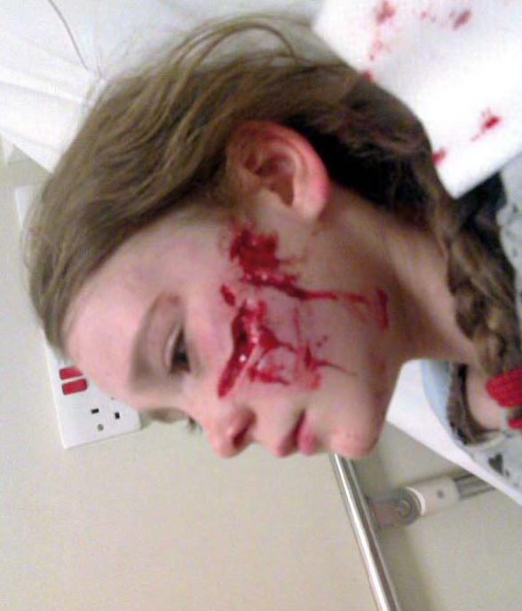

Source: ‘Girl needed 175 stitches 9after dog attack’ – Ross Parry agency, 21 August 2010

Activity sheet – Dog bites on people (2)
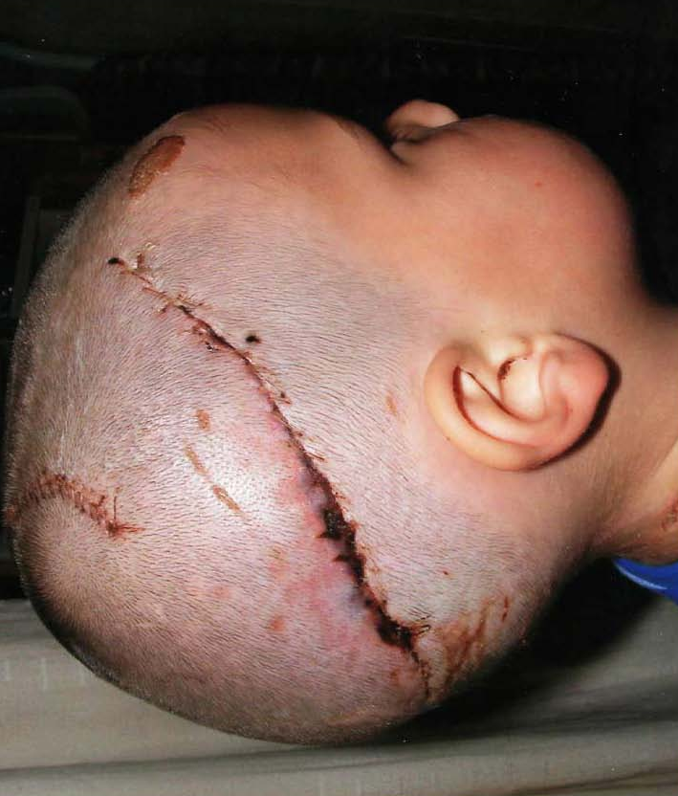

Source: ‘Boy, 5, ‘scalped’ by Rottweiler in horror attack’ – Daily Mail, 26 February 2010

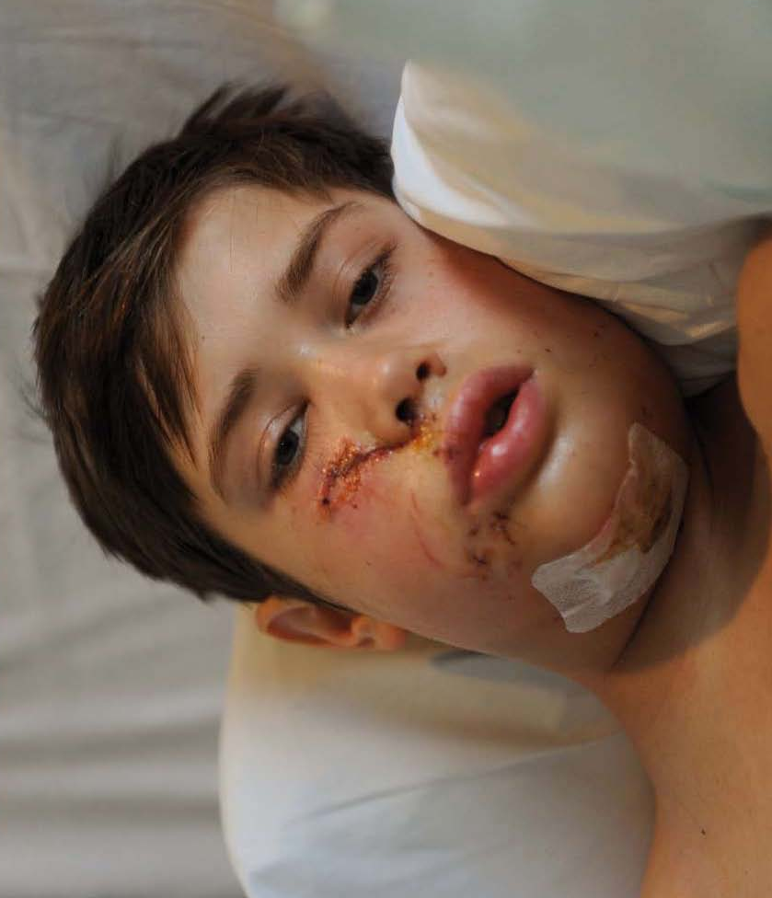
Activity sheet – Dog bites on people (3)

Source: ‘Boy, 11, savaged by dog his father rescued off the streets days earlier’ – Mail online, 29 December 2010

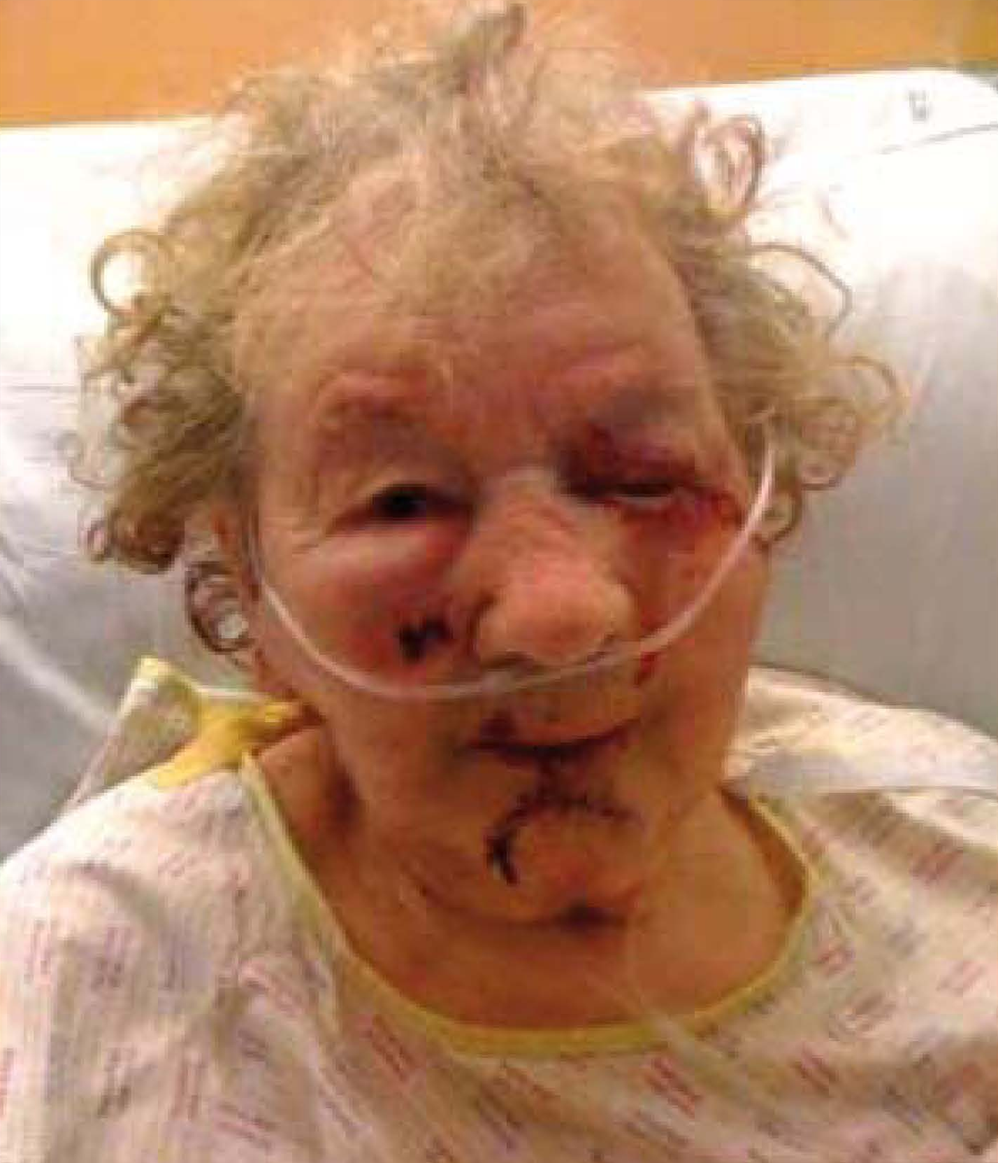
Activity sheet – Dog bites on people (4)

Source: ‘Dog attack grandmother, 90, left in hospital’, News Shopper, 25 February 2010

Activity sheet – Human feelings cards

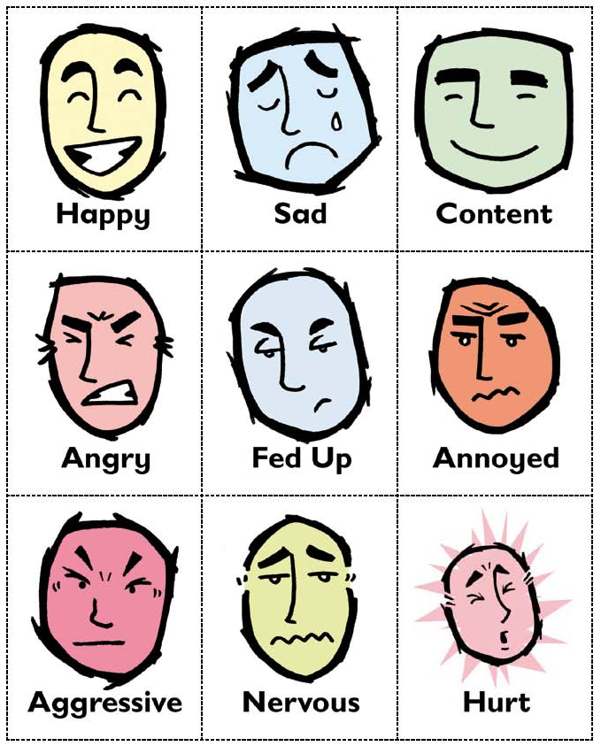

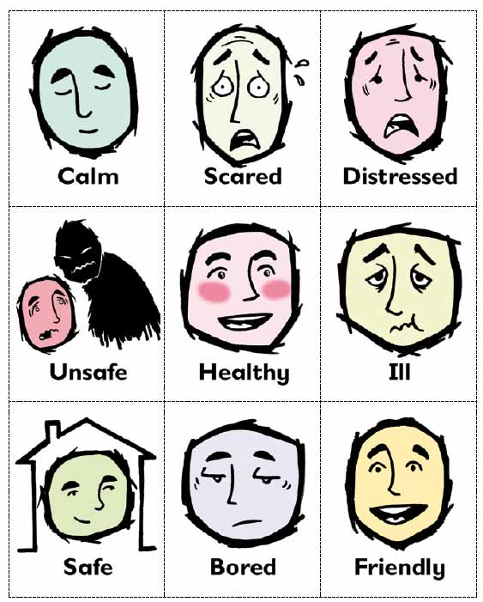

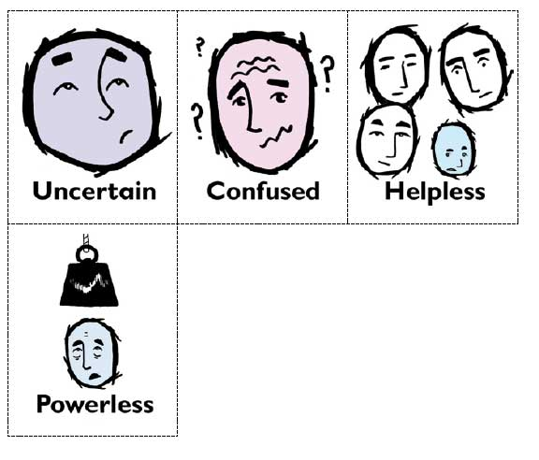

Fact sheet – The five freedoms

